ASTRAQ ET-M
18 kg-class collaborative robotic massage and therapy platform for wellness, physiotherapy and recovery applications.
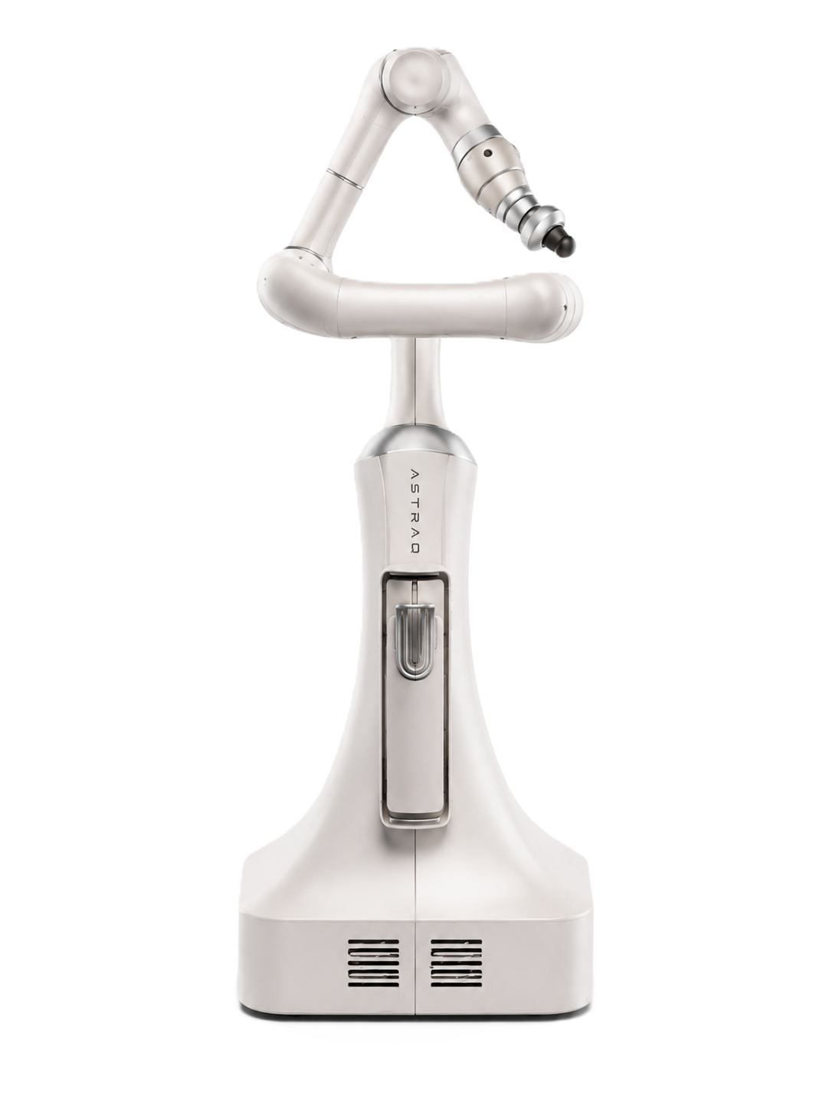  ET-M Robotic Massage System | Key Configuration  Series ET-M CR18-18/1.0  Robot architecture 6-axis collaborative robotic therapy arm  Payload 18 kg  Reach 1,062 mm  Repeatability ±0.03 mm  Typical power 600 W  Noise ≤ 70 dB(A)  Protection rating IP54  Programming Direct teaching control and graphical interface  Application focus Robotic massage, rehab assistance, wellness and sports recovery  SYSTEM POSITIONING  ET-M combines a soft medical-wellness exterior with a class collaborative robot platform. It is designed for controlled, repeatable and configurable therapy paths in professional treatment spaces under operator supervision.
CORE ADVANTAGES
Force-aware therapy  Built-in joint sensing supports compliant and safe interaction. | High payload margin  18 kg payload supports robust therapy end-effectors. | Practical reach  1,062 mm working reach for table-side treatment coverage. | Easy workflow setup  Direct teaching and graphical programming reduce deployment time. | Clinic-ready design  Quiet, smooth and premium appearance for wellness environments.

Technical Parameters

ROBOT ARM  Model / Series ET-M CR18-18/1.0  Robot type 6-axis collaborative robotic therapy arm  Payload 18 kg  Reach 1,062 mm  Robot weight About 38 kg  Degrees of freedom 6  MTBF > 80,000 h  Power supply 48 VDC  Typical power 600 W  PERFORMANCE AND MOTION  Repeatability ±0.03 mm  Force sensing Force x-y-z: 0.1 N; Torque x-y-z: 0.02 Nm  Cartesian stiffness 0-18,000 N/m; 0-2,500 Nm/rad  Joint working range Axis 1 ±360°; Axis 2 ±360°; Axis 3 ±168°; Axis 4 ±360°; Axis 5 ±360°; Axis 6 ±360°  Max joint speed Axis 1 163°/s; Axis 2 163°/s; Axis 3 135°/s; Axis 4 155°/s; Axis 5 199°/s; Axis 6 228°/s  Max tool-end speed ≤ 6.0 m/s | SAFETY AND ENVIRONMENT  Safety functions More than 21 adjustable safety features including collision detection, virtual walls and collaboration mode  Safety references EN ISO 13849-1; EN ISO 10218-1 / PL d, Cat. 3; ISO 15066; CE, KCs and EAC marking requirements  IP rating IP54  ISO cleanroom class Class 5  Noise ≤ 70 dB(A)  Temperature 0°C to 50°C  Humidity ≤ 93% RH, non-condensing  Installation orientation At any angle  CONTROLLER AND INTERFACE  Controller Built-in controller option for CR18-class architecture  Operator interface Notebook / PAD / drag interactive module  Safety devices Handheld enable and handheld emergency stop  Communication TCP/IP 1000Mbit, Modbus TCP, Profinet, Ethernet/IP, DeviceNet, CC-Link, CC-Link IE Field Basic  Tool I/O 2 digital outputs, 2 digital inputs, 2 analog inputs  Tool communication RS485; alternatively two analog input pins  Tool I/O power 12 V / 24 V, 1 A rated  Base output power 24 V, 1.5 A  Teach pendant xPad2, 10.1-inch LCD, 1920 x 1200, IP54
THERAPY APPLICATION PACKAGE
Massage workflow  Configurable back, shoulder and limb massage paths for treatment-bed scenarios. | End-effector options  Massage, percussion, pressure or soft-tissue therapy modules can be configured. | Human-machine safety  Collaborative safety setup supports shared therapist, client and robot workspaces. | Future integration  Open interfaces can support treatment UI, scheduling and therapy-data platforms.
Note: Final specifications may be refined for the ET-M therapy end-effector, software interface and clinical workflow package.

