ASTRAQ | DPM1 6x4 Diesel Prime Mover  Formal product specification

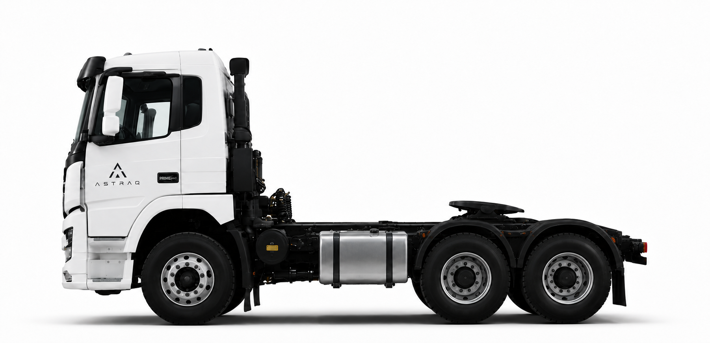
DPM1 6x4 Diesel Prime Mover
KEY DIMENSIONS  Application 6x4 prime mover / semi-trailer tractor  Length (mm) 7025  Width (mm) 2490  Height (mm) unloaded 3317  Wheelbase (mm) 3200 + 1400  GVM (kg) 25,000  GCM (kg) 90,000  Max speed (km/h) 100  Fuel tank (L) 700 + 240  Fifth-wheel height (mm) 1260 unloaded | FEATURES  • 6x4 diesel prime mover with one front steering axle and tandem rear drive axles.  • Right-hand drive cab configured for Australian prime mover applications.  • MC13.54-61 12.42L diesel engine: 400 kW / 1800 rpm and 2500 Nm / 950-1400 rpm.  • ZF 12TX2621TD 12-speed automated transmission with overdrive top gear.  • 25,000 kg GVM and 90,000 kg GCM.  • Tandem rear drive axles with inter-wheel and inter-axle differential locks.  • Dual-circuit compressed-air braking with EBS, ESC and hill-start assist.  • ACC, AEBS, LDW and reversing camera included for driver assistance.

ASTRAQ | DPM1 6x4 Diesel Prime Mover  Vehicle parameters

WEIGHTS  Kerb weight (kg) 8,800  Kerb axle load - front (kg) 4,820  Kerb axle load - rear (kg) 3,980  GVM (kg) 25,000  GCM (kg) 90,000  Design axle load - front (kg) 7,000  Design axle load - rear (kg) 18,000  CAPABILITY  Max speed (km/h) 100  Minimum turning diameter (m) 14  Max gradeability (%) ≥34  Max parking grade (%) ≥20  Fuel tank capacity (L) 700 + 240  CABIN / COMFORT  Cab model DPM1 RHD prime mover cab  Passenger capacity 2  Cab suspension Four-point air suspension  Driver seat Air suspension seat  Cab tilting Electric + manual hydraulic  Multimedia MP5  Air conditioning Semi-automatic  Remote key 1 key | DIMENSIONS  Length (mm) 7025  Width (mm) 2490  Height (mm) unloaded 3317  Wheelbase (mm) 3200 + 1400  Wheel track - front (mm) 2041  Wheel track - rear (mm) 1842  Front overhang (mm) 1475  Rear overhang (mm) 950  Approach angle 19°  Departure angle 22°  Fifth-wheel height (mm) 1260 unloaded  Front / rear fitting radius (mm) 2280 / 1961  PRIME MOVER INTERFACE  Application interface Rear fifth-wheel coupling  Semi-trailer connection Included  Axle layout 1 front steering + 2 rear drive axles

ASTRAQ | DPM1 6x4 Diesel Prime Mover  Powertrain and chassis

ENGINE  Model MC13.54-61  Displacement (L) 12.42  Power rating 400 kW / 1800 rpm  Max torque 2500 Nm / 950-1400 rpm  Application Heavy-duty diesel prime mover  TRANSMISSION AND CLUTCH  Transmission model FAST  Forward ratios 16.688, 12.924, 9.926, 7.688, 5.895, 4.656, 3.655, 2.831, 2.174, 1.684, 1.291, 1.00  Reverse ratios 15.537, 12.033  Clutch model 430 push-type diaphragm spring clutch  Clutch operation Electronically controlled pneumatic power assist | AXLES AND SUSPENSION  Front axle model VPD71DS  Driving axle model MCY13BES  Final drive ratio 3.08 / 3.36 / 3.70  Differential lock Inter-wheel and inter-axle differential lock  Suspension model Non-independent suspension  Front suspension Parabolic springs, 3 leaves  Rear suspension Air suspension, 8 air springs  TYRES AND FRAME  Rim Front 22.5 x 9.0 aluminium alloy; rear 22.5 x 8.25 aluminium alloy  Tyres Front 295/80R22.5; rear 11R22.5  Frame model Trapezoidal frame with wide front and narrow rear  Main beam section (mm) Slot type 270 x 85 x 8  Frame width (mm) Front 942; rear 762

ASTRAQ | DPM1 6x4 Diesel Prime Mover  Steering, braking, safety and electrics

STEERING  Model Recirculating ball hydraulic power steering  Steering ratio 17-20:1  Max pump pressure (kPa) 20,000  Working pressure (kPa) 1,250  Steering way Steering wheel  BRAKING / SAFETY  Service brake Dual-circuit compressed-air brake  Brake power assist type EBS + ESC + HSA  Parking brake type Spring stored energy air cut brake  Circuit type Dual  Driver assistance ACC + AEBS + LDW  Reverse camera Included | ELECTRICS / COMFORT  Operating voltage 24 V  Generator power 3 kW  Batteries 2 x 12 V / 240 Ah  Multimedia MP5  Air conditioning Semi-automatic  Remote key 1 key  PRODUCT POSITIONING  • DPM1 is configured as a 6x4 diesel prime mover for semi-trailer operation.  • The rear fifth-wheel coupling distinguishes DPM1 from a rigid cab chassis.  • The specification emphasises GCM, fifth-wheel height, tandem drive axles, air suspension, long-haul braking and driver-assistance functions.  • This document presents DPM1 as a product specification rather than a comparison or target configuration sheet.

ASTRAQ | DPM1 6x4 Diesel Prime Mover  Chassis structure layout

STRUCTURE DRAWING
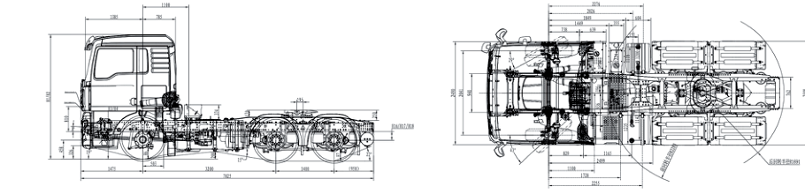
DPM1 6x4 prime mover chassis layout - side view and top view
LAYOUT HIGHLIGHTS  Axle configuration 1 front steering axle + 2 rear drive axles  Wheelbase (mm) 3200 + 1400  Application interface Rear fifth-wheel coupling  Frame arrangement Trapezoidal ladder frame  Rear suspension Air suspension, 8 air springs  Fuel system 700 + 240 L | PACKAGING NOTES  • Side-view layout supports fifth-wheel, axle-spacing and rear overhang review.  • Top-view layout supports frame, driveline and component-packaging review.  • Chassis configuration is arranged for semi-trailer operation rather than direct rigid-body mounting.

