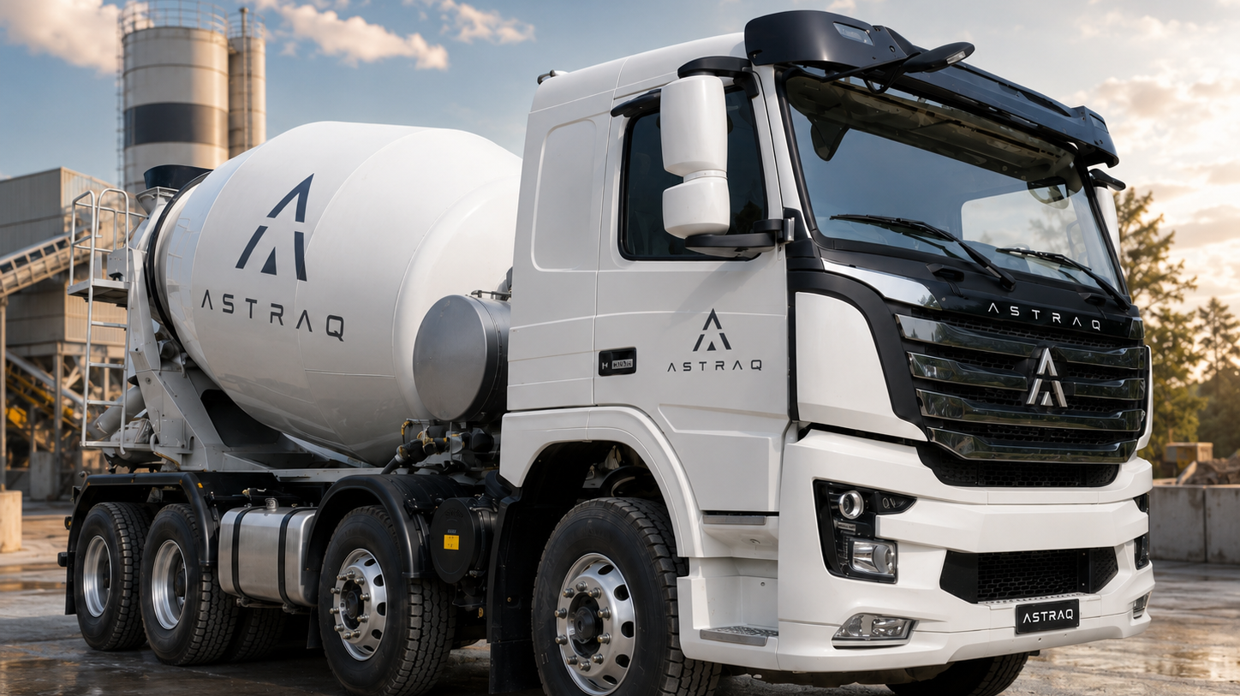
(Reference Photo)
EXTERNAL DIMENSIONS
Length (mm) | 8615
Width (mm) | 2518*
Height (mm) (empty) | 3120
Wheel base (mm) | 1800+3000+1350
Wheel track (mm) | Front 2030/2030; Rear 1850/1850
Front overhang (mm) | 1490
GVM (Kg) | 35000
Max speed (km/h) | 100
Max climb gradient (%) | Theoretical 54%
Fuel tank (L) | 250L
FEATURES
• Cummins X11EVIE360 10.5L engine; 265 kW / 1900 rpm and 1800 Nm / 1000-1400 rpm.
• F12JZ20A 12-speed transmission with 0.78 overdrive top gear.
• Right-hand drive flat-roof short semi-sleeper cab for mixer applications.
• Four-point air suspension cab and air suspension driver seat.
• 7.5t disc front axle and 10t drum rear axle with dual differential locks.
• Four-airbag rear suspension designed for mixer platform stability.
• EBS + ESC, AEBS, FCWS, LDWS and reversing camera included.
• Right-side water tank reserved space: 1335 mm; customer target: 2000 mm.

WEIGHTS
GVM (kg) | 35000
Front axle rating | 7.5t + 7.5t
Rear axle rating | 10t + 10t
GCM (kg) | To be confirmed
CAPABILITY
Max speed (km/h) | 100
Max climb gradient (%) | 54
Fuel tank (L) | 250
Turning diameter | <20
ENGINE
Model | Cummins X11EVIE360
Displacement (L) | 10.5
Power rating | 265 kW / 1900 rpm
Max torque | 1800 Nm / 1000-1400 rpm
TRANSMISSION
Model | F12JZ20A
Forward ratios | 12.26, 9.56, 7.36, 5.73, 4.52, 3.52, 2.71, 2.11, 1.63, 1.27, 1.00, 0.78
FRAME
Model | Ladder framework
Main beam | 1000-850 x 300 x 80 x (8+4)
Reserved water tank space | Right side 1335 mm
FRONT AXLE
Model | 7.5t disc front axle
Type | Mercedes type front axle
Wheel track | 2030 / 2030 mm
DRIVING AXLE
Model | 10t drum oil-lubricated 440 axle
Differential lock | Interwheel / interaxle diff. lock
Ratio | 4.44
Wheel track | 1850 / 1850 mm

SUSPENSION
Front | Few-leaf spring 3/3
Rear | Four airbags, 2+ - / 2+ -
Cab suspension | Four-point air suspension
CABIN
Model | Flat-roof short semi-sleeper
Steering | Right-hand drive
Cab tilting | Electric + manual hydraulic
Seat | Air suspension seat
BRAKING / SAFETY
EBS + ESC | Included
AEBS | Included
FCWS | Included
LDWS | Included
Reverse camera | Included
ELECTRICS / COMFORT
Battery | 180 Ah low-temperature
Remote key | 2 key
Multimedia | MP5
Air conditioning | Semi-automatic

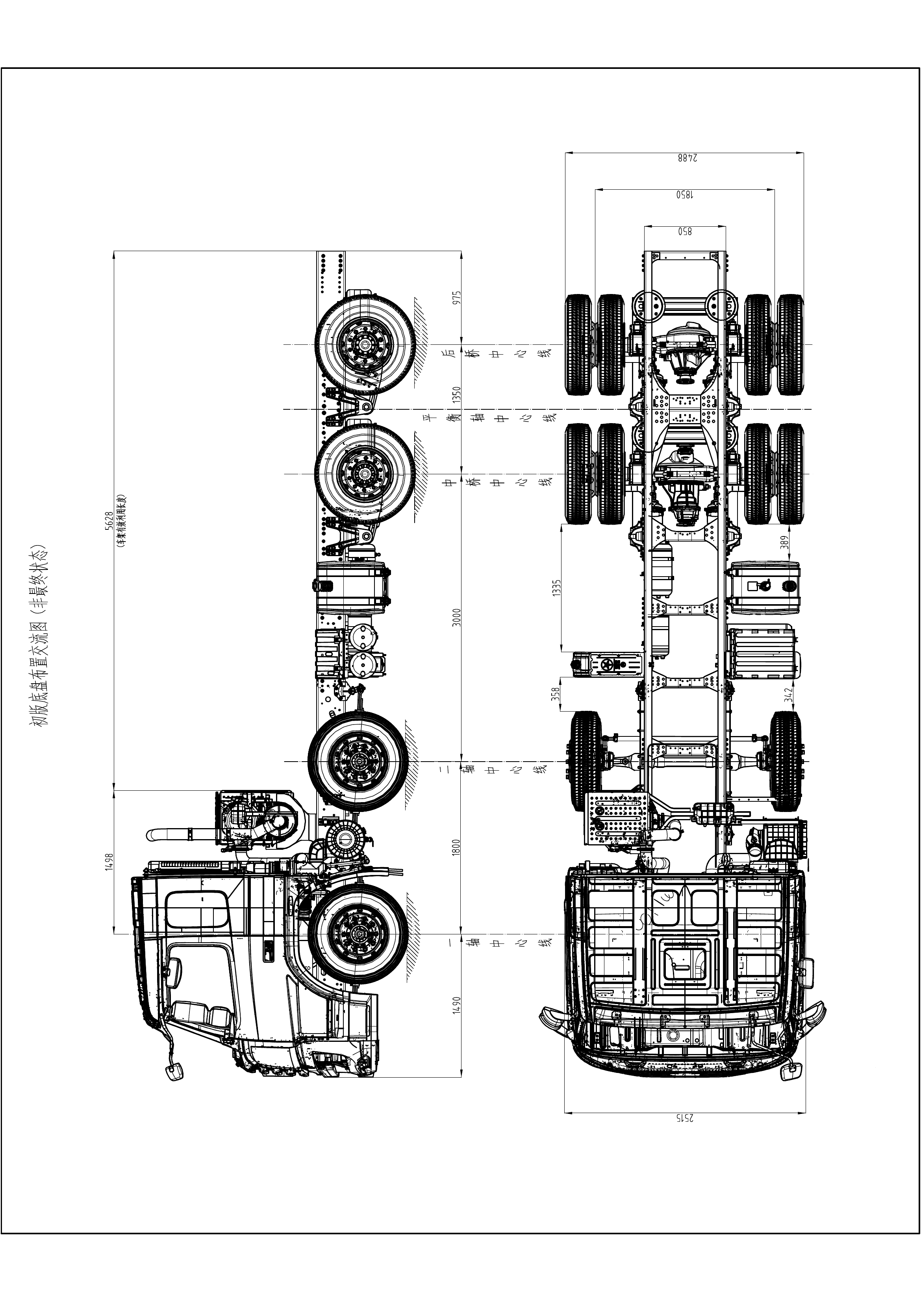
Preliminary chassis layout drawing (non-final status)

