ASTRQ | 6x4 Battery-Electric Prime Mover
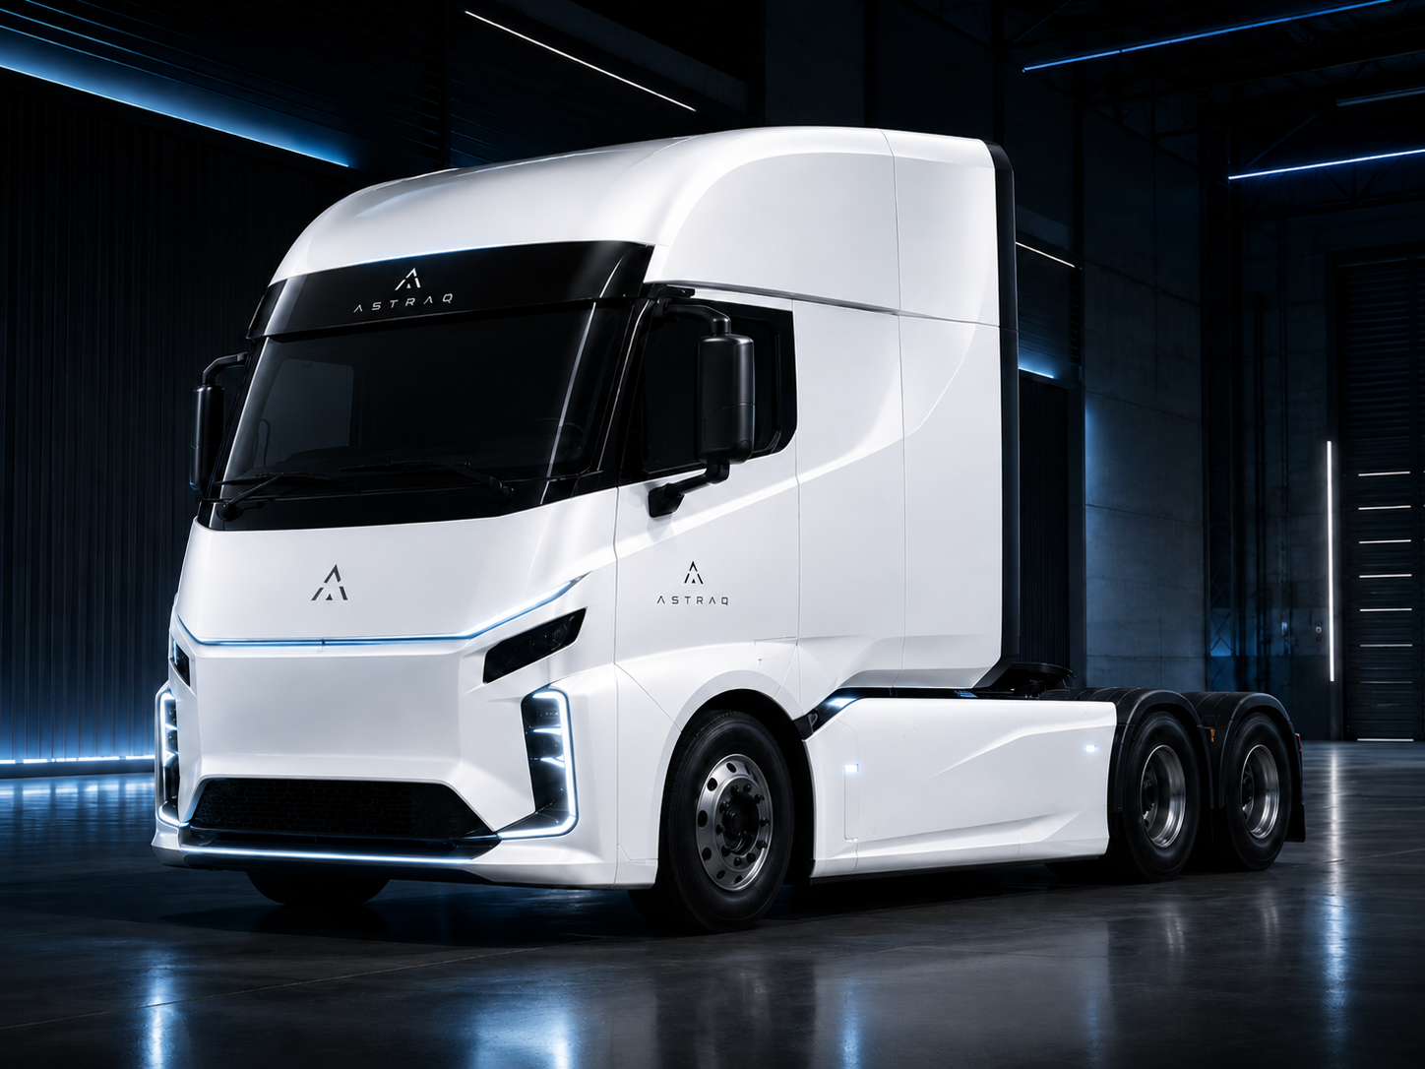
Configuration Specification | 6x4 BEV Prime Mover
KEY VEHICLE PARAMETERS
Vehicle type | 6x4 battery-electric prime mover, right-hand / centre-driving configuration
Cabin | High-roof, flat-floor aerodynamic cab; dual-door configuration; white body with ASTRAQ branding
Dimensions (L x W x H) | 7,500， 2,500, 3,500 mm
Wheelbase | 4,550 + 1,350 mm
Kerb weight | 10,900 kg including battery system
Gross combination mass | Up to 60,000 kg for B-Double / multi-trailer line-haul operation
Battery system | LFP battery system, approx. 500-600 kWh; underfloor battery layout
Electrical platform | 800 V high-voltage platform
Driving motor | Dual-motor electric drive, approx. 600 hp class
Driving range | > 400 km under intended line-haul operation profile
Charging / energy supply | Fast charging and battery-swap compatible; swap-led operation strategy
Maximum gradeability | >= 20%
astraq.com.au | Product Configuration Specification
ASTRAQ 6x4 Battery-Electric Prime Mover - Configuration
POWERTRAIN & CHASSIS  Drive system Direct electric drive with regenerative braking  Rated / peak motor power Approx. 2 x 138 kW rated / 2 x 290 kW peak benchmark class  Rated / peak torque Approx. 2 x 300 Nm rated / 2 x 820 Nm peak benchmark class  Front axle / rear axle Approx. 5.6 t front axle / 13 t rear tandem axle benchmark class  Suspension Front independent suspension and full air-suspension configuration  Tyres 12R22.5 heavy-duty road tyres  Frame Heavy-duty ladder frame with integrated battery protection  Fifth wheel Prime mover fifth-wheel coupling for semi-trailer operation | SAFETY, INTELLIGENCE & COMFORT  Braking system Electronic braking system with EMB, ABS, EBS and ESC  Active safety AEB, LDW/LDWS, FCW and driver assistance functions  Autonomous readiness L2+ capable hardware architecture with upgrade path  Chassis-by-wire Brake-by-wire, steer-by-wire and drive-by-wire architecture  Sensor package High-resolution cameras, millimetre-wave radar and LiDAR-ready layout  Redundancy Independent computing, sensor and power backup design  Connectivity Satellite positioning; V2X upgradable electrical architecture  Comfort Air-suspension driver seat, air conditioning and digital cockpit interface

