ASTRAQ | ASTRAQ Electric Light Truck  4x2 Battery-Electric Urban Logistics Truck

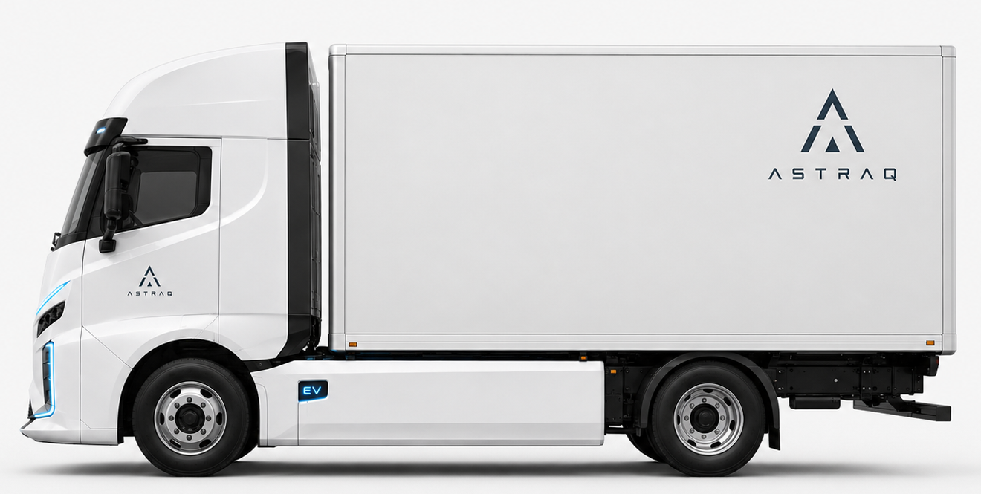

Key Configuration
Model positioning | 4x2 battery-electric light-duty box truck for urban and metro distribution
Overall dimensions (mm) | 5,995 x 2,200 x 3,150 (box-body configuration)
Wheelbase (mm) | 3,400
GVM | 4,495 kg
Body type | Dry van / box body; refrigerated body available
Traction battery | LFP / blade battery, liquid-cooled pack
Battery capacity (kWh) | 100 kWh standard; 132 kWh long-range option
Motor power | 70 kW rated / 150 kW peak
Driving range | 220-300 km typical urban operation, depending on load and body type
Charging method | CCS2; AC 11 kW, DC fast charge up to 70 kW
astraq.com.au | Electric Light Truck Specification

ASTRAQ | ASTRAQ Electric Light Truck  Technical Specification

Vehicle & Chassis
Drive configuration | 4x2
Vehicle category | 4.5t electric light-duty truck
Cab | Forward-control EV cab, white exterior, aerodynamic front styling
Body | Integrated box body for city delivery applications
Frame | Ladder frame with box-body mounting provision
Front axle capacity | 2,600 kg
Rear axle capacity | 4,500 kg
Suspension | Front independent / coil spring; rear leaf spring with shock absorbers
Tyres | 17.5-inch commercial tyres; 205/75R17.5 reference size
Turning circle | Approx. 12.8 m for 3,400 mm wheelbase configuration

Electric Drive, Battery & Charging
Motor | Permanent-magnet synchronous motor
Peak torque | 430 Nm peak / 250 Nm continuous
Transmission | Single-speed reduction gearbox; no gear changes
Battery chemistry | LFP / blade battery
Battery capacity | 100 kWh standard; 132 kWh option
Battery cooling | Liquid-cooled battery thermal management
Charging standard | CCS2
AC charging | Up to 11 kW
DC fast charging | Up to 70 kW
Auxiliary power | 12V / 24V electrical system with body-builder support

Safety, Intelligence & Comfort
Active safety | AEB / Active Brake Assist, LDWS, ESP/ESC, ABS + EBD
Urban safety | Acoustic Vehicle Alerting System (AVAS), reverse warning buzzer
Lighting | LED headlamps, LED taillamps and daytime running lamps
Braking | Hydraulic dual-circuit disc brakes with regenerative braking
Parking brake | Electric park brake
Cab safety | ECE-R29 cab strength concept; driver and passenger SRS airbags
Driver interface | Digital display with speed, battery percentage, range and temperature
Comfort | Air conditioning / heater / demister; electric windows; central locking
Designed for zero-emission urban logistics, quiet delivery operation and practical city access.

