FP2

 | DE LA SALLE-COLLEGE OF SAINT BENILDE  School of New Media Arts  Multimedia Arts Program | 

Name | : | Alecssa Czairyl O. Pascua
ID Number | : | 12413573
Subject and Section | : | MMINTER FAMA14

SITEMAP

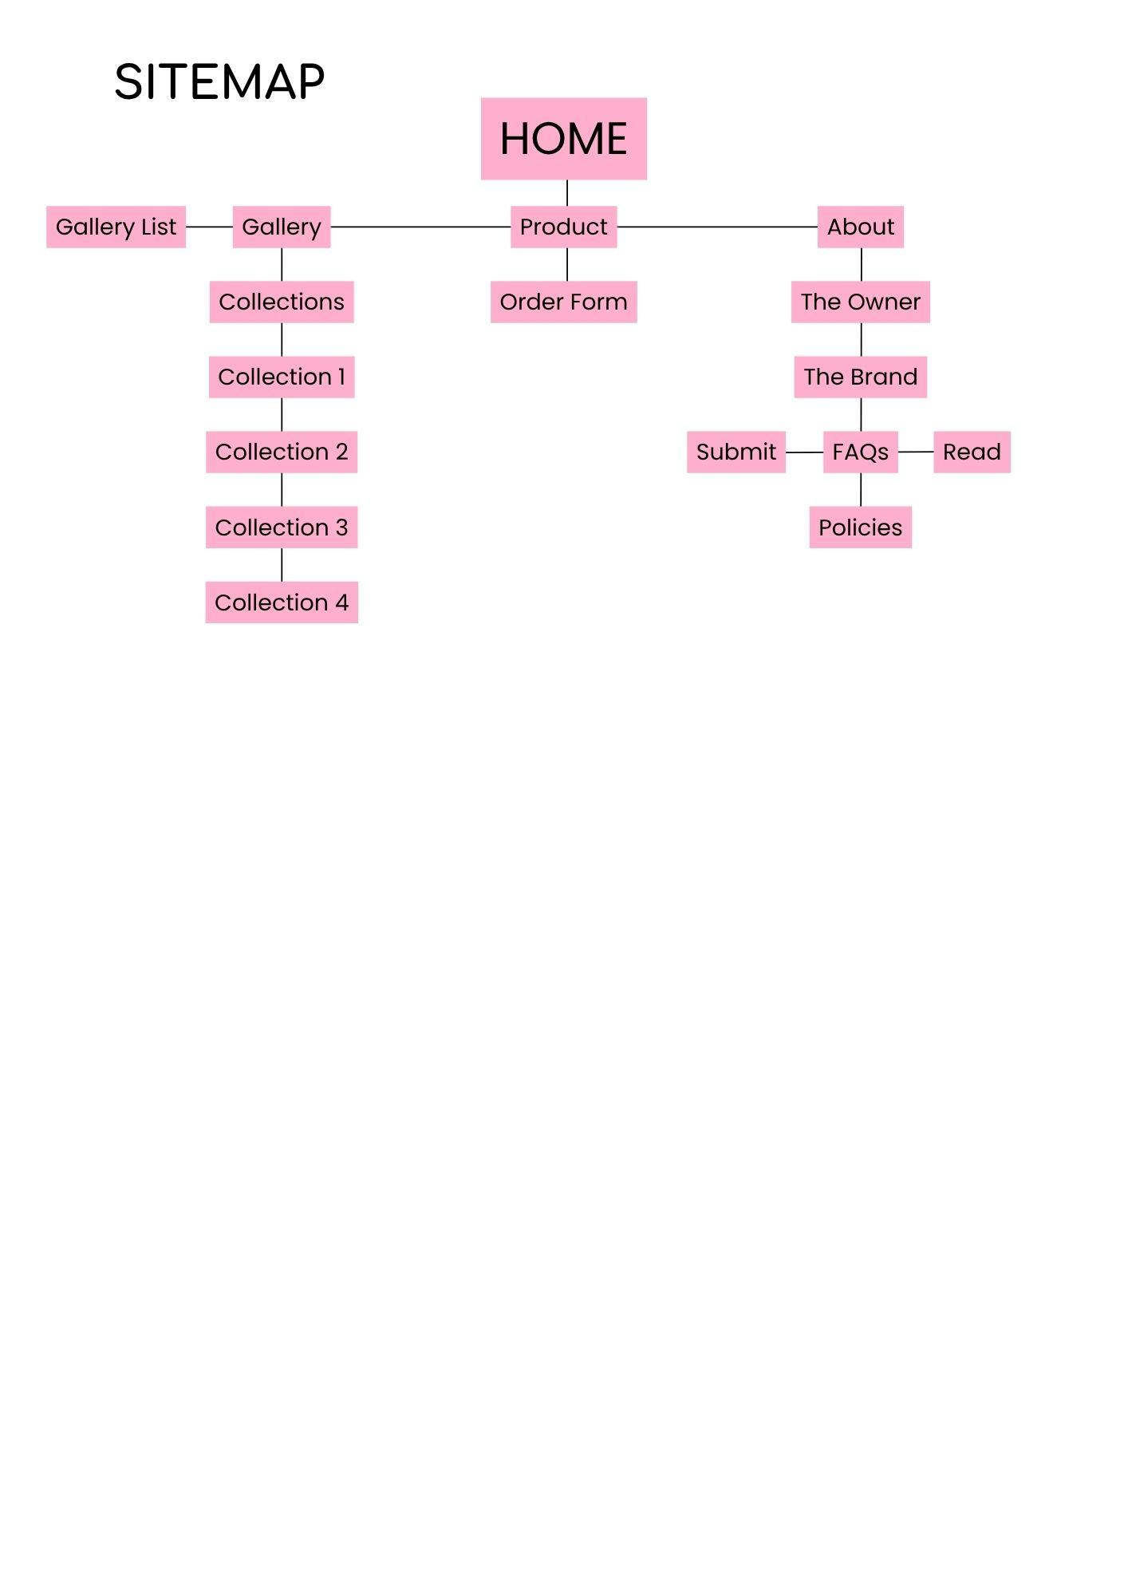Content

Homepage
Navigation Header
- Logo
- CTA:
  - Our Kuko
  - Order Form
  - About Us
  - Log In/Register
  - Cart
  - Bell
  - User
Hero Section
- Main Headline
  - Pan de kuko (logo)
- Subheadline:
  - Custom Press-On Nails, made for every vibe. You customize, we deliver— pan.de.Kuko always nails it!
- CTA:
  - NAIL THE LOOK TODAY!
Special Offer
- Main headline:
  - SPECIAL OFFER!
- Subheadline:
  - Want to slay and have nails that are cosmic-level cute?—Our press-ons are made just for you! Enjoy a 10% discount on your first order!
- CTA:
  - CLAIM VOUCHER
Featured Collection
- Main Headline:
  - Featured Collection
- CTA:
  - BROWSE COLLECTION
Feedback
- Main headline:
  - Bestsellers!
- Subheadline:
  - Curious about our nails? Read genuine reviews from those who’ve already nailed their look. Stellar nails, stellar reviews!
- CTA:
  - VIEW PRODUCT
Footer:
- Branding: pan de kuko
- Copyright Notice: pan de kuko © 2024
- Web Design by Czairyl Pascua
- Instagram Icon
- Email Icon
- Phone Icon

Gallery
Navigation Header
- Logo
- CTA:
  - Our Kuko
  - Order Form
  - About Us
  - Log In/Register
  - Cart
  - Bell
  - User
Hero Section
- Main headline:
  - Our Kuko
- Subheadline:
  - Explore our galaxy-wide range of nail designs. Every design is crafted to be out of this world.
- CTA:
  - Browse Category
- Featured Collections
  - DARK AND WILD
    - CTA:
    - Browse Collection
- X-TRALICIOUS
  - CTA:
    - Browse Collection
- KAWAII DAZZLE
  - CTA:
    - Browse Collection
- BLOODY REDS
  - CTA:
    - Browse Collection
Footer:
- Branding: pan de kuko
- Copyright Notice: pan de kuko © 2024
- Web Design by Czairyl Pascua
- Instagram Icon
- Email Icon
- Phone Icon

Gallery Subpages

COLLECTION 1
Navigation Header
- Logo
- CTA:
  - Our Kuko
  - Order Form
  - About Us
  - Log In/Register
  - Cart
  - Bell
  - User
Hero Section
- Main headline:
  - DARK AND WILD
- Subheadline:
  - The dark and wild collection features our artist’s expertise at moody, glamorous, alternative nail designs. This collections includes blacks, whites, reds, chromes, and silver charms, fit for your edgy looks
- CTA:
  - Shop this look!
Footer:
- Branding: pan de kuko
- Copyright Notice: pan de kuko © 2024
- Web Design by Czairyl Pascua
- Instagram Icon
- Email Icon
- Phone Icon

COLLECTION 2
Navigation Header
- Logo
- CTA:
  - Our Kuko
  - Order Form
  - About Us
  - Log In/Register
  - Cart
  - Bell
  - User
Hero Section
- Main headline:
  - X-TRALICIOUS
- Subheadline:
  - The X-TRAlicious collection is all about going bigger, brighter, and bolder.Packed with vivid hues, chunky glitters, gems, and standout details, these designs are made for those who love to shine and stand out.
- CTA:
  - Shop this look!
Footer:
- Branding: pan de kuko
- Copyright Notice: pan de kuko © 2024
- Web Design by Czairyl Pascua
- Instagram Icon
- Email Icon
- Phone Icon

COLLECTION 3
Navigation Header
- Logo
- CTA:
  - Our Kuko
  - Order Form
  - About Us
  - Log In/Register
  - Cart
  - Bell
  - User
Hero Section
- Main headline:
  - KAWAII DAZZLE
- Subheadline:
  - The Kawaii Dazzle collection showcases dreamy cutesy designs with a sparkly touch.Featuring candy-colored tones, delicate charms, iridescent glitters, and twinkling accents, each set is made to look sweet, soft, and magical.
- CTA:
  - Shop this look!
Footer:
- Branding: pan de kuko
- Copyright Notice: pan de kuko © 2024
- Web Design by Czairyl Pascua
- Instagram Icon
- Email Icon
- Phone Icon

COLLECTION 4
Navigation Header
- Logo
- CTA:
  - Our Kuko
  - Order Form
  - About Us
  - Log In/Register
  - Cart
  - Bell
  - User
Hero Section
- Main headline:
  - BLOODY REDS
- Subheadline:
  - The Blood Reds collection is bold, deep, and unapologetically fierce.Think crimson tones, gory finishes, and monstrous details that command attention.
- CTA:
  - Shop this look!
Footer:
- Branding: pan de kuko
- Copyright Notice: pan de kuko © 2024
- Web Design by Czairyl Pascua
- Instagram Icon
- Email Icon
- Phone Icon

Main Catalogue
Navigation Header
- Logo
- CTA:
  - Our Kuko
  - Order Form
  - About Us
  - Log In/Register
  - Cart
  - Bell
  - User
Hero Section
- Main headline:
  - Pande Kuko’s Catalogue
- CTA: Sort
  - A-Z
  - Oldest
  - Newest
- CTA: Search Filter
  - By Category
    - Bestsellers
  - Color
    - Neutrals
    - Bold
    - Pastel
    - Metallic
  - Design
    - Simple
    - Basic
    - Advanced
  - Length
    - Short
    - Medium
    - Long
  - Shape
    - Almond
    - Coffin
    - Round
    - Stiletto
    - Square
  - Rating
    - 5
    - 4
    - 3
    - 2
    - 1

- Product 1
  - Headline:
    - Electric Swagger
    - P550
  - Sub Headline
    - Long Coffin
  - CTA:
    - Add to Cart
- Product 2
  - Headline:
    - 2010’s McBling
    - P550
  - Sub Headline
    - Long Stiletto
  - CTA:
    - Add to Cart
- Product 3
  - Headline:
    - New Yorker
    - P550
  - Sub Headline
    - Long Square
  - CTA:
    - Add to Cart
- Product 4
  - Headline:
    - Popmart
    - P550
  - Sub Headline
    - Medium Almond
  - CTA:
    - Add to Cart
- Product 5
  - Headline:
    - Inside Flesh
    - P550
  - Sub Headline
    - Long Stiletto
  - CTA:
    - Add to Cart
- Product 6
  - Headline:
    - Rotten kore
    - P550
  - Sub Headline
    - Medium Stiletto
  - CTA:
    - Add to Cart
Footer:
- Branding: pan de kuko
- Copyright Notice: pan de kuko © 2024
- Web Design by Czairyl Pascua
- Instagram Icon
- Email Icon
- Phone Icon

Product
Navigation Header
- Logo
- CTA:
  - Our Kuko
  - Order Form
  - About Us
  - Log In/Register
  - Cart
  - Bell
  - User
Hero Section
- Main headline:
  - Customize Your Kuko!
- Sub Headline
  - You customize, we deliver— pan.de.Kuko always nails it!
Footer:
- Branding: pan de kuko
- Copyright Notice: pan de kuko © 2024
- Web Design by Czairyl Pascua
- Instagram Icon
- Email Icon
- Phone Icon

Order Form
Navigation Header
- Logo
- CTA:
  - Our Kuko
  - Order Form
  - About Us
  - Log In/Register
  - Cart
  - Bell
  - User
Hero Section
- Main Headline
  - Customize Your Kuko!
- CTA: Nail
  - Right
    - Thumb
    - Index Finger
    - Middle Finger
    - Ring Finger
    - Little Finger
  - Left
    - Thumb
    - Index Finger
    - Middle Finger
    - Ring Finger
    - Little Finger
  - Apply to All
- CTA: Size
  - XS
  - S
  - M
  - L
    - Subheading:
      - SIZING CHART (mm)
Size | Thumb | Index | Middle | Ring | Pinky
XS | 14 | 10 | 11 | 10 | 7 - 8
S | 15 | 11 | 12 | 11 | 8 - 9
M | 16 | 12 | 13 | 12 | 9
L | 17-18 | 13 | 14 | 13 | 10
- CTA: Shape
  - Almond
  - Coffin
  - Round
  - Stiletto
  - Square
- CTA: Length
  - Short
  - Medium
  - Long
  - Others: Please Specify
- CTA: Aftercare
  - Remover
  - Glue
  - Nail File
- CTA: Type
  - Simple
    - Plain Color
    - Minimal Line Work/Stone
    - Patterns, French Tips, Etc
  - Basic
    - Embossed, Chrome
    - Simple 3D Sets
  - Advanced
    - Detailed 3D Sets
    - Claw Nails
    - Character Sets
    - Sculptura Sets
- Color Picker: Color
- Text Input:
  - Design Notes and Specifications…
- CTA:
  - Add Photo
- Subheadline:
  - Have your own inspiration? Upload them here!
- Side Bar
  - Headline:
    - Price List
  - Sub Heading:
    - Simple
      - Plain Color ₱200
      - Minimal Line Work/Stone ₱450
      - Patterns, French Tips, Etc ₱550
    - Basic
      - Embossed, Chrome ₱600
      - Simple 3D Sets ₱700
    - Advanced
      - Detailed 3D Sets ₱800
      - Claw Nails ₱800
      - Character Sets Starts at ₱900
      - Sculptural Sets Starts at ₱1,000
  - CTA
    - Proceed to Checkout
Footer:
- Branding: pan de kuko
- Copyright Notice: pan de kuko © 2024
- Web Design by Czairyl Pascua
- Instagram Icon
- Email Icon
- Phone Icon

About
Navigation Header
- Logo
- CTA:
  - Our Kuko
  - Order Form
  - About Us
  - Log In/Register
  - Cart
  - Bell
  - User
Hero Section
- Headerline
  - About Us
- Subheadline:
  - Feeling lost in this gnarly space? Get to know us more with this page!
- CTA:
  - The Owner
  - The Brand
  - FAQs
  - Feedback
  - Policies
Footer:
- Branding: pan de kuko
- Copyright Notice: pan de kuko © 2024
- Web Design by Czairyl Pascua
- Instagram Icon
- Email Icon
- Phone Icon

The Owner
Navigation Header
- Logo
- CTA:
  - Our Kuko
  - Order Form
  - About Us
  - Log In/Register
  - Cart
  - Bell
Hero Section
- Headline:
  - Meet The Owner
- Sub Headline
  - Hi, I am Marianne Yshhi Pineda
- Body
  - The founder and owner of Pan de Kuko, 21 years of age from Kamuning, Quezon City. As a kid I've always loved painting and making miniatures which have paved the path for this nail business.I started focusing on making nails because I got burnt out from other mediums, I'm the type to always seek for mediums to use and experiment with and making nails has been refreshing for me! So now I make press-on nails for creatives who love fashion and photography.
  - @marianne.com_
  - @marianneysshii@gmail.com
Footer:
- Branding: pan de kuko
- Copyright Notice: pan de kuko © 2024
- Web Design by Czairyl Pascua
- Instagram Icon
- Email Icon
- Phone Icon

The Brand
Navigation Header
- Logo
- CTA:
  - Our Kuko
  - Order Form
  - About Us
  - Log In/Register
  - Cart
  - Bell
Hero Section
- Headline:
  - Get To Know Us
- Body
  - It started out as an interest of mine, then transitioned into a hobby. There was a time that I wanted it to be self-sustaining, so I figured I should sell these custom press-ons that are good quality, but at a lower price for students like me. Considering that I am surrounded by creatives I figured that people will be interested. From then on, I got more and more orders and got offers to work in a few photoshoots with professional models unti pan.de.kuko became what it is today.
- Sub Headline
  - VISION & MISSION
- Body
  - To be one of the leading press-on nail brand for creatives and fashion enthusiasts who value unique, high-fashion nail art.To be a trusted brand that consistently delivers innovative designs, exceptional quality, and inspiration for self-expression.
- Contact
  - Instagram
    - pan.de.kuko
  - Phone
    - +639 000 000 000
  - Email
    - nichiclaws@gmail.com
Footer:
- Branding: pan de kuko
- Copyright Notice: pan de kuko © 2024
- Web Design by Czairyl Pascua
- Instagram Icon
- Email Icon
- Phone Icon

FAQs
Navigation Header
- Logo
- CTA:
  - Our Kuko
  - Order Form
  - About Us
  - Log In/Register
  - Cart
  - Bell
Hero Section
- Headline:
  - Learn More About Your Nails
- Application Guide
- Care Guide
- Measurement Guide
- Sub Headlines
  - Application Guide
  - Care Guide
  - Measurement Guide
Footer:
- Branding: pan de kuko
- Copyright Notice: pan de kuko © 2024
- Web Design by Czairyl Pascua
- Instagram Icon
- Email Icon
- Phone Icon

Feedback
Navigation Header
- Logo
- CTA:
  - Our Kuko
  - Order Form
  - About Us
  - Log In/Register
  - Cart
  - Bell
Hero Section
- Headline:
  - Community Space
- Sub Headlines
  - NAILED THE LOOK? TELL US!
  - LOOKING FOR SOMETHING GNARLY?
- Body
  - Loving our nails? We love to hear about your experience!
- CTA
  - Submit Feedback
  - Browse Feedback
Footer:
- Branding: pan de kuko
- Copyright Notice: pan de kuko © 2024
- Web Design by Czairyl Pascua
- Instagram Icon
- Email Icon
- Phone Icon

Review
Navigation Header
- Logo
- CTA:
  - Our Kuko
  - Order Form
  - About Us
  - Log In/Register
  - Cart
  - Bell
Hero Section
- Headline:
  - Write A Review
- Text Field
  - Subject Title
  - Tell us more about your experiences and share your thoughts about our product.
- CTA
  - Rate Product
  - Submit Feedback
  - + Add Photo
  - + Add Video
Footer:
- Branding: pan de kuko
- Copyright Notice: pan de kuko © 2024
- Web Design by Czairyl Pascua
- Instagram Icon
- Email Icon
- Phone Icon

Feedback List
Navigation Header
- Logo
- CTA:
  - Our Kuko
  - Order Form
  - About Us
  - Log In/Register
  - Cart
  - Bell
Hero Section
- Headline:
  - Feedback
- Subheadline
  - Username
- Body
  - Feedback
- CTA
  - Star Rating
Footer:
- Branding: pan de kuko
- Copyright Notice: pan de kuko © 2024
- Web Design by Czairyl Pascua
- Instagram Icon
- Email Icon
- Phone Icon

Policies
Navigation Header
- Logo
- CTA:
  - Our Kuko
  - Order Form
  - About Us
  - Log In/Register
  - Cart
  - Bell
Hero Section
- Headline:
  - Learn More About Your Nails
- Sub Headlines
  - Order
    - A diva’s guide to know more about our commission contract and rush policies!
  - Refund
    - A diva’s guide to know more about our refunding policies!
  - Complaints
    - A diva’s guide to know more about how one can submit their complaints!
Footer:
- Branding: pan de kuko
- Copyright Notice: pan de kuko © 2024
- Web Design by Czairyl Pascua
- Instagram Icon
- Email Icon
- Phone Icon

    - Heading/s:
      - Meet The Owner
    - Subheading/s:
      - Hi! I am Marianne Ysshi Pineda!
    - Content Body:
      - The founder and owner of Pan de Kuko, 21 years of age from Kamuning, Quezon City. As a kid I've always loved painting and making miniatures which have paved the path for this nail business. I started focusing on making nails because I got burnt out from other mediums, I'm the type to always seek for mediums to use and experiment with and making nails has been refreshing for me! So now I make press-on nails for creatives who love fashion and photography.
    - CTA
      - @marianne.com_ (personal)
      - marianneysshii@gmail.com (personal)
  - The Brand
    - Brand Logo
    - Heading/s:
      - Vision & Mission
    - Content Body:
      - Origin: It started out as an interest of mine, then transitioned into a hobby. There was a time that I wanted it to be self-sustaining, so I figured I should sell these custom press-ons that are good quality, but at a lower price for students like me. Considering that I am surrounded by creatives I figured that people will be interested. From then on, I got more and more orders and got offers to work in a few photoshoots with professional models unti pan de kuko became what it is today.

      - Vision: To be one of the leading press-on nail brand for creatives and fashion enthusiasts who value unique, high-fashion nail art.
      - Mission: To be a trusted brand that consistently delivers innovative designs, exceptional quality, and inspiration for self-expression.

    - Contact Us
      - Instagram
      - Email
      - Phone Number
  - FAQs
    - Heading/s:
      - Learn More About Your Nails!
    - Tutorials Content Body:
      - Application
      - Care Guide
      - Measurement Guide
  - Feedbacks
    - Heading/s:
      - Nailed the Look? Tell Us!
    - CTA
      - Submit Feedback
        - Subpage Heading/s: Write A Review
        - Subpage Button/s:
          - Add Photo
          - Add Video
        - Subpage CTA:
          - Rate Product
          - Submit
        - Subpage Text Field:
          - Title
          - Tell us more about your experiences and share your thoughts about our product.

      - Browse Feedback
        - Subpage Heading/s:
          - Feedback
        - Subpage CTA:
          - Grid testimonial reviews from customers
          - See More Reviews
  - Policies
    - Heading/s
      - Order
      - Refund
      - Complaints
    - Subheading/s:
      - A diva’s guide to know more about our refunding policies!
      - A diva’s guide to know more about our commission contract and rush order policies!
      - A diva’s guide to know more about how one can submit their complaints!
  - Footer
    - Branding: pan de kuko
    - Copyright Notice: pan de kuko © 2024
    - Contact information

