**CHAPTER FOUR**

* 1. **SYSTEM DESIGN**

This chapter deals with the system design based on the analysis of the FRSC Oyo-Ibadan express way accident monitoring, the system will be designed to solve accident management system.

**4.2 OUTPUT DESIGN**

The output design is sub-sectioned into three:

1. Reports to be generated
2. Screen forms of report
3. File used to produce report
4. **REPORT TO BE GENERATED**

Below are the lists of reports to be generated:

1. Staff registration report
2. Driver registration report
3. Accident victim monitoring report
4. Accident decision report
5. **SCREEN FORM OF REPORT**

Below is the format the various reports will be displayed on the screen.

**SCREEN FORM OF STAFF REGISTRATION** **REPORT**

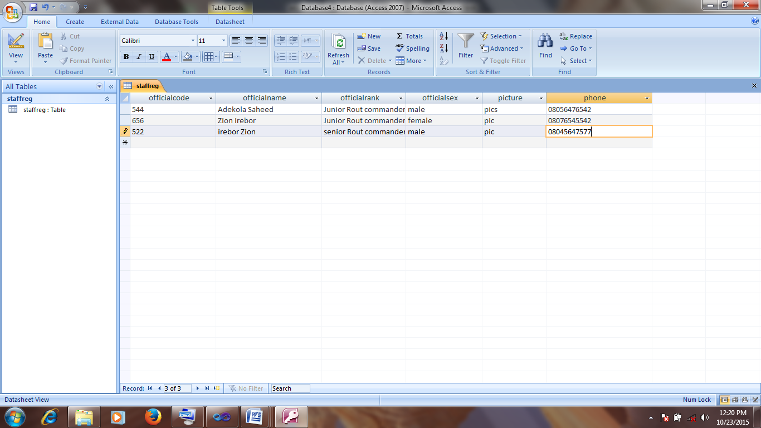

**SCREEN FORM OF DRIVER REGISTRATION REPORT**

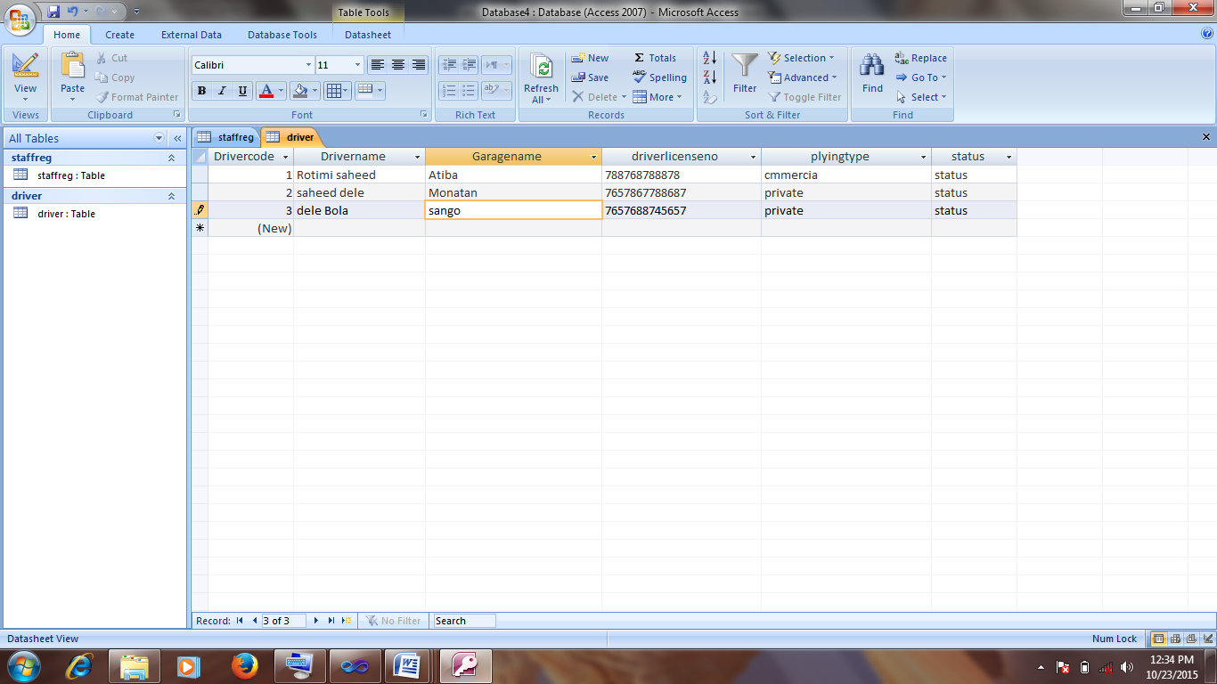

**SCREEN FORM OF ACCIDENT VICTIM MONITORING** **REPORT**

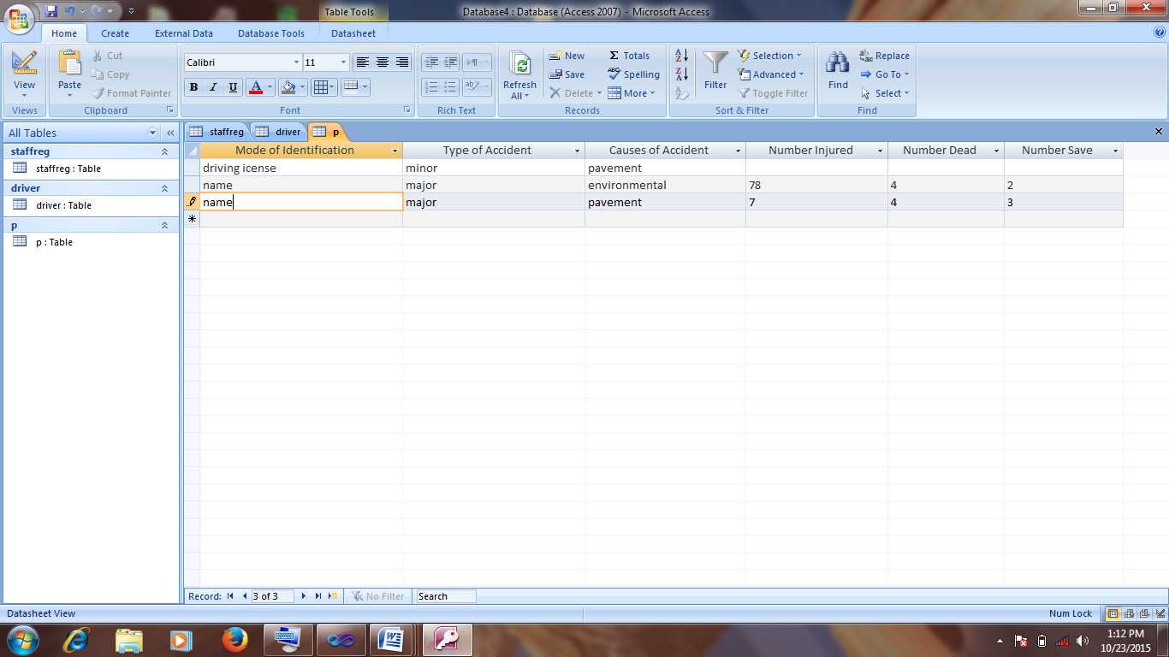

**SCREEN FORM OF ACCIDENT DECISION** **REPORT**



1. **FILE USED TO PRODUCE REPORT**

There are three files used for the generation of reports, they are as follows:

1. staff registration report (staffreg.aspx)
2. driver registration report (driver.aspx)
3. accident victim report (accident.aspx)
4. decision report (decision.aspx)

**4.3 INPUT DESIGN**

However, input design is sub-sectioned into three parts namely:

1. List of input items required
2. Data capture screen forms for input
3. File used to retain input
4. **LIST OF INPUT ITEMS REQUIRED**

Name of file: staff registration

Database name: accident.mdb

Input medium: keyboard

Storage medium: hard disk

|  |  |  |
| --- | --- | --- |
| **FIELD NAME** | **DATA TYPE** | **SIZE** |
| Official Code | Text | 5 |
| Official Name | Text | 50 |
| Official Rank | Text | 50 |
| Official Sex | Text | 50 |
| Phone Number | Text | 50 |
| Picture | Text | 50 |

Name of file: driver registration

Database name: accident.mdb

Input medium: keyboard

Storage medium: hard disk

|  |  |  |
| --- | --- | --- |
| **FIELD NAME** | **DATA TYPE** | **SIZE** |
| Driver Code | Text | 10 |
| Driver Name | Text | 50 |
| GARAGE Name | Text | 50 |
| PLYING TYPE | Text | 50 |
| DRIVING LICENSE NO | Text | 850 |
| DRIVING EXPERIENCE | Text | 100 |
| ROAD SIGN IDENTIFICATION | Text | 100 |
| STATUS | Text | 100 |

Name of file: accident victim

Database name: accident.mdb

Input medium: keyboard

Storage medium: hard disk

|  |  |  |
| --- | --- | --- |
| **FIELD NAME** | **DATA TYPE** | **SIZE** |
| Mode of Identification | Text | 10 |
| Type of Accident | Text | 50 |
| Causes of Accident | Text | 50 |
| Number Injured | Text | 50 |
| Number Dead | Text | 50 |
| Number Save | Text | 150 |
| Car/Bike Plate Number | Text | 100 |
| Car Colour | Text | 100 |
| Car Picture | Text | 100 |
| Intervention Hospital Unit | Text | 100 |
| Year | Text | 100 |

**(B) DATA CAPTURE SCREEN FORM FOR INPUT**

**DATA CAPTURE SCREEN FOR STAFF REGISTRATION**

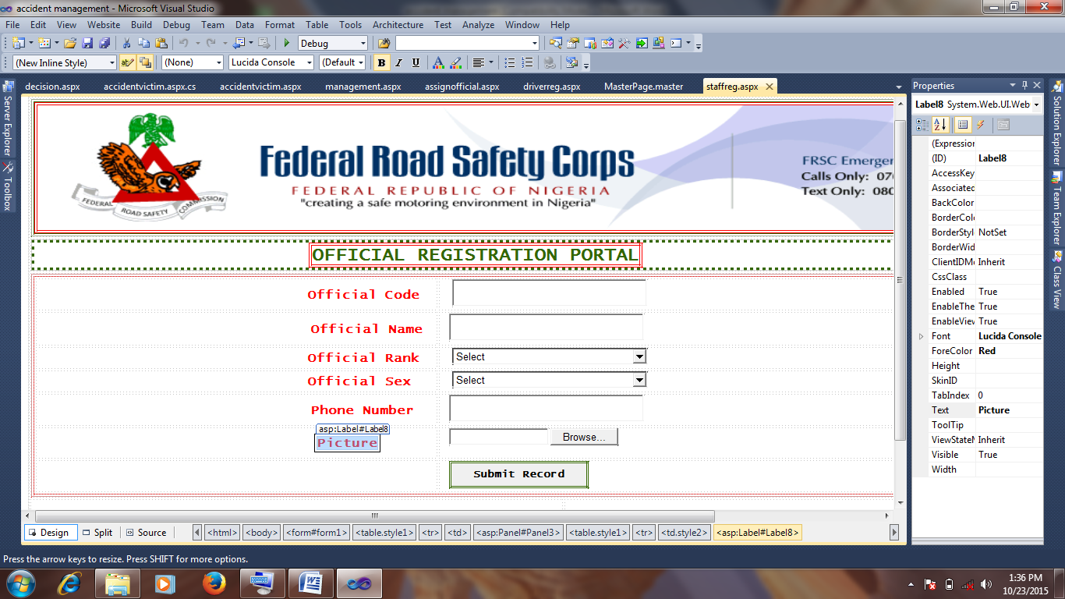

**DATA CAPTURE SCREEN FORM FOR DRIVER REGISTRATION**

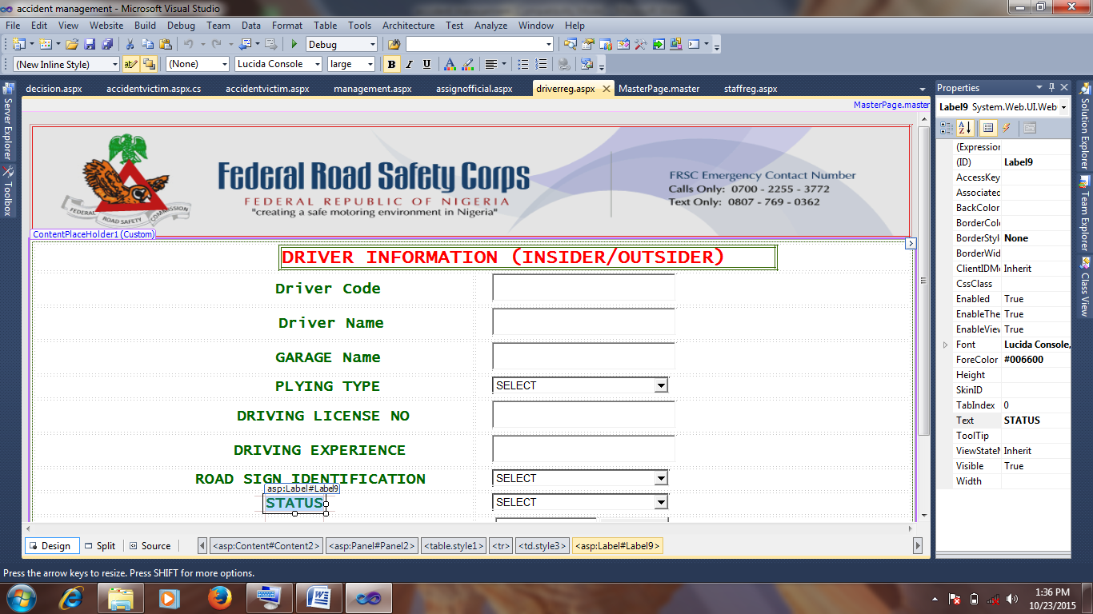

**DATA CAPTURE SCREEN FOR ACCIDENT VICTIM**

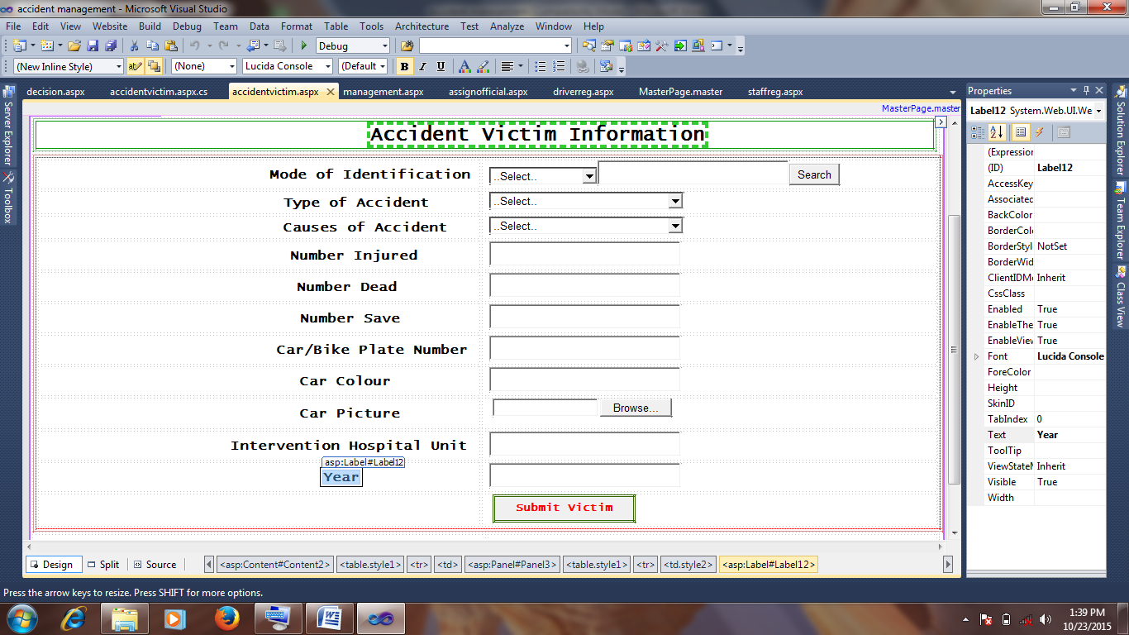

1. **FILES USED TO RETAIN INPUT**

The files are as follows:

1. staff registration.aspx
2. driver registration.aspx
3. accident victim.aspx
4. accident monitoring

**4.4 PROCESS DESIGN**

These can be categorized as follows:

1. List of programming activities
2. Identification of program modules to be developed
3. Visual table of content (VTOC)
4. **LIST OF PROGRAMMING ACTIVITIES**

The programming activities involved in this project is the design of programming modules forms used in extracting activities partake in accident management system

1. **IDENTIFICATION OF PROGRAM MODULES TO BE DEVELOPED**

Below is a list of program modules to be developed:

* Home page module
* Staff registration module
* Driver registration module
* Accident victim module
* Management view module
* Report module
* Logout module

1. **VISUAL TABLE OF CONTENT (VTOC)**

This is a structural chart showing each of the modules and sub modules used in the program developed, the VTOC is shown below.

**VTOC**

**Home page**

**Driver registration**

**Staff**

**Report**

**Victim**

**Logout**

**Staff**

**report**

**Victim**

**Driver**

**Review**

**Review**

**4.5 STORAGE DESIGN**

These are the devices used to store the tables created in the database and the description are as follows:

1. **DESCRIPTION OF DATABASE USED**

The data base used for the storage of this new system is Microsoft Access 2007; this was used to link up with the Visual Studio 2010, software that was used in the design of crime information system.

1. **DESCRIPTION OF FILE USED**

Descriptions of all files used are as follows:

1. **STAFF REGISTRATION INFORMATION FILE**

The staff registration file (staffreg.aspx) is designed to store staff details.

1. **DRIVER REGISTRATION FILE**

The driver registration file (driverreg.aspx) is designed driver accident management system.

1. **ACCIDENT VICTIM FILE**

The accident victim file (victim.aspx) is designed to store accident victim information

1. **RECORD STRUCTURE OF ALL FILES USED**

Each file is structured in such a way that will be able to accept more data to be inputted, be able to delete any unwanted records and be able to retrieve any saved file by making use of index key created in such table to call for the data for the re-accessing of the records in the fields of accident management.

**4.6 DESIGN SUMMARY**

In the course of input and output design, hardware and software components of the system are involved in proper execution of accident management system. It involved two parts:

1. System flowchart
2. HIPO chart
3. **SYSTEM FLOWCHART**

This is the graphical representation that shows the processing procedure and how the procedure is arranged from input to output with the detail as how the processing is to be achieved.

**SYSTEM FLOWCHART**

Home page

Username and password

1. Staff registration
2. Driver registration
3. Accident victim
4. Review
5. Report
6. Logout

If option 1?

If option 2?

A

Staff registration

Driver registration

P

Yes

No

Yes

No **Yes**

No

A

If option 3?

Accident victim

If option 4?

If option 5?

If option 6?

Review

Report

P

Yes

No

Yes

No

Yes

No

1. **HIPO (HIERARCHY PLUS INPUT-PROCESS-OUTPUT PACKAGE)CHART**

This is a tool for program designed and documentation. It includes an overview diagram, which are interwoven to form a HIPO chart. The diagram below gives detailed description.

**INPUT PROCESS OUTPUT**

Accident database

record

Staff record

Accident database

record

Driver record

Accident victim

record

Accident database

**CHAPTER FIVE**

**5.1 SYSTEM DEVELOPMENT AND IMPLEMENTATION**

**5.2 PROGRAM DEVELOPMENT ACTIVITIES**

These are:

1. Programming language used
2. Environment used for development
3. Source code
4. **PROGRAMMING LANGUAGE USED**

The programming language used for the development of software for accident management Microsoft is Visual Studio 2010.

1. **ENVIRONMENT USED FOR DEVELOPMENT**

The environment used for developing this program is Microsoft developer studio (MSDEV) environment. This environment is shared with several Microsoft products such as Microsoft visual c++, Microsoft visual test, Microsoft visual basic e. t. c.

However, because they share the same environment, it become easy to integrate the product with each other, it is possible to share data from Microsoft excel, Microsoft access with Visual Studio 2010, to create quick professional looking interface data presentation.

MSDEV environment integrate the entire program development process including program coding, writing user interface, building and quick language reference.

1. **SOURCE CODE**

These are the codes used in the generation of both the input and output data, these codes are used to save each field name created in each form of input data into the database system.

**5.3 PROGRAM TESTING**

During the programming stage, each modules of the program were tested to determine the reliability of the system for installation and to specify laid down rules by the designer.

The testing of this particular program is easy because it is menu driven and modular in structure. Testing has been performed both by desk checking the program, design with the original specification and by running the final program using test data and selecting options from the main to carry out the desired goal. Program testing can be categorized into two parts:

1. Coding problem encountered
2. Use of test data
3. **CODING PROBLEM ENCOUNTERED**

At different stages of developing this program, the different types of problems encountered are:

1. **SYNTAX ERROR**

Visual Studio 2010 simplifies coding by applying syntax coloring during compilation stage any mis-used rules governing visual studio such as keywords are changed from default color to green with arrows showing where error occurred and refused to compile until corrected before compilation.

1. **LINKING ERROR**

These errors occur during linking when a reference module is not found for linking, an error occurs.

1. **LOGIC ERROR**

This error is as a result of improper sequencing of program statements. However, results produced by the computer are not reliable.

1. **RUN TIME ERROR**

These errors occur as a result of condition that arises making it impossible for program to continue running e. g “Arithmetic flow”.

1. **USE OF SAMPLE DATA**

. The various sample data drawn and collected are used for easy imputing of activity records; these are used for effective generation of the various reports.

**5.4 SYSTEM IMPLEMENTATION**

System implementation is an important phase in system development life cycle. System implementation involves acquiring hardware, software, training, data conversion, switching over operation from the manual to the new computerized system. This is categorized into one part:

1. **SYSTEM REQUIREMENT**

When a system starts functioning it is necessary to monitor its operation to ensure that the user requirements are met. The new system has to be examined from time to time to ensure that it works as expected.

The user and operators of the system should constantly check the output of the system to ascertain its performance. The purpose is to deal with unforeseen problems that may occur during the operation of the system and ensure that objectives are being met.

**5.5 TASK PRIOR TO IMPLEMENTATION**

This includes the hardware and software required for the execution of activities in the organization. This task can be divided into three:

1. Hardware requirement
2. Software requirement
3. Program installation
4. **HARDWARE REQUIREMENT**

The hardware requires ensuring proper running of the new system are:

1. Pentium iv processor
2. 512MB Random Access Memory
3. 40 Giga byte hard drive for primary storage
4. Enhanced keyboard and mouse
5. A printer
6. External hard drives as back up for database.
7. U.P.S (Uninterrupted Power Supply)
8. **The software requirement includes:**
9. Operating system from window Xp and above
10. Visual studio 2010
11. Updated anti-virus for protection of the software.
12. **PROGRAM INSTALLATION**

Follow the steps below to install the software compact disc (CD):

1. Insert the CD in the CD ROM
2. Locate my computer, double click on it to see accident management folder.
3. Copy the folder to hard disk by dragging
4. For more operation on the software see operation manual in the next chapter

**5.6 STAFF TRAINING**

This is the training of the users to the new system, if it is to be operated correctly and full benefit of the new system to be obtained. The personnel management of the organization should functionally support to assist in training the necessary staff within the organization.

However, by the time the system is ready to be fully implemented all the personnel involved in the system should be competent to operate the system correctly and effectively.

**5.7 CHANGING OVER**

This is the process of changing from one system to another especially from the existing manual system to the automated system. There are four different methods of changing from existing system to new system, namely:

1. **DIRECT CHANGE OVER**

This is a situation where by the system in use is discarded and new system replaced. This system is risky and not advisable.

1. **PARALLEL CHANGE OVER**

This is a situation where the old system and the new system are being used concurrently; the old system is then discontinues immediately the new system is satisfied to be working well.

1. **PILOT CHANGE OVER**

The new system is implemented in a specific area of the organization; it is brought into another area of the organization immediately it is successful in the first area.

1. **PHASED CHANGE OVER**

The new system is divided into phases; the first phase is introduced, if it is working well the next phase is made operational. However, the kind of changeover to be used for room allocation is parallel change over. So that both new and old system will be used until there is enough confidence in the new one to discontinue the old system so as to give room to work out debug.