**Accuweather Watchfolder + Thumbnail Updates**

Objective

The goal of these changes was to ensure that when video assets are updated within the JW Platform that their thumbnails were also updated to reflect the new media.

Solution

Before this change, the watchfolder would update the content, metadata, captions of an asset and that was it. Now, we have added a messaging system that sends a message into a queue that waits for the media asset to finish updating. A polling function watches all the media assets in the queue and checks for their status to be “ready” which directly correlates to ensuring the updated file has been fully uploaded.

Once the polling function confirms the media asset is ready, it then makes a JW Platform API call to update the thumbnail. Upon receiving a response confirming the update to the thumbnail was successful, we remove the media’s ID from our queue.

Services

The polling function was designed using Lambda which is triggered every (n) minutes using cloudwatch alerts. The minimum interval for (n) is 1 minute, and there is no maximum.

The queueing service was designed using Amazon’s Simple Queueing Service (SQS) which is a managed service messaging system.

Both systems are highly available, highly elastic, and highly scalable with no issues running concurrently at scale.

Change Log

**Watchfolder**

1. New Instance of SQS - (L25-27)
   1. Defines SQS as part of exisitng BOTO library and also defines the API endpoint where we can interact with our SQS instance
2. New Function *sendSQS* - (L112-120)
   1. Defines the method by which we can send SQS notifications while taking arguments for the SQS endpoint as well as the JW Player Media ID
3. JW Player API Response confirmation that triggers the media_id being sent to SQS (L241-242 & 260-261)
   1. We check the JW API response ***only when assets have been updated*** and then send the media_id to the queue using our method defined in change #2

**Polling Function**

This code is entirely new so there is no change log. It interacts with an out of the box SQS instance with no special configurations as seen below. Also, please see below the configuration in Lambda for the CloudWatch trigger (this was updated to be ‘rate(1 every minute)’ not the CRON regex documented in the screenshot below).

*\* You do not need a FIFO instance of SQS as the JW Platform rate limits would be the limiting reagent so your throughput would never exceed the default SQS settings.*

*SQS Configuration (default config)*

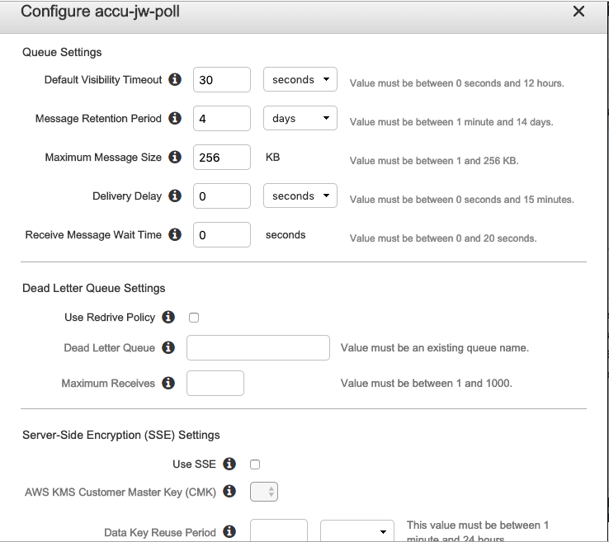

*CloudWatch Alert Configuration in Lambda*

