Interactive tool to generate time/frequency tables out of a type II burst for convenient CME speed analysis, based on Newkirk model

1. Start Spyder3 (Python 2.7) as part of Anaconda2 (64-bit) as instructed during Mekelle workshop in 2017  
2. Load the Python script, currently named as *Multi_FIT_Newkirk.py*3. The FIT file doesn’t need to be in the same directory as the Python script

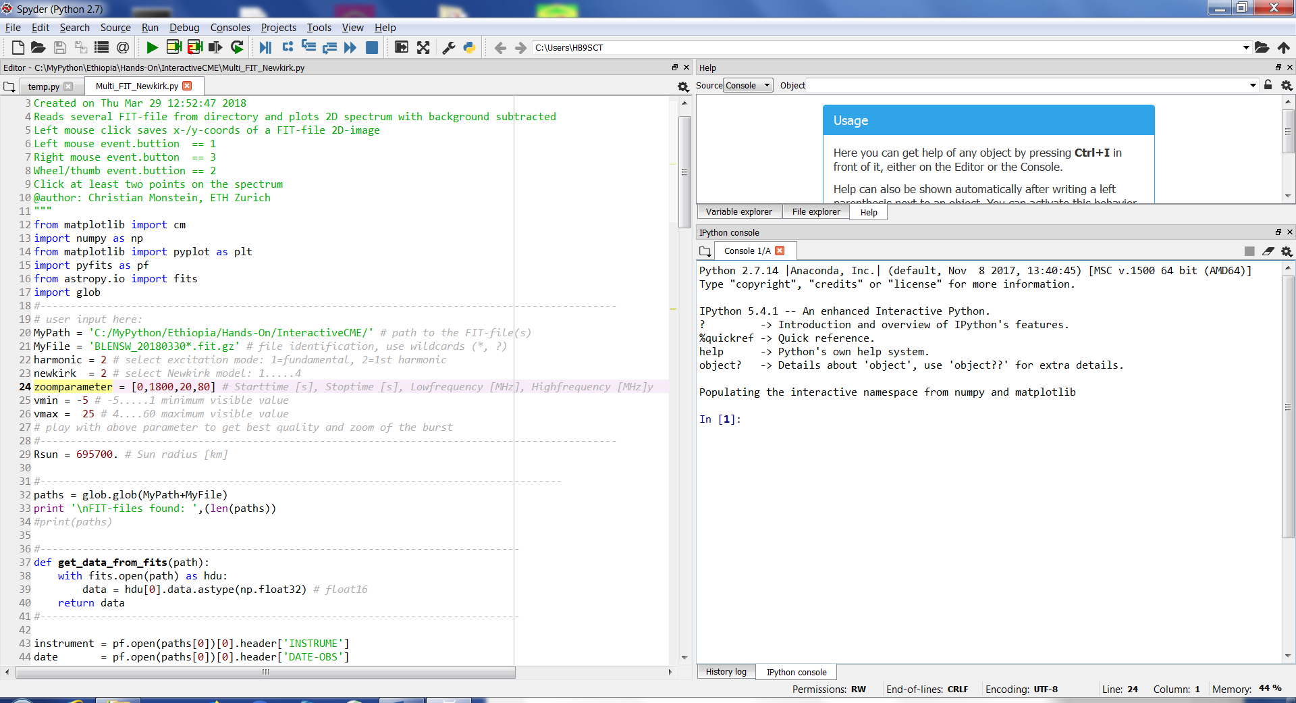

Fig. 1: Start-up screen after loading the Python script

4. Fill in path and filename of the FIT-file(s) you want to investigate (*.fit or *.fit.gz, wildcards allowed (?,*))

5. Decide an fill in whether you want to analyse fundamental (1) or 1st harmonic (2)

6. Decide and fill which Newkirk model you want to use (1, 2, 3 or 4)  
  
7. Fill in the zoom parameter (time-range in seconds and frequency-range in MHz  
  
8. Fill in vmin and vmax which describe colour table cuts. You may change all parameters by trial and error until you see the full burst as demonstrated in the following plot.  
9. Press F5 or press the green triangle. Now you should see something like this below:  
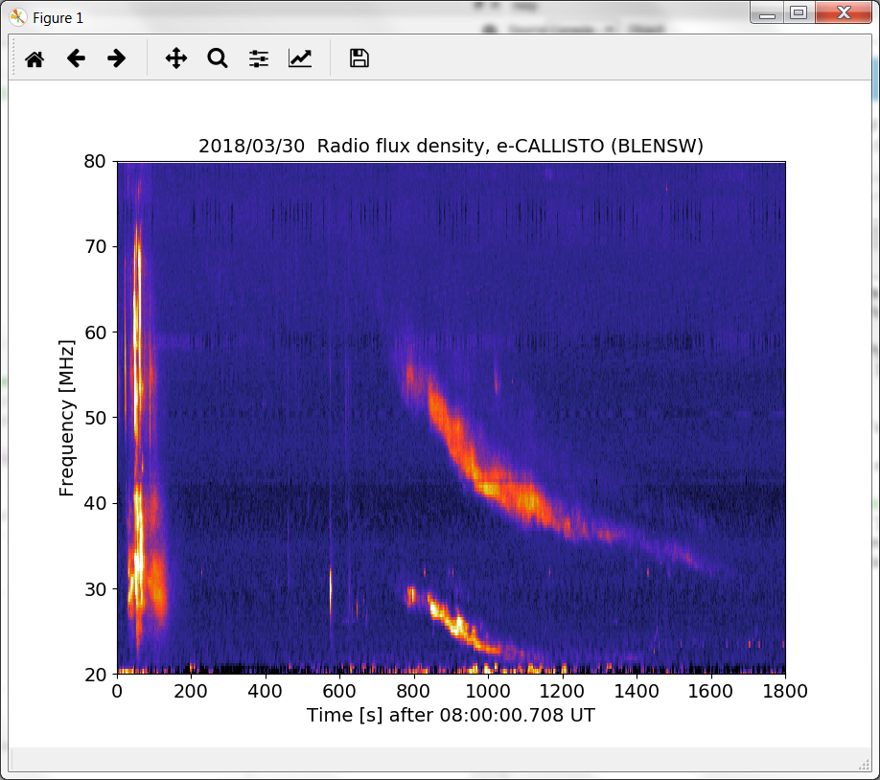

Fig. 2: Raw 2D-plot of a burst sequence.

Be aware that this plot might be hidden behind your Spyder3 application, depending on your monitor resolution, so just move Spyder3 to the side or to a second monitor.

10. Decide the structure to analyse and start to press left mouse button along the burst structure as precise as you can. Each click produces a white pixel on the image and on the same time the time/frequency-values are written to the Sypder3 console. This may look like this:

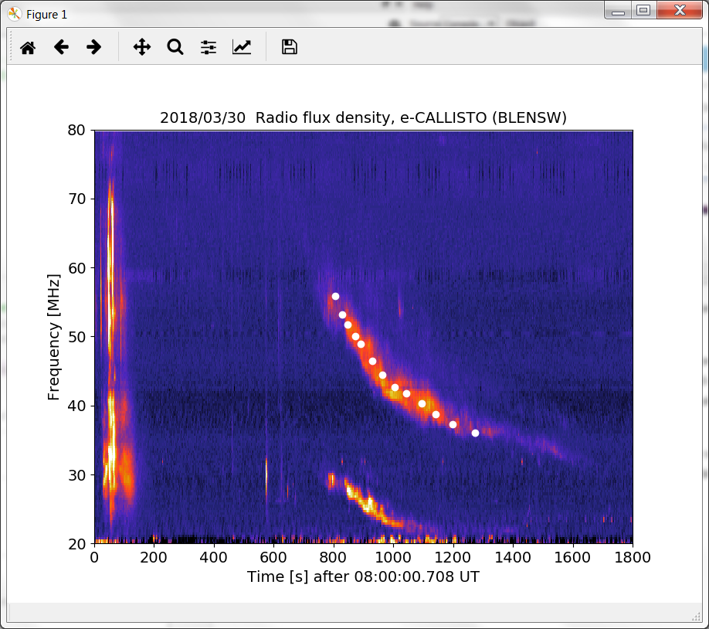

Fig. 3: First harmonic marked with white dots.

When you finished clicking dots, press right mouse button which closes the script and writes all x/y-values to an ASCII-file which can be imported into EXCEL or any other spreadsheet for further analysis. File containing intermediate results is comma delimited with one header line.

T[s], F[MHz], Ne[cm^-3], Rs[Rsun]  
 806.452, 55.876, 9685464.7, 2.10  
 829.677, 53.189, 8776343.7, 2.14  
 847.742, 51.733, 8302606.8, 2.17  
 873.548, 50.054, 7772318.9, 2.20  
 891.613, 48.934, 7428514.9, 2.22  
 930.323, 46.471, 6699520.9, 2.27  
 963.871, 44.456, 6131068.3, 2.32  
1005.161, 42.665, 5646930.5, 2.36  
1043.871, 41.769, 5412327.5, 2.39  
1095.484, 40.313, 5041713.1, 2.43  
1141.935, 38.746, 4657288.4, 2.48  
1198.710, 37.291, 4313971.2, 2.53

In case there is no extra plot on the desktop:

Change the backend to automatic:  
Tools > preferences > IPython console > Graphics > Graphics backend > Backend: Automatic  
Then close and open Spyder3.

Results shown in the Ipython console:  
Statistical results for CME velocity:  
Mean = 784.6 km/s  
Median = 807.3 km/s  
1st order = 706.0 km/s

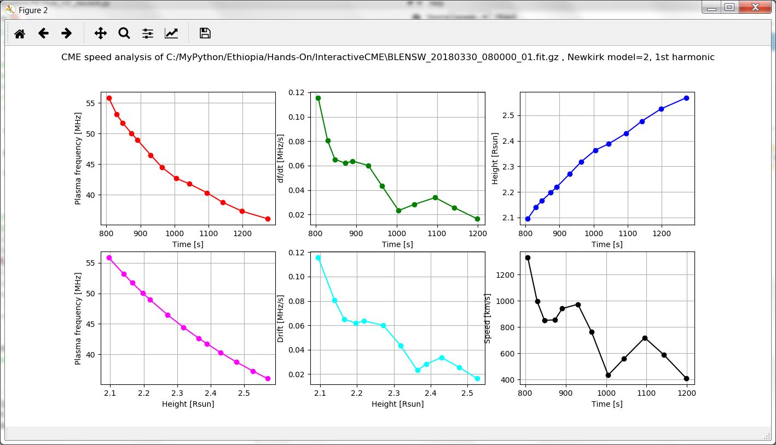

Fig. 4: Graphical expression of results