Natalie Cluck, Megan Fischer

February 24, 2017

CSCE 313-504

Machine Problem 3 Report

1. For a process run by a user other than yourself, find the following items from Table #1: [Identifiers, State, Thread Information, Priority, Time Information, Resources, and Memory Map]
   1. To find these items, type: “cat /proc/<pid>/status” and it displays all information about that process if it’s run by another user.
   2. 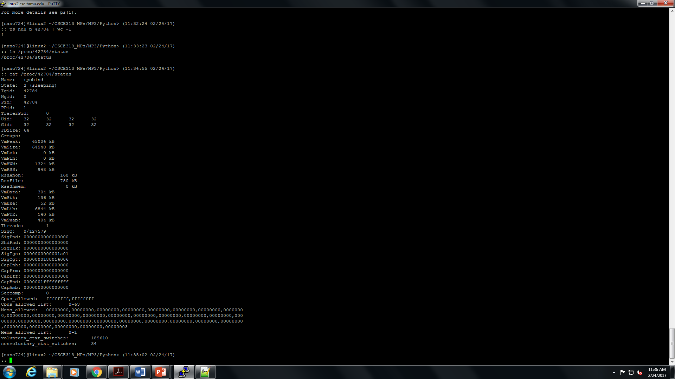
2. For a process that you have created, retrieve all items enumerated in Table.
   1. 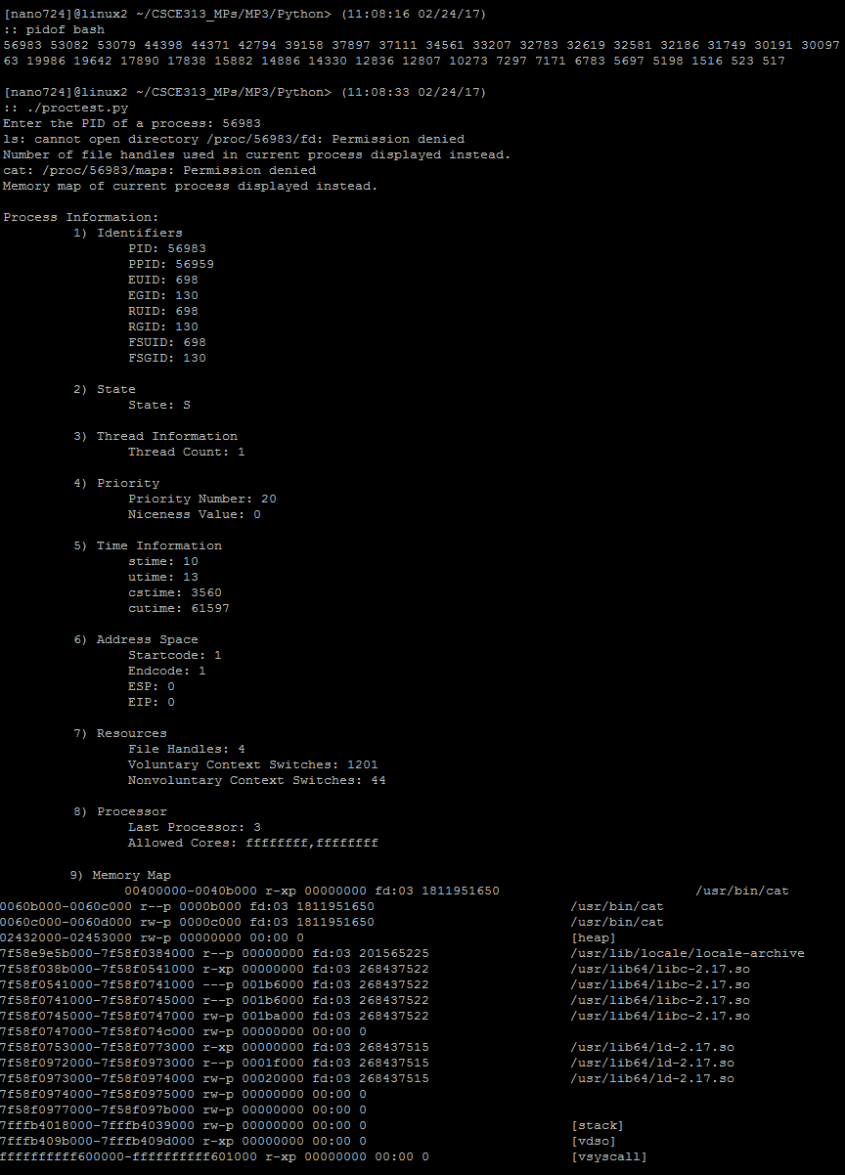
3. What are the differences between the real user IDs and effective user IDs, and what is a situation where these will be different?
   1. An effective user ID is used when you may need to temporarily take over another user’s identity. With only one user ID, there would be no way of changing back to the original user ID. Real user ID is the actual ID, where the effective user ID is where the OS determines whether certain tasks are allowed for that ID. A situation where these will be different is when a setuid program is executed.
4. Why are most of the files in /proc read only?
   1. They contain a lot of important fundamental information about a process, and if the /proc files were easily writable, it could do serious damage, or it would allow an intruder to more easily corrupt the system. It is mostly read-only for security reasons.
5. Why is the task_struct so important to the kernel and what is it used for?
   1. The task_struct is so important to the kernel because it contains all the information about a particular process. It is the ultimate information that a kernel needs to know about any process. Without the task_struct, the kernel would not have the necessasary data needed to execute a program.