**CSCE-313 Quiz2 SP’17 (10 points)**

**Student Name** ………………………………………………………………………

**Student ID** ………………………………………………………………………

**Question 1 (2.5 points, 0.5 points each): Circle TRUE (T) or FALSE (F) for the following statements:**

1. T F The exec () system call creates a new process.
2. T F After a process creates a child process using fork(), both execute the program of the parent process in its entirety.
3. T F In a program, if an exec () precedes the call to fork (), we will end up with 3 processes -  
    one that will run the main program, second that will run the program called by exec (), and   
    third that will run another copy of main program from the point of fork ().
4. T F A shell runs a program by calling fork () and exec ().
5. T F The fork () system call returns 0 when the new process finishes.

**Question 2 (4.5 points, 0.5 points for each correct label] Label the solid circles in the below Webserver transaction model. No explanation is needed, simply write the LETTER next to the solid circles. CHOICES ARE: SYSCALL (S), WAIT (W), INTERRUPT (I), COPY (C).**

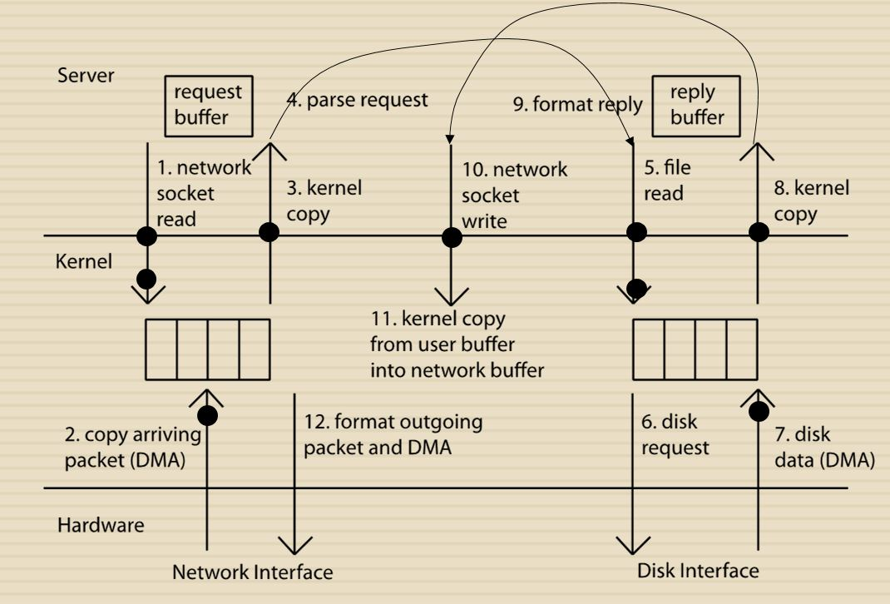

**Question 3 (3 points, 1 point each)** Consider the program below:

#include <stdio.h>

#include <unistd.h>

int counter = 0;

int main()

{

int i;

for (i=0; i<2; i++) {

fork();

counter++;

printf("counter = %d\n", counter);

}

printf("counter = %d\n", counter); */* LINE Y */*

return 0;

}

**Please answer the questions 3a-3c below. In one line for each part, explain the reason why.**

3a. What is the total number of lines that will be printed and why?

____________________________________________________________________________

3b. What is printed in the first line and why?

_____________________________________________________________________________

3c. What is printed in the last line (LINE Y) and why?

_____________________________________________________________________________