**CSCE-313 Quiz 4 [20 points]**

**Solutions must be posted by 11:59pm Mon Feb 20 on eCampus to receive credit. Late submissions are not allowed. You can print, write, scan and upload to eCampus. Or you can type answers and upload. In either case, please upload your answers in PDF format.**

**NOTE1: For details regarding any system calls invoked in the code below: you can grab the usage from MAN pages in linux (example:** [**http://linux.die.net/man**](http://linux.die.net/man) **or from command “man <cmd>” in shell).**

**NOTE2: Answers to questions below without explanation will only receive partial credits.**

**Q1. [10 points]** Consider the following code:

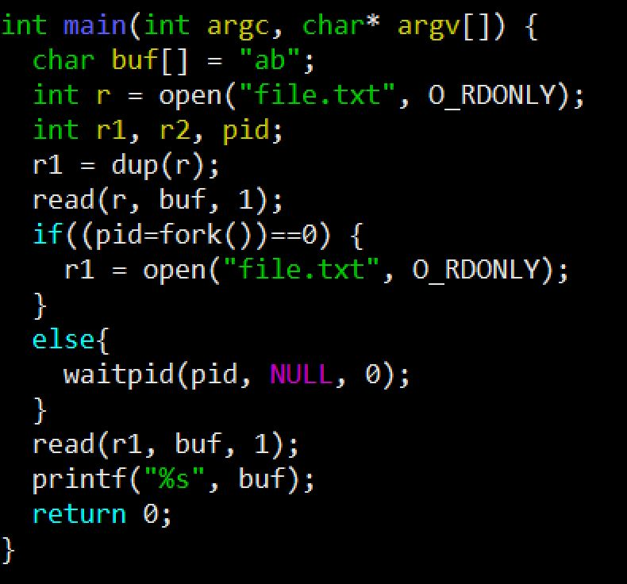

**Assume that the disk file “file.txt” contains the string of bytes 15213 . Also assume that all system calls succeed. What will be the output when this code is compiled and run and why? Explain your answer by providing a high level description of the code functionality.**

**Q2. [10 points]** Consider the following code

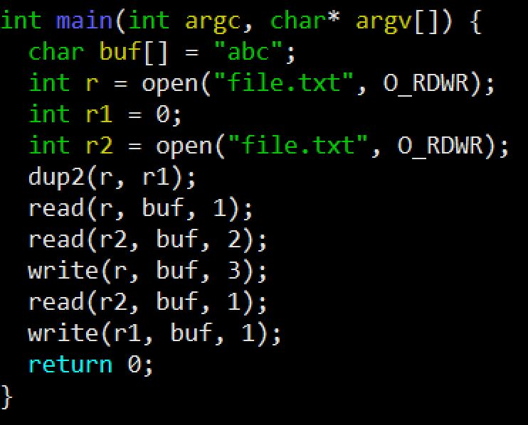

Assume that the disk file ***file.txt*** originally contains the string of bytes **12345** . Also assume that all system calls succeed. **What will file.txt contain when this code is compiled and run and why? Explain your answer by providing a high level description of the code functionality.**