Reaction and logic, do they change in space?

# Introduction

This document provides the information and reasoning behind our idea for the Astro Pi challenge. This includes: the hypothesis (what we would like to find out); controls for the experiment; where the information is stored; the code itself; coding errors; analysis and improvement suggestions.

# The team and our roles

Henry Barker-Programmer

Theo Drabble-Programmer/tester

Ralph Reader-Sullivan- project management

# The hypothesis

Our hypothesis is that during a prolonged time in space reaction times reduce and that there could be possible changes to how somebody may think which could impact on their logic. There is already documented proof of muscle strength deterioration in space, hence the exercise machines already up on the ISS, and so we devised a theory following discussions that reaction times may drop due to this lowered amount of strength. We also discussed a second theory which is that, possibly due to being in a completely different environment this may cause logical thinking to change. Therefore the software created is our way of testing these theories. There is however the chance that reactions and logical thinking won’t change because these tests are being undertaken regularly. This may ensure that reaction levels continue at the same levels as if they were on earth; they could even improve.

The theories to be tested followed on from a team discussion based on a paper that was produced on muscle atrophy <http://www.nasa.gov/pdf/64249main_ffs_factsheets_hbp_atrophy.pdf>. This was the main source of the hypothesis and is from a very reputable source in industry.

# Controls to ensure better results

The tests should be undertaken for 7 days while on earth, 3 times each day. The programme designed will note the date and time tests are taken and will store all results from every test. The tests will also be taken 3 times every day in space to ensure a wide range of results which we hope will prove or disprove our theories. After returning from space the tests will continue for another 7 days being performed 3 times a day to see if they start to return to pre space results quickly or gradually, if there is any change at all. In order to prevent over familiarity with the tests, we will encourage them to be performed first thing when the user wakes up or at least not long after waking, at lunchtime or around then and finally at the end of the day just before sleep to monitor any changes depending on the length of time the user has been awake for to see if that has an impact as well.

As we are aware the user’s time is precious as they have roles and jobs to do while in space, so we’ve made sure that the tests can be done at the easiest possible time without any large impact to what activities need to be completed. It also allows us to take a wider range of results over the time that the user is in space.

# Where is the data stored?

The tests are logic and reaction based, with the results output to files. This will be done for each test and will show the data collected including the number of times played with data being recorded in date order.

When the user returns from the ISS we will take this data and test it against the theory to see whether the hypothesis is correct and if proved then we may be able to improve the software and find a way of creating a way to ensure reactions and logic are maintained in space. We will also collate these results into a series of tables detailing the times and scores of each and creating graphs, an example is shown below.

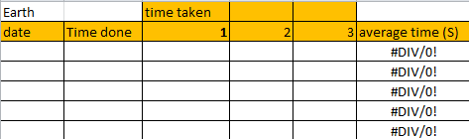

Figure . Mock table of results

This template will be used to record the reaction times from the arrow application. Recording and saving the data will allow comparisons between pre-space, space and post-space results. A spreadsheet has been set up for each test in the same format. Through the use of a spreadsheet it will be possible to generate graphical results. These will provide another form of evidence that can be used to prove the theory.

# The code

The application has been coded using Python 3 and will run on the Astro-Pi. The applications have been developed using an iterative approach producing multiple versions of different programs in order to evaluate how they would work on the Astro-Pi. Generic functions were developed that were used that were used on a variety of programs.

We have also developed a basic User Interface (UI) that displays a small graphical menu (without text) which when an option is highlighted will display an animation of that test. This is to simplify navigation through the tests and make it easier to understand.

# Black Box Testing

A series of black box testing has been carried out on each program to ensure it works. Black box testing is where an input is used to check that a specific output is produced and that it was correct. With this sort of testing there is limited focus on the code overall, only that it functions as expected.

Each program has been tested multiple times to test functionality and to try and introduce intentional errors and ensure they were handled correctly. Errors that were identified were rectified prior to the next phase of testing.

# White box testing

White box testing has been carried out on each program as well to ensure the code works correctly on a much more accurate level. White box is far more in depth and relies on going through each line of code and making sure it functions according to the design. This is a better way of finding any bugs that may be causing minor problems or issues in the code, as it is similar to going over it with a fine toothcomb.

While there were around 2,500 lines of code we did our best to run through every single line looking for any errors and misspellings and such. This allowed us to rectify the problems picked up during the black box testing due to the greater level of depth in testing.

# Coding errors

During the testing, which is detailed below, we found only a few errors in sections of the code which were only needed on very special parameters. These were either removed or solved to ensure that the code still functions correctly. Overall it has been coded very well, making sure to follow an agreed standard such as naming variables correctly and the layout overall, such as where operations are declared.

Testing was undertaken by several different users of varying abilities and feedback taken into account in order to improve the tests.

# Possible code improvements

When correcting errors, we identified that it would have been really useful if the code was commented on to a more detailed standard – for example detailing what each line will do as there is no obvious link between sections at times. Some variables were on occasion declared during the inside of an operation so not really where they should be, however the code still does function correctly without errors. This is something that we can all improve on for future developments.

# The tests

# Arrow

The first test involves an arrow appearing on the screen after an unspecified amount of time. The user (Tim Peake) will then be expected to use the 5 point joystick to point in the same direction as the arrow. A countdown appears on the screen letting the user know the test is about to start. A timer runs from the moment the arrow appears and stops when the joystick is used to point in the correct direction, this is then exported to a file.

When the user has returned from space the files will be exported and we will review the results to measure by how much it decreases. The test will remain at a steady pace throughout and hopefully the results will show a gradual drop (to support our theory) and then they will begin to return to the normal earth standard after a while of acclimation to the different environment. We will also be able take measurements from the user’s preferred arrow (for example, quicker reactions to an arrow 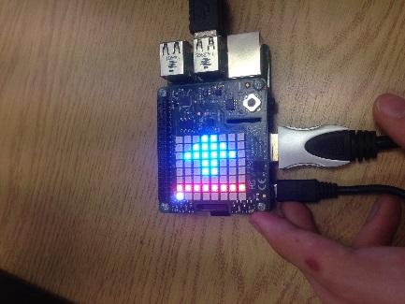pointing in a certain direction).

# Caterpillar

The third test is something called Caterpillar which when playing the test stores the information of the number of apples eaten. This is completed using the joystick again. This test is very quick and relies on your quick reactions, there’s also a bit of logic as you have to remember to not eat yourself.

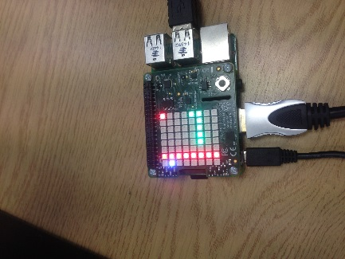

# Lights Off

The fourth test is a ‘lights off’ style game which starts off with a random selection of lights appearing on a 6x6 grid which you have to turn off. A white star will appear as a cursor which causes the lights to activate when the joystick is pressed either turning them on or turning them off. Due to the complexity there is a blue dot at the edge of the area that allows the user to exit the game. With lights off the data being recorded is the time taken to complete the game.

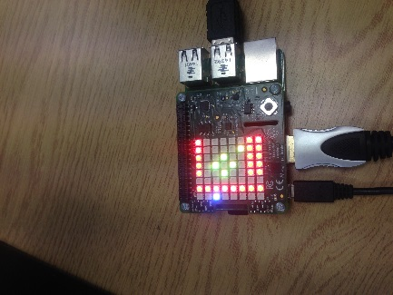

# Maze

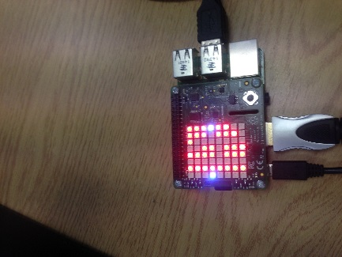The second test involves a maze, this is simply a case of trying to find the exit. However, the test has been programmed to ensure the position of the exit changes, to ensure that the user doesn’t try to go to the same point causing the time taken to be quicker. The results taken from this is the time taken to reach the exit.

# Memory

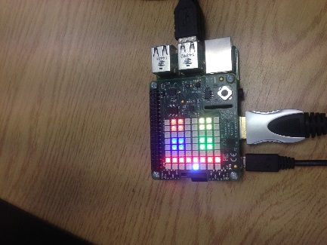The final test is a memory game, very similar to those sold in shops. The test displays 4 different colours that flash up in a certain order and get harder as you progress through it. The level achieved is what we measure here, if the user gets the sequence wrong 3 times then the test returns to the main menu.

# Pong

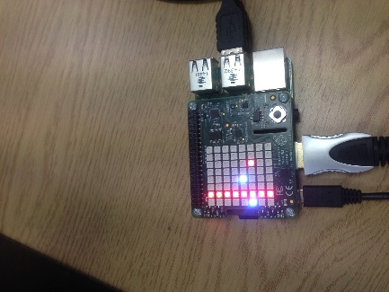The fifth test is our version of the classic arcade game ‘Pong’ of which we developed two different versions, both versions involve playing against an imaginary wall. Whilst it was planned to use the gyroscope during testing we found that while it worked it was rather slow to pick up inputs from the user. Due to time constraints we have therefore used the joystick to move the paddle in the final version. The measurement will be the length of time taken. This is both a reaction test and a logic test.

# Speed

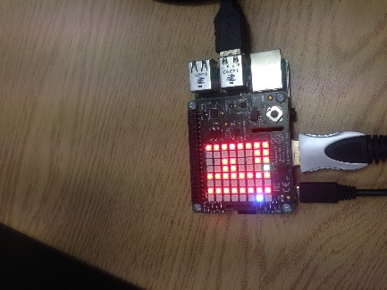The sixth test is titled ‘Speed’ this involves you directing a vehicle along a course and as you survive for longer the speed increases, this test is all about the speed of reactions. So the measurement used here is the time that you have successfully survived for.

# The menu

We have developed a menu to navigate through the many games that have been made, each option shows a small animation of what the game actually does and so allows the user to select which one they wish to play. This does not record any data due to it not being part of the experiment, just a way to navigate around the system and easily access the tests.

# Project planning

As we were engrossed in understanding the theory and tests, we didn’t create a project plan right at the start. However because of the nature of the task we decided to take a rapid application development approach, ensuring that the product was still produced at the end of the project while allowing us to experiment and produce the system we wished. This gave us a lot of room to manoeuvre and still meant we could deliver at the end of the cycle. There was still a critical path in that we understood the final deadline and the activities that were required in order to meet the deadline.

# Conclusion

The challenge was quite exciting as all the team members were inspired by the possibility of identifying any differences in reaction and logic whilst in space. The outcomes of the tests could provide assistance to the space industry and indeed, should life on another planet be an option for the future, the outcomes of these tests could form the basis of an understanding of how best to support the development of a new culture and people on a different planet. The results will be an amazing insight into how our brains operate in unfamiliar conditions.