A PBL-I Synopsis on

AI-Assisted Quantum Simulation & Modelling with Salesforce Agentforce

Submitted to Manipal University Jaipur
Towards the partial fulfillment for the Award of the Degree of
BACHELORS OF TECHNOLOGY
In Computers Science and Engineering
2025-2026

By
Shriya Desai
2427030171



Under the guidance of
Dr. Ankit Shrivastava

______________________________
Signature of Supervisor

Department of Computer Science and Engineering
School of Computer Science and Engineering
Manipal University Jaipur
Jaipur, Rajasthan
Table Of Contents

I. Introduction to Problem 3
1. Quantum Simulations – Current Status and Associated Challenges 3
2. Project Scope - Leveraging AI for Quantum Simulations 4
3. Agentic AI for End-to-End Quantum Simulation: Salesforce Agentforce Integration 5
II. Literature Survey 6
Key Literature Highlights 6
Literature Review – Focus areas, Pros & Cons 7
III. Comparative Study of Literature 8
IV. Problem Statement 8
V. Objectives 9
Phase-wise Objectives 9
VI. Planning of Work / Proposed Solution 9
Phase 1: Research & Learning 9
Phase 2: Solution & Database Design 10
Phase 3: Technology Selection 11
Phase 4: Prototype Development 13
Phase 5: Implementation, Integration & Testing 15
VII. Screenshots of sample simulation code 16
Bibliography 17

I. Introduction to Problem

1. Quantum Simulations – Current Status and Associated Challenges
Quantum simulation has become an indispensable tool in scientific research, providing insights into complex phenomena in materials science, quantum chemistry, condensed matter physics, and more. Traditionally, researchers rely on two major types of simulation strategies: classical computational approaches (using high-performance computers to approximate quantum systems) and, more recently, digital or analog quantum simulators leveraging emergent quantum computers and quantum devices.
In classical simulation, various numerical algorithms—such as density functional theory (DFT), quantum Monte Carlo (QMC), tensor network methods (like Matrix Product States), and configuration interaction—are used within software frameworks like Quantum ESPRESSO, QuTiP, PySCF, and Qiskit. These tools help approximate solutions to the many-body Schrödinger equation, model quantum dynamics, and compute electronic structure or molecular properties.
However, major challenges persist across the field:
- Exponential computational cost: Accurately simulating quantum systems requires resources that grow exponentially with system size, making large or highly entangled systems intractable for even the largest supercomputers.
- Resource limitations on quantum hardware: Current quantum computers have limited qubit counts, short coherence times, high error rates, and require sophisticated error correction. This restricts practical quantum simulation to small systems.
- Parameter tuning complexity: Selecting the right simulation parameters (basis sets, cutoff energies, time steps, etc.) typically requires deep expertise and involves trial-and-error. Mistakes can lead to wasted computation or meaningless results.
- Diagnostic and interpretive bottlenecks: Interpreting raw simulation data, identifying convergence issues, or diagnosing faulty results remains manual, error-prone, and slow.
- Scalability and accessibility: Most advanced quantum simulation workflows require command-line usage and customized scripting, posing accessibility hurdles for new learners and interdisciplinary researchers.
Despite innovation, these intricacies result in slow turnaround, expertise silos, and limited experimental throughput. Research breakthroughs—such as new material discoveries or pharmaceutical innovations—are sometimes delayed for months or years, largely due to these inefficiencies. Thus, the field is ripe for transformation through new methodologies that can streamline, accelerate, and democratize quantum simulation.​

2. Project Scope - Leveraging AI for Quantum Simulations
This project focuses on revolutionizing quantum simulation workflows by integrating Artificial Intelligence (AI) and Machine Learning (ML) in two key areas:
a. AI-Powered Modeling of Quantum Simulations:
Instead of running resource-intensive calculations for every quantum system or parameter scenario, the project leverages ML surrogates—especially those based on advanced neural architectures like Graph Neural Networks (GNNs):
- Surrogate models rapidly predict quantum properties and outcomes for new scenarios, after training on sets of full simulations or experimental results.
- This enables rapid candidate screening (e.g., for materials or molecules) and allows the workflow to prioritize detailed simulations only on the most promising subsets, thus massively saving time and computational resources.

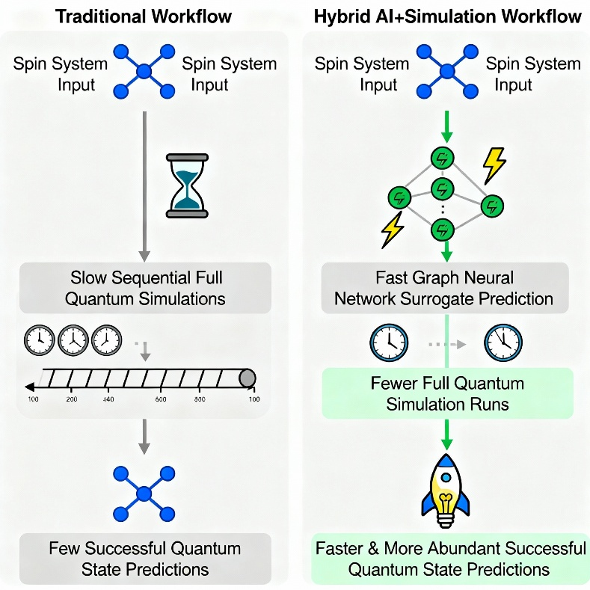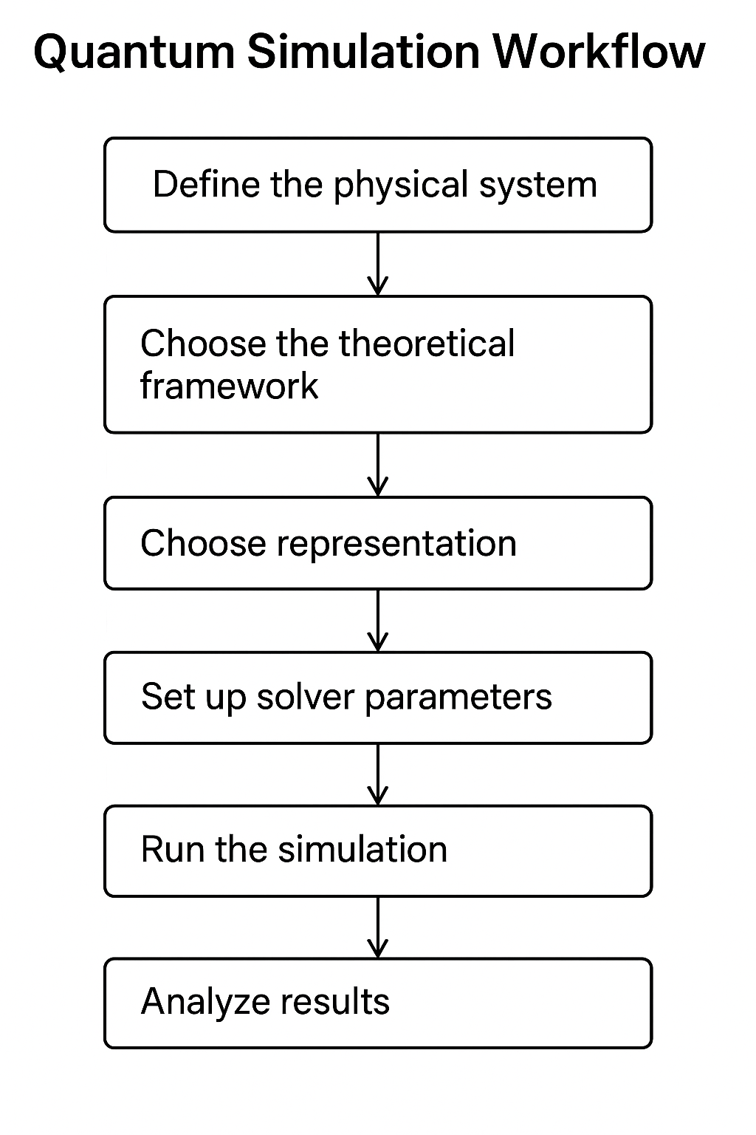

b. Scope of the Automated Workflow:
- Enables capabilities that open the door to automated parameter optimization, and uncertainty quantification, providing robust tools for guiding both experts and newcomers through simulation-driven discovery.
- Integrate the AI-driven flow with diverse modeling toolkits (both classical and quantum-native simulators), allowing seamless handoff from fast ML prediction to authoritative quantum calculation and back.

3. Agentic AI for End-to-End Quantum Simulation: Salesforce Agentforce Integration
Beyond modeling and AI-driven guidance, achieving a truly transformative quantum simulation experience requires integrating these elements into a coherent, user-friendly platform. The third pillar of this project is the adoption and orchestration of an agentic AI framework—specifically, Salesforce Agentforce—to build a conversational, automated, and accessible end-to-end workflow:
- Agentic Integration:
Salesforce Agentforce acts as the ‘brain’ of the assistant, orchestrating user interactions, backend simulation tasks, and ML surrogate calls through accessible web or chat interfaces.
- Key Capabilities:
  - Users start simulations in their respective quantum problem space
  - The agent triggers ML surrogates with multiple sets of simulation parameters
  - ML surrogates are invoked for instant predictions, rapidly narrowing down feasible or interesting parameter sets and flagging scenarios for detailed quantum calculation.
  - Once the optimal scenario is identified, the agent triggers full-physics quantum simulations via tools such as QuTiP or Qiskit, tracking execution and collecting comprehensive results.
  - Post-simulation, the agent parses and interprets results.
In summary:
By combining advanced AI/ML surrogates for quantum modeling with agentic automation for workflow, diagnostics, and user guidance, the project delivers an end-to-end, accessible, and adaptive quantum simulation ecosystem. This not only accelerates science, but also opens quantum modeling to a broader, more diverse audience—pushing the boundaries of both research and education.
Most traditional simulation tools offer strong core capabilities but lack workflow guidance, ML integration, and user onboarding. LLM agents provide automation and conversation but can be unreliable and complex for non-experts. Surrogate ML delivers speed but suffers from poor integration and accessibility.
My solution takes best practices from these, introducing an accessible, AI-driven assistant that guides, predicts, and interprets throughout the workflow, fully integrating simulation tools and ML surrogates in a modular platform.

II. Literature Survey
In quantum mechanics, the wavefunction(Ψ) tells us the complete characteristics and behaviour of a quantum system. For a large system containing many particles, this wavefunction is very difficult to computationally calculate.
This is where NNQS comes in. Neural Network Quantum State is an ML surrogate that becomes the model of the quantum state. Instead of calculating Ψ, our NN learns to approximate it.
The first paper that introduced this idea is the Carleo & Troyer (2017): “Solving the Quantum Many-Body Problem with Artificial Neural Networks”
Another paper describing how Agentic AI helps optimize scientific workflows is the “Müller et al. (2020): "Revolution of Scientific Workflows in the Agentic AI Era”. It shows how Agentic AI reduces manual effort and hence accelerates discovery.
My model applies both NN surrogates and agentic workflows directly to practical quantum simulation tasks(parameter selection, interpreting outputs, estimating results)

Key Literature Highlights
- El Agente Q (LLM agent, 2025)
Automates complex quantum chemistry workflows using large language models, allowing scientists to perform simulations and analyses via conversational commands. Showcased the promise of LLMs for orchestration but exposed limitations: LLMs can hallucinate facts and require careful prompting; not robust for beginners’ needs.
- ML Surrogates (Nature 2019)
Demonstrated the use of neural network surrogates to rapidly estimate quantum properties, enabling scalable screening of molecular candidates. Proved huge speedups over traditional simulation, though integration into practical, user-facing scientific workflows remained lacking.
- Design Agents (RL, Innsbruck)
Presented reinforcement learning agents capable of autonomously planning quantum experiments and adapting based on feedback, pushing the frontier of AI-driven scientific creativity. Focus was narrow — specific experiment design, not broad workflow support.
- SpinQ Quantum AI Lab
Advanced research in quantum ML hardware/software integration for fast quantum information processing. While powerful for expert research, much was inaccessible for average scientists and users.

Literature Review – Focus areas, Pros & Cons
Reference | Main Contribution | Pros (Carried Forward) | Cons (Minimized)
El Agente Q (LLM agent, 2025) | Automates quantum chemistry workflows via LLM conversations | Powerful automation, Multi-tool orchestration | LLM hallucinations, Complexity, Not robust for novices
ML Surrogates (Nature 2019) | Fast ML surrogate models for quantum properties | Fast predictions, ML generalizability | Not workflow-integrated, Less user-facing
Design Agents (RL, Innsbruck 2020) | RL agents for quantum experiment design | Creative, Autonomous experiment planning | Narrow use, Not an accessible UI
SpinQ Quantum AI Lab | Hardware/software quantum ML research advances | Cutting-edge algorithms, HW/SW co-design | Not designed for accessible interaction
PySCF (2018) | Open-source quantum chemistry simulation toolkit | Flexible, modular, academic support | Steep learning curve, not conversational
Quantum ESPRESSO (2017) | Density Functional Theory based quantum simulation software | High accuracy, broad material coverage | Slow simulation pipeline, command-line centric
Qiskit (2019) | General quantum computing toolkit for IBM Q systems | Cloud-ready, broad quantum algorithm support | Needs programming skill, limited parameter guidance
QuTiP (2012) | Quantum Toolbox in Python for dynamics/simulation | Easy quantum system setup, Python friendly | No integrated workflow builder, limited ML support
SmartChem (2019) | ML-driven retrosynthesis planning for chemistry | Predictive, ML integration, accessible UI | Focused on chemistry, not general quantum simulation
Google DeepMind Ferminet (2020) | Neural network model for electronic structure calculation | High surrogate accuracy for many-electron systems | Research-grade, not general user workflow
Quantum Surrogate Benchmarks (2023) | Systematic analysis of surrogate models for quantum data | Showed ML surrogates can learn quantum landscapes | Benchmark focus, no practical workflow integration

III. Comparative Study of Literature
Reference /  Approach | Automation | Accessibility | Surrogate ML | Parameter Guidance | Output Interpretation | Workflow Integration | Scalability
El Agente Q (LLM agent, 2025) | Yes | Moderate | No | Partial | Yes | Multi-tool | Yes
ML Surrogates (Nature 2019) | No | Low | Yes | No | No | Poor | Yes
Design Agents (RL, Innsbruck) | Partial | Low | No | No | No | Narrow | Yes
SpinQ Quantum AI Lab | No | Low | Yes | No | No | Poor | Yes
PySCF, ESPRESSO, Qiskit, QuTiP | No | Moderate | Limited | No | No | Strong | Moderate
SmartChem | Yes | High | Yes | Yes | Partial | Moderate | Yes
Google Ferminet | No | Low | Yes | No | No | Poor | Yes
Quantum Surrogate Benchmarks | No | Low | Yes | No | No | Poor | Yes
Proposed Solution | Yes | High | Yes | Yes | Yes | Full | Yes

IV. Problem Statement
How can we harness state-of-the-art AI techniques to model and accelerate quantum simulations, providing smart guidance and refined scenario selection, to democratize access, reduce computational cost, and transform the speed and scope of scientific discovery in quantum mechanics?
Quantum simulation is a vital research tool but remains inaccessible to many due to complexity, resource constraints, and a lack of user-centered guidance. The absence of automated parameter selection, real-time diagnostics, and fast prediction via ML surrogates means that both experts and newcomers experience slow, inefficient workflows, limited explorative capabilities, and a steep learning curve. There exists a critical need for an integrated, AI-powered assistant that streamlines the simulation workflow, democratizes access, and accelerates quantum discovery.

V. Objectives
- Develop foundational skills in AI & ML through hands-on model building, deployment, and testing.
- Gain practical exposure to quantum simulation techniques and learn how modern AI models (especially neural networks) can accelerate quantum research.
- Learn how to integrate agentic AI tools (such as Salesforce Agentforce) into complex scientific workflows.
- Acquire end-to-end project execution skills, from research and design to technology selection and implementation.

Phase-wise Objectives
Phase | Learning Objective
Research & Learning | Understand quantum simulation, neural networks, and agentic AI basics.
Solution & Database Design | Architect workflow, design relational/NoSQL storage for simulation and ML data.
Technology Selection | Evaluate, select, and set up Python, ML frameworks, simulation tools, Agentforce.
Prototype Development | Train ML models, build simulation API, connect Salesforce agent, validate workflow.
Implementation & Integration | Deploy, test, and refine assistant and backend, ensure seamless user experience.
Reflection & Demonstration | Analytically review learning outcomes, present project, suggest future expansions.

VI. Planning of Work / Proposed Solution

Phase 1: Research & Learning
Objectives:
- Develop foundational understanding of quantum mechanics, quantum simulation techniques, and machine learning fundamentals.
- Review current scientific literature and existing software frameworks/tools.
- Engage with tutorials for ML algorithms (neural networks, GNNs) and basic quantum simulation platforms (QuTiP, Qiskit, Quantum ESPRESSO).
Activities and Outcomes:
- Explored tutorial notebooks for Python-based quantum simulation and ML, including QuTiP’s quantum system solvers and PyTorch’s neural net modules.
- Studied benchmark references on surrogate ML in quantum mechanics and agentic AI for scientific workflows.
- Conducted literature review, summarizing pros and cons in a comprehensive table.

Phase 2: Solution & Database Design
Objectives:
- Architect the end-to-end workflow combining quantum simulation, AI surrogates, agentic automation, and a user-friendly dashboard.
- Design the backend’s data model, ensuring traceability of simulations and ML predictions.
- Define agentic interaction flows and scenarios.
Activities and Outcomes:
- Designed the overall workflow as a block diagram (see below).
- Created ER-diagrams for backend database, laying out SimulationInputs, SimulationOutputs, SurrogateModels, and UserFeedback tables.
- Mapped agentic flows: parameter guidance, ML prediction, diagnostics, simulation results reporting.
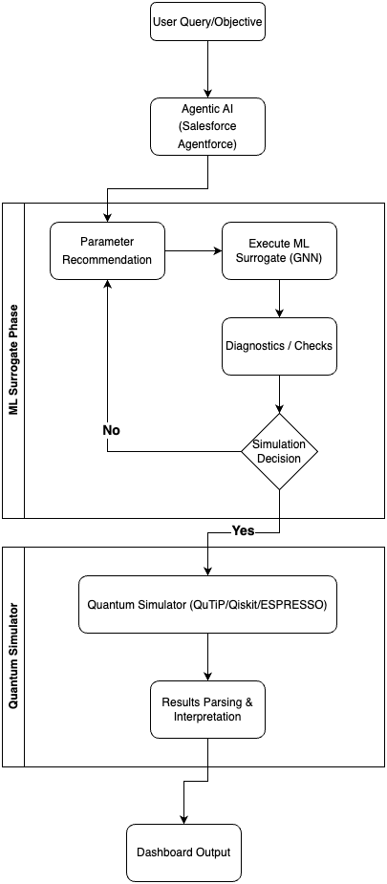
End-to-End Project Workflow

Phase 3: Technology Selection
Objectives:
- Identify, evaluate, and configure the stack: ML frameworks, quantum simulation tools, agentic AI interface, dashboard technologies, and database systems.

Technology Options and Rationales (can change if need arises as implementation phase begins)
Component | Options Evaluated | Final Choice | Reasoning
Quantum Simulation | QuTiP, Qiskit, ESPRESSO | QuTiP & Qiskit | Python-integrated, flexible, scalable
ML Framework | PyTorch, Tensorflow, scikit-learn | PyTorch Geometric | GNN support, community, performance
Agentic Platform | Salesforce Agentforce,  AWS Strands, Databricks Agentbricks, CrewAI, Beam AI | Salesforce Agentforce | Enterprise-grade, easy UI integration
Database | PostgreSQL, MySQL, MongoDB | PostgreSQL | Structured modeling, reliability
API/Backend | Flask, FastAPI | Flask | Lightweight, easy setup
Dashboard | Salesforce Lightning, React | Salesforce Lightning | Seamless with Agentforce

ML Selection Rationale:
Graph Representation of Quantum Systems:
- Each quantum system (e.g., molecule, spin chain) encoded as a graph:
  - Nodes: Atoms (features: element type, charge, quantum state)
  - Edges: Bonds/interactions (features: bond type, distance, coupling constant)
So, while simpler models (Linear, MLP, SVM) provide rapid prototyping and interpretability, they are fundamentally limited in capturing the highly-interconnected, non-linear relationships present in quantum systems, especially molecules, crystals, or spin networks, which are naturally represented as graphs. GNNs, with their ability to process node and edge features, update representations via message passing, and perform efficient pooling/readout for graph-level prediction, have proven superior for this scientific context.
Training & Evaluation:
- Data: Used publicly available quantum datasets (e.g., QM9) representing molecular graphs with labeled properties.
- Metrics: Evaluated mean absolute error (MAE), root mean squared error (RMSE), and calibration of uncertainty estimates.
- Iteration: Compared results with baseline MLPs, confirming substantial improvements for GNNs on graph-structured quantum data.
Deployment:
- Integrated trained GNN model into Flask backend as /surrogate_predict endpoint.
- Enabled real-time predictions for user-defined quantum systems/scenarios, displayed on dashboard and agentic interface.

Phase 4: Prototype Development
Objectives:
- Develop working backend APIs to support parameter recommendations, simulations, and surrogate predictions.
- Train and deploy a GNN model on quantum system data (e.g., QM9 molecules for property prediction).
- Build and iterate conversational agent flows on Salesforce Agentforce.
Activities and Outcomes:
- Implemented backend endpoints in Flask for parameter suggestion, simulation execution, surrogate prediction, and diagnostic checks.
- Trained a PyTorch Geometric GNN on small molecular graphs to predict quantum properties (energy, dipole moment, etc.) with uncertainty estimation.
- Developed agentic conversational flows allowing users to:
  - Specify simulation goals,
  - Get smart parameter suggestions with supporting rationale,
  - Receive instant surrogate predictions,
  - Run full simulations selectively,
  - Receive diagnostics and plain-language interpretation.

Surrogate Model Training using public Quantum Datasets
Several benchmark quantum chemistry and physics datasets have been released for open research, enabling scalable ML model development.
Dataset Name | Size | Features / Properties | Quantum Use Cases
QM9 | ~134,000 molecules | 19 quantum properties (energy, HOMO/LUMO, dipole, polarizability, etc.) | Small molecule property prediction, screening, generative modeling, quantum chemistry GNN benchmarking
QM7 & QM7b | ~7,000 molecules (QM7), ~7,200 (QM7b) | Atomization energies, geometric and electronic properties | Fast regression/prototype studies, benchmarking ML architectures
QMugs | ~665,000 molecules | Quantum mechanical descriptors for pharmacologically relevant compounds | Drug discovery, property prediction in bio-chemistry
QM40 | ~163,000 compounds | Quantum properties from ZINC database | High-throughput materials screening
QCDGE | ~450,000 molecules | Ground and excited state properties | Excited state ML, spectroscopy modelling
BDE-db | ~200,000 radicals | Bond dissociation energies, quantum descriptors | Radical chemistry, reaction modeling
tmQM | ~86,000 transition metal complexes | Quantum properties, coordination geometries | Transition metal and catalyst modeling
QCML | ~14.7 billion entries (semi-empirical), 33.5 million DFT | Energies, forces, multipole moments, wavefunctions | General quantum property ML, force field generation, molecular dynamics
QDataSet | 52 one-/two-qubit systems, 10,000 samples per set | State vectors, Hamiltonians, measurement distributions, noise/pulse data | Quantum control, quantum tomography, noise spectroscopy, gate errors

Implementation in the Prototype
By selecting a dataset, our GNN model is trained to predict a wide range of molecular quantum properties. The training process involves:
- Step 1: Loading the dataset
- Step 2: Constructing graph representations for each molecule (nodes = atoms with features; edges = bonds/interactions).
- Step 3: Building and training the GNN as outlined previously, validating accuracy on held-out molecular structures.
- Step 4: Deploying the trained surrogate model as a backend API, enabling instant property prediction as a part of the conversational agent workflow.
- Step 5: If possible, testing the model’s capability for other for broader use cases, and benchmarking against traditional simulation outputs.
Property | Description | Use Case
U0 | Atomization energy at 0K | Thermochemical studies
HOMO/LUMO | Energy of highest occupied/lowest unoccupied molecular orbital | Electronic structure, band gap analysis
Dipole moment | Measure of molecular polarity | Spectroscopy, reactivity
Polarizability | Response to electric field | Dielectric studies
Heat capacity | Thermal analysis/chemistry | Materials science

Phase 5: Implementation, Integration & Testing
Objectives:
- Integrate all modules into a coherent, user-friendly platform.
- Validate functionality, usability, performance, and robustness across all workflows.
Activities and Outcomes:
- Connecting Salesforce conversational agent to Flask backend via secure REST APIs.
- Implementing error-handling, parameter validation, and result reporting modules.
- Deploying PostgreSQL database for persistent logging of user interactions, results, feedback, and ML model versions.
- Running extensive testing with sample scenarios

VII. Screenshots of sample simulation code
(actual implementation will start in later phases)
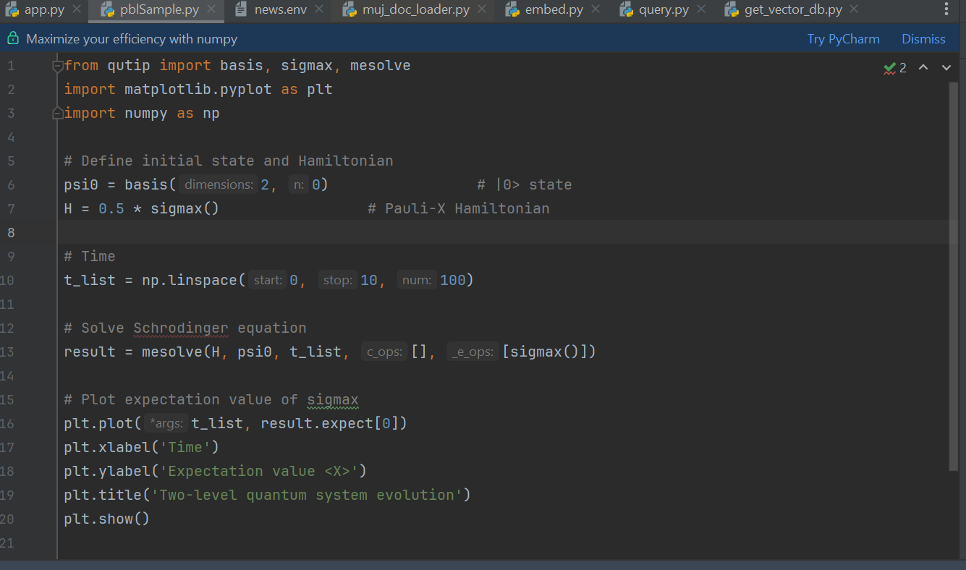
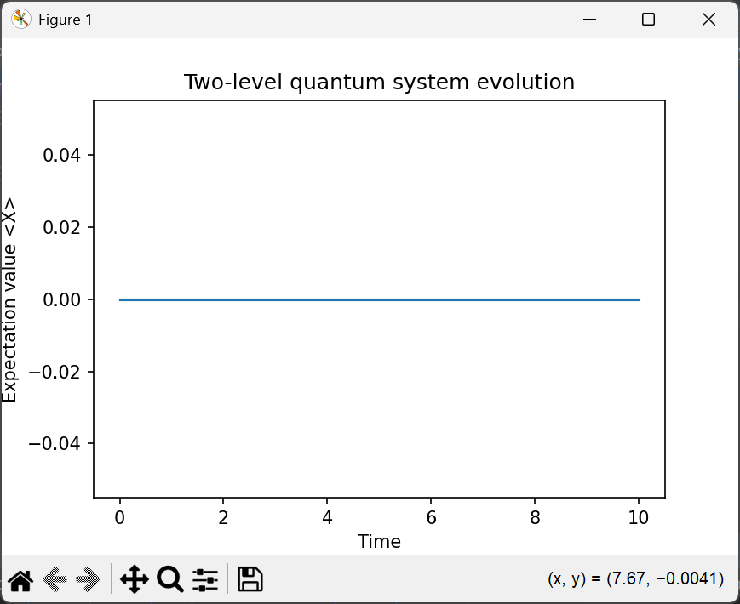

Bibliography

- https://www.geeksforgeeks.org/machine-learning/neural-networks-a-beginners-guide/
- https://news.skhynix.com/all-about-ai-the-origins-evolution-future-of-ai/
- Carleo, G., & Troyer, M. (2017). Solving the quantum many-body problem with artificial neural networks. Science, 355(6325), 602-606.
- https://doi.org/10.48550/arXiv.2509.09915
- https://elagente.ca/
- https://www.cell.com/matter/fulltext/S2590-2385(25)00306-6
- https://www.uibk.ac.at/en/th-physik/qic-group/research/ai-and-science/
- https://www.spinquanta.com/news-detail/spinq-quantum-artificial-intelligence-lab-research-project-overview
- https://medium.com/@mihir473/simulating-quantum-systems-with-qutip-a-deep-dive-c3daf829b05f

