Weak prompts:
- Explain regression
b) Help me understand SQL
c) Create a dataset

Improved prompt results:

A)
Got it — let’s make this short, simple, and clear.

🔹 What is Regression?
Regression = using data to predict a number
👉 It finds a pattern between two things:
- Input (x) → what you control
- Output (y) → what you want to predict

🔹 Simple Example
Hours Trained (x) | Skill (y)
1 | 2
2 | 4
3 | 6
Pattern:
👉 Skill = 2 × Hours

🔹 The Formula
genui{"math_block_widget_always_prefetch_v2":{"content":"y = mx + b"}}
For this example:
👉 y = 2x

🔹 Prediction
If x = 4 hours:
👉 y = 2(4) = 8

🔹 Key Idea
👉 Regression = find pattern → use it to predict

🔹 Quick Check
- If y = 3x, what is y when x = 2?
- If more training leads to higher skill, is that a positive or negative relationship?
Improved prompt results:
B)
Perfect — SQL is one of the most useful skills in data analytics. Let’s keep it simple and practical.

🔹 What is SQL?
SQL = a language to talk to databases
👉 You use it to:
- Get data
- Filter data
- Analyze data

🔹 Think of a Database Like a Table
Example: Students table
name | belt | classes
Alex | White | 10
Ben | Blue | 20
Chris | White | 15

🔹 Basic SQL Command
1. Get all data
SELECT * FROM students;
👉 Meaning:
- SELECT = choose columns
- * = all columns
- FROM = which table

2. Get specific columns
SELECT name, belt FROM students;
👉 Only shows name and belt

3. Filter data (VERY IMPORTANT)
SELECT * FROM students
WHERE belt = 'White';
👉 Only shows White belts

4. Filter numbers
SELECT * FROM students
WHERE classes > 15;
👉 Only students with more than 15 classes

🔹 Real-Life Use (Your Gym)
You could ask:
- Who trained more than 20 classes?
- How many white belts do I have?
- Who are my most active students?

🔹 Key Idea
👉 SQL = ask questions → get answers from data

🔹 Your Turn (Quick Check)
Using this table:
name | classes
A | 5
B | 10
C | 15
- How would you write a query to get all students?
- How would you get students with more than 10 classes?
Type your answers — I’ll check them and then teach you the next step (GROUP BY, which is where things get powerful).
Improved prompt results:

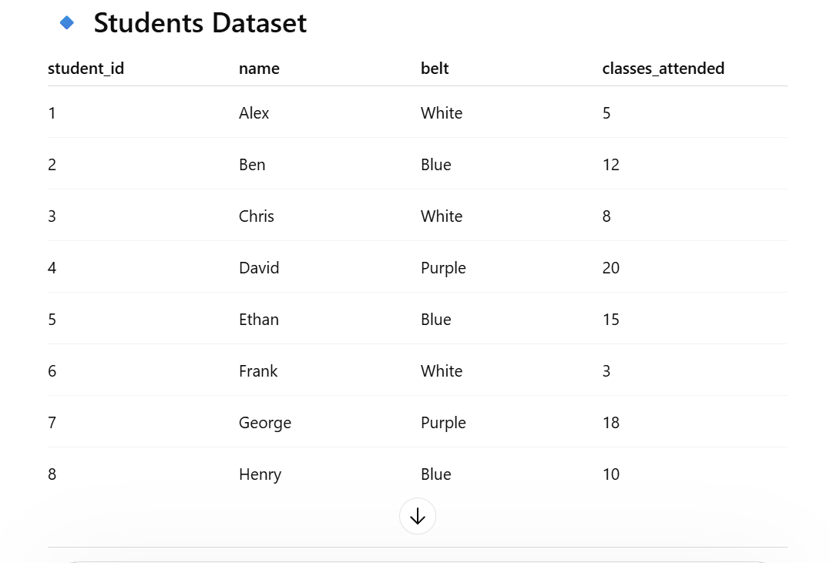

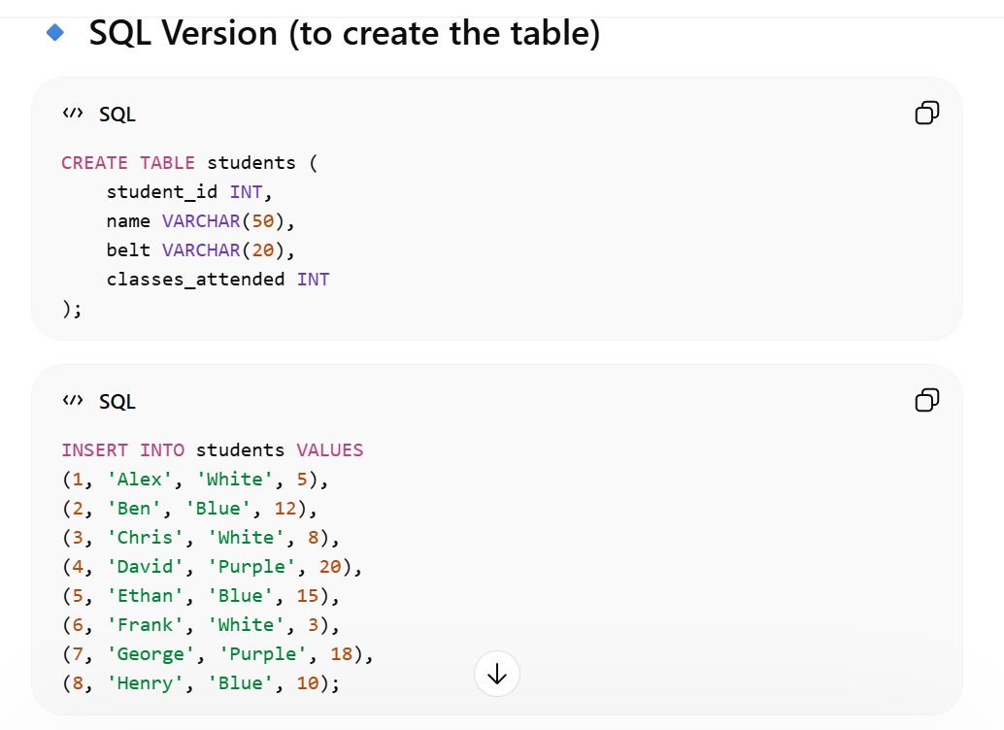
Explanation:
The prompts are stronger because they are simple, concise and use real life examples that I can follow and understand.

