Planning Ahead
- Plan where you want to look for data – take into consideration day, time, and location
- Make sure the battery is charged

Packing List*
Essentials:
- Horn
- Amplifier and filter filter
- RTL-SDR and SMA cable
- Pi + Mouse + USB-C cable for power
- Monitor, HDMI cable, USB micro cable for power
- Battery
- Tape, aluminum tape, foil
- Notebook, pen, observing sheets
- Phone (for determining pointing)
If Needed and Available:
- RF explorer
- Table
- Garden stakes, lawn chair, and boxes for propping up horn
- Tarp (to stay dry on wet grass)
- Sunscreen
- Bug spray (long pants and sleeves)
- Flashlight or headlamp

*For our build specifically, we used the Nooelec amp + filter and the raspberry pi 400

Assembly
- Place telescope on ground
- Connect the nooelec amp and filter onto the horn by twisting the bolt
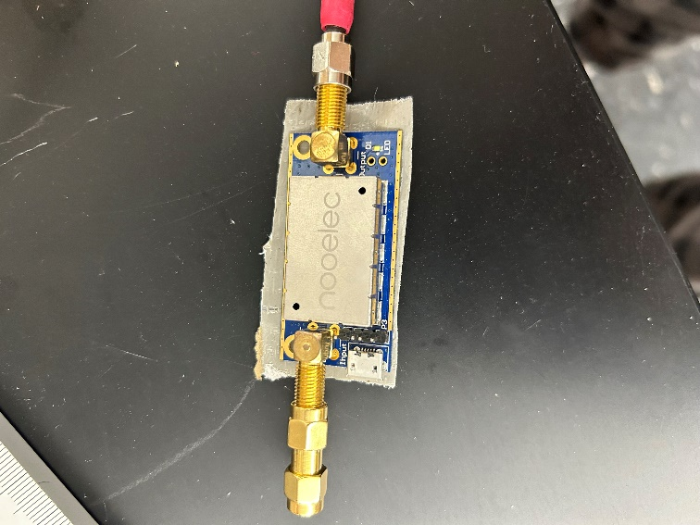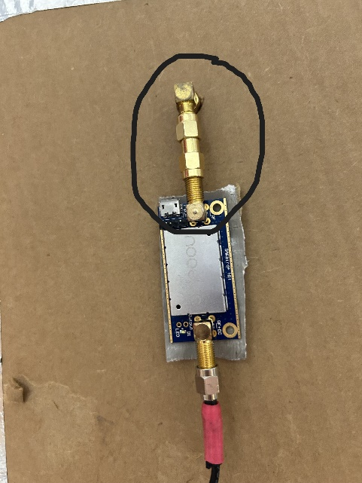
- Connect the nooelec amp and filter with the RTL-SDR using the SMA cable
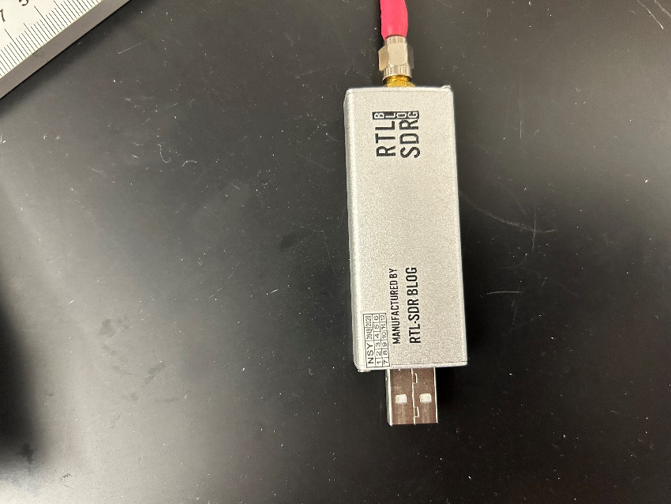 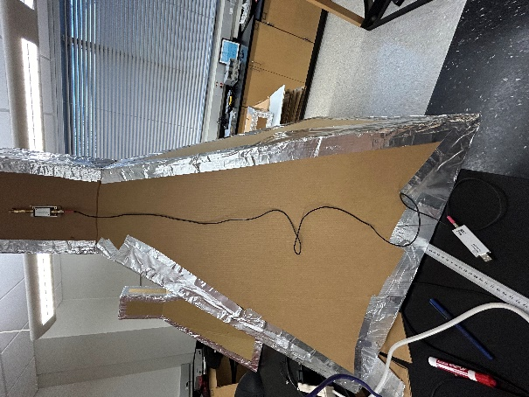 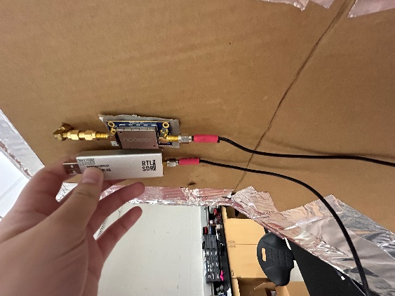
- Plug the RTL-SDR into the raspberry pi USB 2 port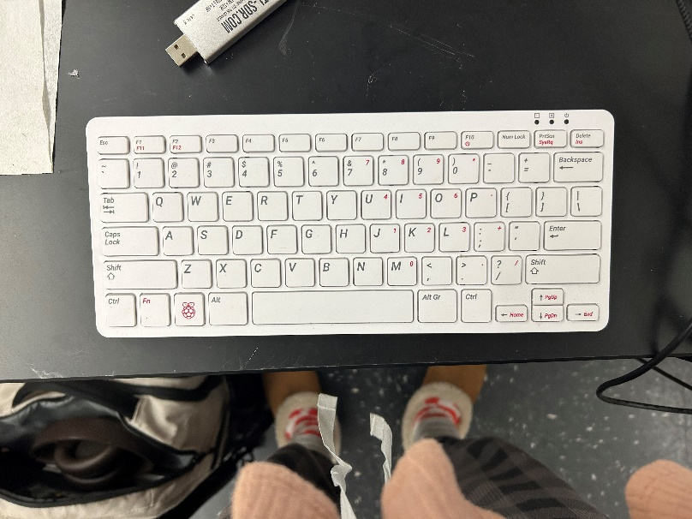 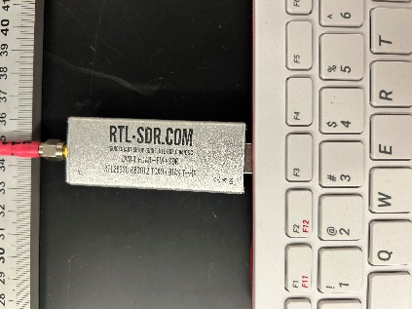
- Plug the mouse into the raspberry pi
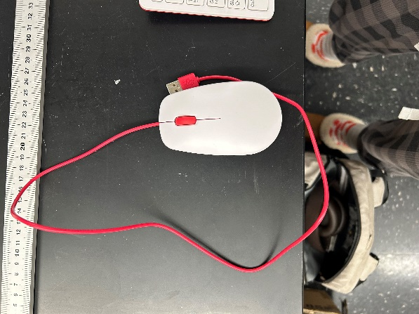 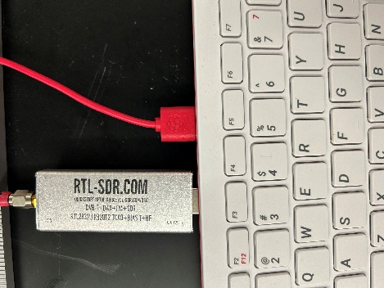
- Plug the small end of the HDMI cable into the raspberry pi and the large end into the monitor
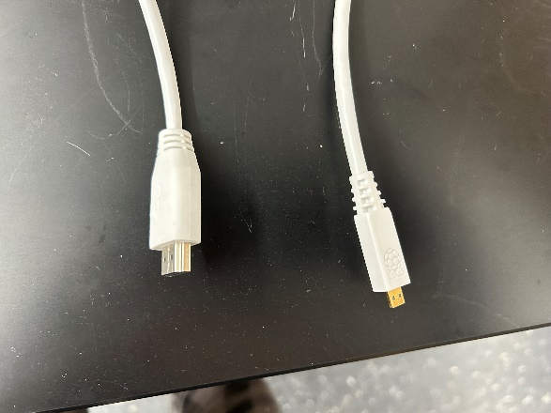 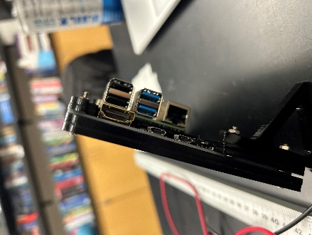 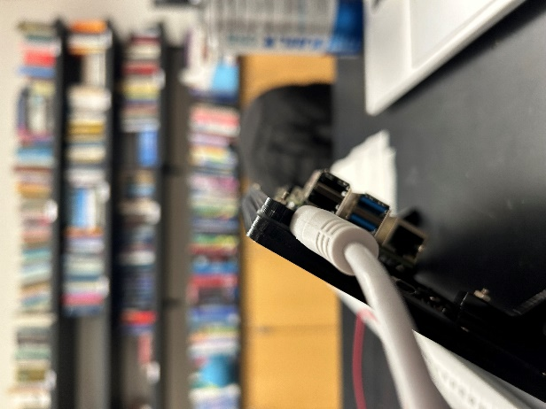
- Plug the small end of the USB C cable into the raspberry pi where the power symbol is, and plug the large end into the battery.
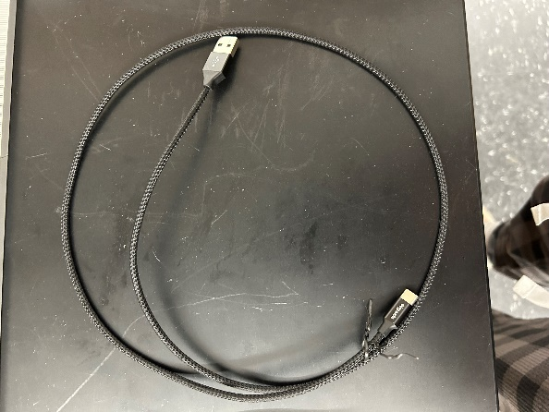 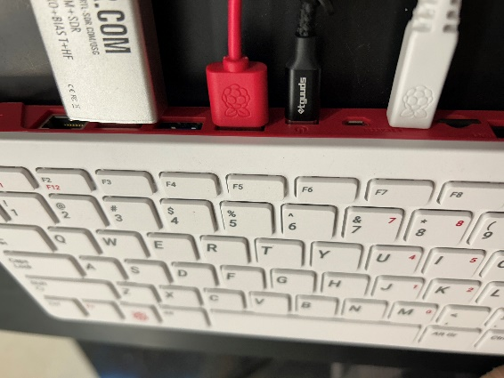 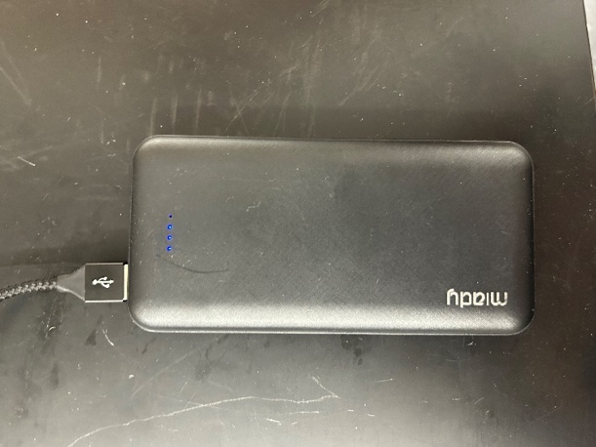
- Plug the small end of the USB 2.0 micro B cable into the “power only” spot in the monitor, and the large end into the battery.
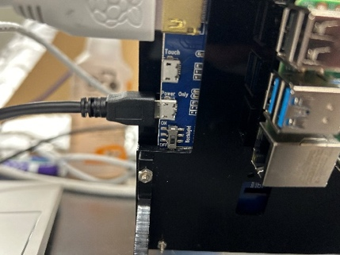 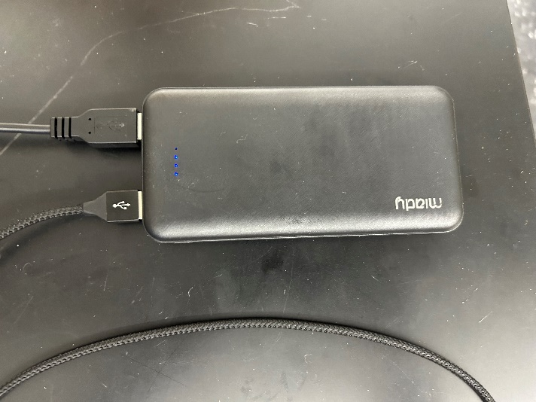
- Once everything is plugged in, the screen should light up and the Pi should boot up.
- Point towards desired quadrant or direction, use compass app on phone
- Set to desired angle, using props to make sure the telescope remains at the same angle
- Check angle with level app on phone
- Hold telescope throughout all the data collection

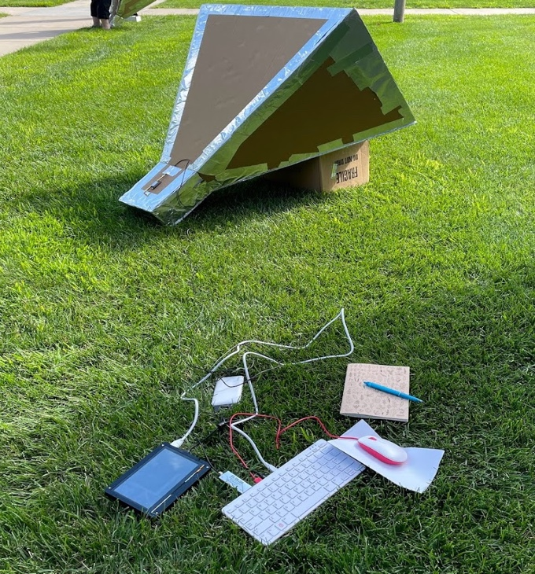
Set Up Software
- Open the chart-observe file on the Pi’s desktop
- If you used the GUI for planning, and saved your settings, it should auto-populate your location. If not, go ahead and put in your name and location.
- If the system time is off, use the button at the top of the window to “Set System DateTime.” You should only need to do this once on a fresh boot-up. But it doesn’t hurt to keep an eye on it if you are observing for an extended time.
- Enter the parameters you want to use for taking data.
  - Your altitude and azimuth should be measured based on where your horn is actually pointed, not necessary exactly what was planned.
  - A short description will help you remember what you were doing with the observation.
  - The Frequency Scan parameters will determine the range of frequencies observed, as well as how much time is spent on each frequency tuning. You can use the default parameters by setting the slider at the top.
- The Enable Bias-T option should only be used if you know for sure that you are using a bias-T. If you are following this tutorial exactly, then Bias-T SHOULD be on. This is what turns on the LNA, which should have a bright white light on when taking data.
  - If you are using the Nooelec filter and amplifier we recommend, then you do have a bias-T and should enable this setting.
- Click “Start.” Note down the directory for your run.
- When your scan is complete, a graph should pop up showing a rough analysis of the data you just took.
- Repoint your horn, update the observing parameters, and keep exploring the galaxy!

