 World's first underwater desalination plant
Welcome back, patron. Chinese scientists have built a sort of time machine that can help researchers fast-forward the effects of geological processes that span centuries and help them make better predictions. Meanwhile, a drug that scientists claim helps humans regrow lost teeth has qualified for human trials and could hit the market in four years.

The most interesting scientific discoveries and breakthroughs this week

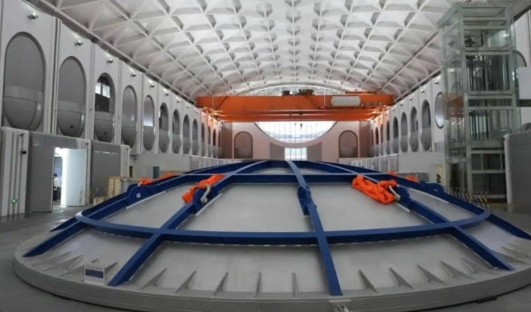
1. China’s new 'time-bending' centrifuge helps geologists compress centuries into days: Chinese scientists have built CHIEF1900, a powerful centrifuge that they claim can compress centuries of geological processes into days. The facility can simulate how pollutants migrate through soil over millennia or test a 3-meter dam model under the same stress as a 300-meter real-world wall, potentially helping researchers fast-forward through decades of environmental scenarios that are impossible to study in real time.
2. World's first subsea commercial desalination plant can cut energy use in half: Norwegian startup Flocean is set to launch a commercial subsea desalination facility this year that operates 300-600 meters below the ocean surface. By tapping into natural ocean pressure, the system slashes energy use and emissions by 30-50% compared to land-based plants. Each pod could theoretically serve 37,500 people, with initial projects already underway in the Mediterranean, Red Sea, and Indian Ocean.
3. Japanese drug that can regrow teeth moves to human trials: After years of animal testing, Japanese scientists are finally running human trials on a drug that reportedly triggers tooth regrowth. The monoclonal antibody treatment targets a protein called USAG-1 that naturally inhibits tooth growth, disrupting its function and unlocking the body's dormant ability to grow new teeth. If it succeeds, the drug could hit shelves around 2030.
4. Scientists unveil transparent solar windows that generate power: Korean researchers have built transparent windows that act sort of like solar panels without blocking your view. The breakthrough system combines distributed Bragg reflectors with bifacial silicon cells to redirect invisible infrared light to solar cells while letting 75.6% of visible light pass through. Scientists claim that the windows could potentially power zero-energy buildings and EVs, finally making see-through solar tech practical for everyday use.

NEW TECH
Our favorite new tech gadgets this week
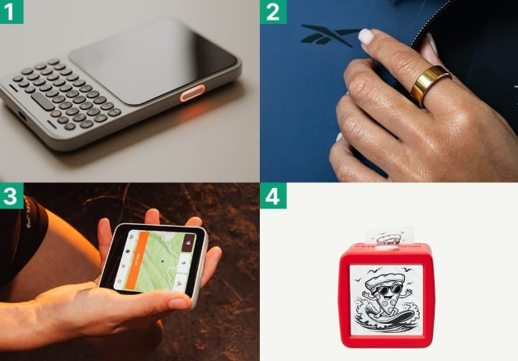
1. Clicks Communicator: A tactile phone for when you just want to stay in touch. It packs a full QWERTY keyboard and cellular connection so you can leave your main phone behind.
2. Reebok Smart Ring: A smart ring that tracks sleep, stress, and temperature trends, turning them into one simple “One Score”.
3. Meadow: A companion device that works with your main phone number. It has full LTE service, runs essentials like Uber, Spotify, and Strava, and is half the size of a smartphone.
4. Stickerbox: An interesting AI-powered printer for kids that lets them speak out an idea and instantly print it as a black-and-white sticker

SOCIAL SIGNALS
What’s trending in tech on socials this week

Speed Run: A video showing a Chinese Maglev test vehicle accelerating from 0 to 318 MPH in two seconds is going viral on Reddit. Here’s a point-of-view shot that’ll help you better understand the amazing velocity of the vehicle.
 Solo Save: After its pilot became "incapacitated," a light aircraft automatically contacted Air Traffic Control, issued a MAYDAY call, and landed safely on its own. It’s the first confirmed real-world use of this technology outside controlled tests or demonstrations. Watch it here.
 Crypto Cave: Ever wonder what the inside of the world’s largest bitcoin mine looks like? Here’s a short video tour.
 Wood Works: Here’s a piece of fascinating trivia you probably didn’t know. The city of Amsterdam is actually built on over a million wooden piles instead of solid ground. A model showing the mechanism in action is doing massive numbers on Reddit.

ONLY GOOD NEWS
A healthy dose of optimism to kickstart your week
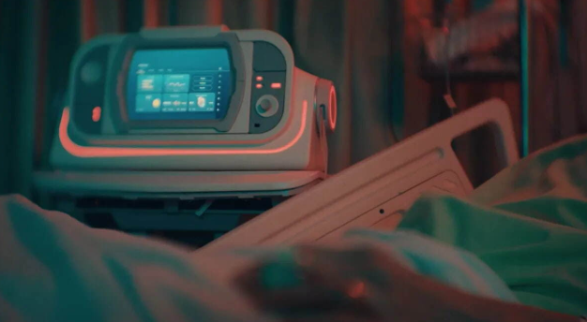
One-Finger Founder: A 36-year-old paralyzed man in China, who can only move one finger and one toe, has reportedly built a smart agriculture control system that's turning a profit. The 36-year-old used just one movable finger and toe to operate a virtual keyboard, designing an entire IoT farm system whilst completely bedridden. If true, the story could prove that accessibility technology and sheer determination can turn even severe physical limitations into thriving entrepreneurship.
Pulse Pilot: Scientists have developed ACIS, a tiny autonomous device that acts like a "self-driving car" for heart attack recovery, delivering precise drug doses, monitoring patient response, and adjusting treatments in real-time. The system uses a "Bio Digital Twin,” a mathematical model of cardiovascular dynamics, to optimize for faster recovery. While still early-stage, it could potentially reduce heart tissue death, cut hospital readmissions, and deliver minute-by-minute care to thousands of heart patients.

WEDNESDAY SCIENCE TRIVIA

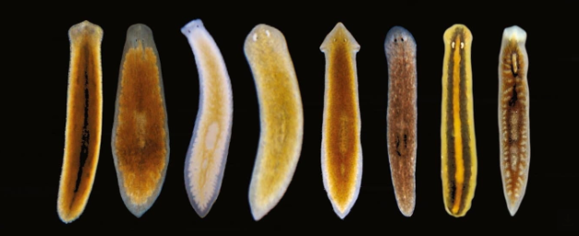

There is a kind of worm that can regenerate its entire body from tiny fragments. As long as the fragments have some stem cells, they'll grow a brain, a central nervous system, eyes, and organs. Scientists still don’t fully understand the entire process.
What is the name of this mind-boggling worm species that has scientists stumped?
Tell me now!

What did you think of today's email?
Your feedback helps me create better emails for you!

Until next time,
Tamojit and the TamojitRoyVerse360 team


Update your email preferences or unsubscribe here

