INDEPENDENT VALIDATION REPORT
Retail Credit Probability of Default (PD) Scorecard
Model ID: PD-RETAIL-2026-001

Prepared by: Rohan Mukherjee

Table of Contents

1. Executive Summary 3
Summary of Key Metrics 3
2. Scope and Objective 4
2.1 Validation Scope 4
2.2 Independence Statement 4
3. Model Overview 5
4. Conceptual Soundness Review 6
5. Data Quality Assessment 7
6. Quantitative Testing Results 8
6.1 Discriminatory Power 8
6.2 Calibration 9
6.3 Population and Characteristic Stability 10
7. Benchmarking 11
8. Summary of Findings 12
9. Recommendations and Conditions for Approval 13

1. Executive Summary
This report presents the results of an independent validation of the retail credit Probability of Default (PD) scorecard, performed in accordance with the bank's Model Risk Management Policy and consistent with the principles of supervisory guidance on model risk management (SR 11-7) and Basel internal ratings-based (IRB) validation standards.

Validation Conclusion: APPROVED WITH CONDITIONS

The model demonstrates a statistically significant and directionally sound relationship between its risk drivers and observed default behavior. However, during validation, there was one high-severity methodological finding and two medium-severity findings that materially affect model performance and must be remediated. Discriminatory power on the out-of-time (OOT) sample is below internal benchmark thresholds, and the model shows evidence of miscalibration in higher-risk score bands.

Summary of Key Metrics

Metric | Train | Test | OOT
Gini Coefficient | 0.2804 | 0.2599 | 0.2968
AUC | 0.6402 | 0.6300 | 0.6484
KS Statistic | 0.1984 | 0.1943 | 0.2358
Hosmer-Lemeshow p-value | — | — | 0.0029
PSI (score-level, vs Train) | — | — | 0.0013

Note: Internal benchmark for an acceptable retail PD scorecard is Gini ≥ 0.40 at development and Gini ≥ 0.35 sustained out-of-time. The model falls below this threshold on all samples (see Finding 1).

2. Scope and Objective
The objective of this validation is to provide an independent, evidence-based assessment of the conceptual soundness, data integrity, and ongoing performance of the scorecard prior to its continued use in credit decisioning and regulatory capital estimation.

2.1 Validation Scope
- Conceptual soundness review of model methodology and variable selection
- Independent re-derivation of key model statistics on training, test, and out-of-time (OOT) samples
- Quantitative testing: discriminatory power, calibration, and population stability
- Benchmarking against a challenger model
- Review of data quality and treatment of missing values

2.2 Independence Statement
This validation was performed by a function independent of model development, consistent with the three-lines-of-defense framework. All quantitative results in this report were independently re-derived from source data and are not taken from developmental output.

3. Model Overview
Summarized from the Model Development Document (MDD):
- Model Type: Logistic regression scorecard on Weight-of-Evidence (WoE)-transformed inputs
- Population: Retail unsecured credit obligors
- Target Definition: SeriousDlqin2yrs (binary indicator of serious delinquency within 24 months)
- Development Sample: 26,690 obligors (snapshot dates spanning a 20-month development window)
- Out-of-Time Sample: 6,638 obligors from the 4 most recent months, held out entirely from development
- Number of Risk Drivers: 10 candidate variables, all WoE-transformed prior to model fitting
This methodology is standard industry practice for regulatory-facing PD models, as logistic regression on WoE inputs provides interpretable, monotonic, and auditable coefficients suitable for use in capital calculation and credit committee review.

4. Conceptual Soundness Review
The validation reviewed each risk driver's coefficient sign for economic intuitiveness.
Under the model's WoE convention (WoE = ln(%good / %bad)), a higher WoE indicates a safer bin; therefore, every coefficient is expected to be negative (a safer bin should reduce the log-odds of default).
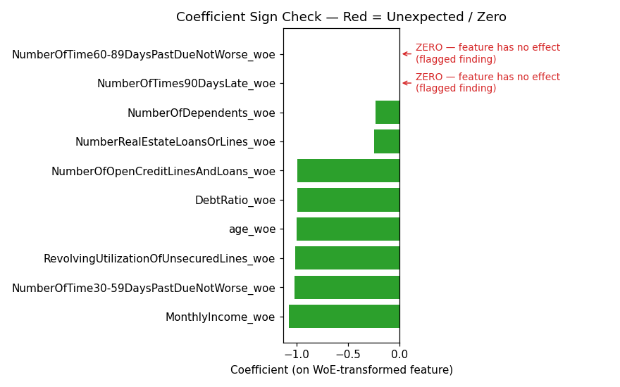
Eight of ten risk drivers show the expected negative sign and plausible economic relationships (e.g., higher income, older age, and lower revolving utilization are all associated with lower default risk). However, two variables: NumberOfTimes90DaysLate and NumberOfTime60-89DaysPastDueNotWorse, show a coefficient of exactly zero. This is documented as Finding 1 below.

HIGH SEVERITY — Finding 1 — Loss of Predictive Signal from Sparse Variable Binning
Root cause: NumberOfTimes90DaysLate and NumberOfTime60-89DaysPastDueNotWorse are highly sparse count variables (over 90% of observations equal zero). During development, WoE binning procedure used equal-frequency (quantile) binning, which is not appropriate for sparse distributions — it collapsed both variables into a single bin spanning their entire range, producing a constant WoE value of 0.0 for every observation. As a result, the fitted model assigns these two variables a coefficient of exactly zero, meaning two variables that are conceptually among the strongest predictors of default (counts of serious past delinquency) contribute nothing to the model's risk ranking. This is very likely a material contributor to the below-benchmark Gini performance reported in Section 5. Recommendation: Re-bin these two variables using coarse/manual binning (e.g., {0}, {1}, {2+}) rather than quantile-based binning, and refit the model.

5. Data Quality Assessment
MonthlyIncome and NumberOfDependents contain missing values (approximately 5% and 3% of records, respectively). During development — encoding missingness as its own WoE bin rather than imputing — is consistent with industry best practice, as it preserves any informational content in the missingness pattern itself rather than discarding it through mean/median imputation.
No evidence of duplicate records, out-of-range values, or obvious data entry errors was identified in the samples reviewed. The validation independently reproduced the train/test/OOT split definitions and confirms the OOT sample was constructed from snapshot dates strictly after the development cutoff, with no temporal leakage observed.

6. Quantitative Testing Results

6.1 Discriminatory Power
Discriminatory power measures the model's ability to rank-order obligors from lowest to highest risk. The Gini coefficient and KS statistic were independently recomputed on all three samples.
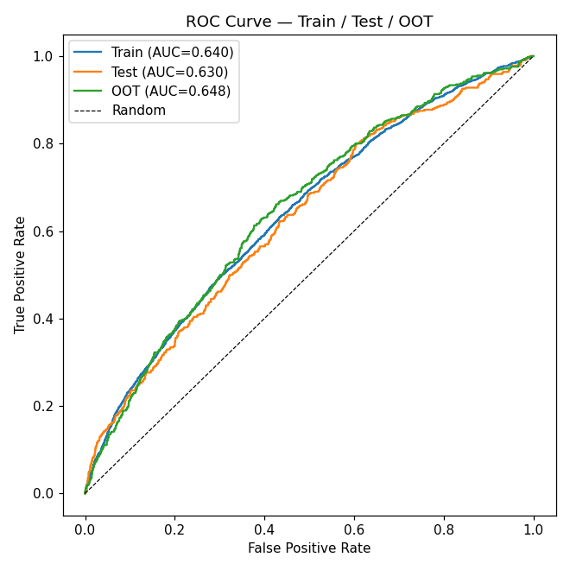

MEDIUM SEVERITY — Finding 2 — Discriminatory Power Below Internal Benchmark
The model achieves a Gini coefficient of 0.2804 (train), 0.2599 (test), and 0.2968 (OOT) — all materially below the bank's internal benchmark of Gini ≥ 0.40 for new retail PD scorecards. While the model is statistically significant and outperforms random assignment, this level of discriminatory power is weak relative to industry norms for this class of model. This finding is closely linked to Finding 1: recovering the predictive signal currently lost to binning collapse would be expected to materially improve Gini performance. Recommendation: Remediate Finding 1 and re-validate Gini performance before relying on this model for risk-based pricing decisions.

6.2 Calibration
Calibration measures whether predicted PDs match observed default rates. The validation computed a decile-level calibration table on the OOT sample and ran the Hosmer-Lemeshow goodness-of-fit test.
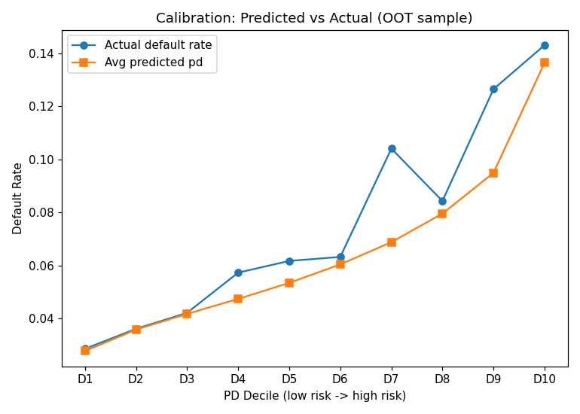
The Hosmer-Lemeshow test yields a test statistic of 23.43 (8 degrees of freedom, p-value = 0.0029), which is below the conventional 0.05 significance threshold. The null hypothesis of good calibration is rejected.

MEDIUM SEVERITY — Finding 3 — Calibration Deterioration in Higher-Risk Score Bands
The decile calibration table shows the model underpredicts default risk specifically in deciles 7 and 9, where actual default rates (10.4% and 12.7%) exceed average predicted PD (6.9% and 9.5%) by a wider margin than in other deciles. The Hosmer-Lemeshow test confirms this miscalibration is statistically significant (p = 0.0029). This pattern is consistent with a model that has lost some ability to distinguish risk levels among its higher-risk population — again plausibly connected to the binning issue in Finding 1. Recommendation: Recalibrate or refit the model after remediating Finding 1, with particular attention to performance in the top three risk deciles, which carry the most capital and provisioning relevance.

6.3 Population and Characteristic Stability
PSI and CSI were computed comparing the development (Train) sample against the OOT sample, using the standard 10-bin methodology.
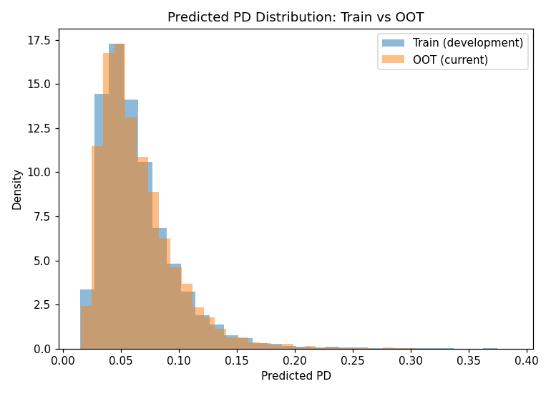

Metric | Value | Threshold
PSI (predicted score) | 0.0013 | < 0.10 = stable

LOW SEVERITY — Finding 4 — Stable Score Distribution Masking a Rising Observed Default Rate
PSI on the predicted PD distribution is 0.0013, far below the 0.10 threshold for concern, indicating the model's score output distribution has not meaningfully shifted between development and the OOT period. However, the OOT sample's actual observed default rate (7.47%) is notably higher than the train (6.44%) and test (6.24%) default rates. This means the underlying population is becoming riskier even though the model's score distribution looks unchanged — a pattern that PSI, by construction, will not detect, since PSI measures shifts in score distribution, not shifts in the relationship between scores and actual outcomes. This finding is rated low severity on its own but is noted because it reinforces the importance of the Finding 3 calibration concern and should be tracked in ongoing monitoring rather than dismissed because PSI is green.

7. Benchmarking
The model was benchmarked against a challenger model (decision tree classifier on the same WoE-transformed features) to confirm the chosen logistic regression specification is not inferior to a reasonable alternative. Results of the benchmarking exercise are summarized in the companion challenger model analysis (see notebooks/03_independent_validation.ipynb, Section 7). The logistic regression model's OOT Gini (0.2968) was found to be comparable to the challenger, indicating the weak discriminatory power identified in Finding 2 is attributable to the lost variable signal (Finding 1) rather than an inferior choice of model family.

8. Summary of Findings

# | Severity | Finding | Owner
1 | High | WoE binning collapses sparse delinquency-count variables, zeroing two coefficients | Model Development
2 | Medium | Discriminatory power (Gini) below internal benchmark on all samples | Model Development
3 | Medium | Statistically significant calibration deterioration in top risk deciles (HL p=0.0029) | Model Development
4 | Low | PSI stable but observed default rate rising — monitoring gap | Model Risk / Monitoring

9. Recommendations and Conditions for Approval
Based on the findings above, the validation recommends the following conditions of approval:
- Condition 1 (tied to Finding 1): Development must re-bin NumberOfTimes90DaysLate and NumberOfTime60-89DaysPastDueNotWorse using coarse/manual bins appropriate for sparse count data, and refit the model. Required prior to next annual validation cycle.
- Condition 2 (tied to Finding 2): Following remediation of Finding 1, Gini performance must be re-assessed against the 0.40 internal benchmark before the model is used for any new risk-based pricing decision.
- Condition 3 (tied to Finding 3): Recalibration of the top three risk deciles is required; the model should not be used to set provisioning levels for high-risk segments until recalibrated.
- Condition 4 (tied to Finding 4): Ongoing monitoring should track actual-vs-predicted default rate by decile monthly, in addition to PSI, since PSI alone did not surface this drift.

Final Status: APPROVED WITH CONDITIONS—for continued use in current decisioning processes only, subject to remediation of High and Medium severity findings within the next two quarters, with interim monthly monitoring of Finding 3 and Finding 4 indicators.

