VaR MODEL BACKTESTING REPORT
Equity Index Trading Book—99% 1-Day Value-at-Risk
Model ID: VAR-EQIDX-2026-001
Backtesting Period: January 2021 - October 2025 (1,250 trading days)

Prepared by: Rohan Mukherjee

Table of Contents

1. Executive Summary 3
Summary of Key Results (99% 1-day VaR, full sample) 3
2. Scope and Methodology Overview 4
3. Champion Model: Historical Simulation VaR 5
4. Backtesting Results: Kupiec POF Test 6
5. Backtesting Results: Christoffersen Independence Test 7
6. Basel Traffic-Light Capital Implications 8
7. Challenger Model Benchmarking 9
8. Summary of Findings 10
9. Recommendations and Conditions for Approval 11

1. Executive Summary
This report presents the results of the periodic independent backtesting of the equity index trading book’s 99% 1-day Value-at-Risk (VaR) model, performed in accordance with the bank’s Market Risk Model Validation Policy and consistent with Basel Committee backtesting standards.

Validation Conclusion: NOT APPROVED FOR CONTINUED UNCONDITIONAL USE—REMEDIATION REQUIRED

The champion model (250-day Historical Simulation) significantly and persistently understates tail risk. Over the 1,250-day backtesting window, the model produced 28 VaR breaches against an expected 12.5—more than double the calibrated rate—and currently sits in the Basel Red Zone, implying a regulatory capital multiplier add-on of 1.00. A challenger model (Filtered Historical Simulation) was benchmarked and passes all backtests, indicating the issue is methodological rather than reflecting genuinely unprecedented market conditions.

Summary of Key Results (99% 1-day VaR, full sample)

Model | Breaches | Kupiec p | Christoffersen p | Traffic Light
HS (Champion) | 28 / 12.5 exp. | 0.0002 | 0.1540 | Red
Parametric | 32 / 12.5 exp. | < 0.0001 | 0.0082 | Red
EWMA | 23 / 12.5 exp. | 0.0075 | 0.4404 | Amber
FHS (Challenger) | 18 / 12.5 exp. | 0.1424 | 0.2578 | Amber

2. Scope and Methodology Overview
The objective of this validation is to independently assess whether the trading book’s VaR model produces statistically reliable risk estimates, using the standard three pillars of VaR backtesting:
- Kupiec’s Proportion of Failures (POF) test—unconditional coverage (right total number of breaches?)
- Christoffersen’s Independence test—conditional coverage (are breaches clustered in time?)
- Basel Traffic-Light approach—the actual regulatory mechanism determining capital multiplier add-ons

All statistics in this report were independently re-derived from the underlying daily P&L and VaR estimate series; none are taken from desk or model development reports.

3. Champion Model: Historical Simulation VaR
The current production model is a 250-day Historical Simulation (HS) VaR at the 99% confidence level: each day’s VaR is the empirical 1st percentile of the trailing 250 daily returns. This is one of the most common VaR approaches in practice due to its simplicity and lack of distributional assumptions, but it is well known in the literature to react slowly to volatility regime changes, since old (pre-shock) observations remain in the rolling window for up to a year.

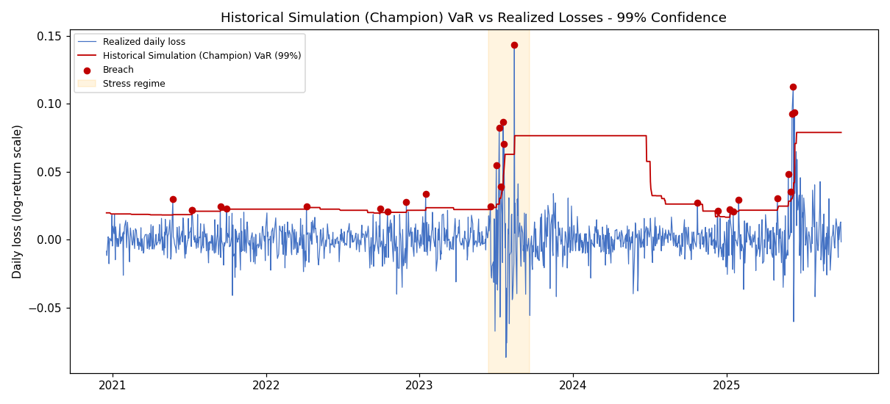

The exhibit above illustrates this weakness directly: during the stress regime observed in the trading book over summer 2023, realized losses breached the model’s VaR repeatedly because the model had not yet absorbed the new volatility regime into its 250-day window. Following the stress period, the model remained elevated for nearly a year longer than realized volatility, illustrating that Historical Simulation is slow both to increase and to decrease risk estimates as conditions change.

4. Backtesting Results: Kupiec POF Test
The Kupiec test asks: over the full backtesting window, did the model produce the statistically expected number of breaches for a 99% confidence VaR (i.e., approximately 1% of days, or 12.5 breaches over 1,250 days)?

Model | Breaches | Expected | LR Stat | p-value
HS (Champion) | 28 | 12.5 | 14.36 | 0.0002
Parametric | 32 | 12.5 | 21.47 | < 0.0001
EWMA | 23 | 12.5 | 7.14 | 0.0075
FHS (Challenger) | 18 | 12.5 | 2.15 | 0.1424

HIGH SEVERITY - Finding 1 - Champion Model Significantly Understates Tail Risk
The Historical Simulation champion model produced 28 VaR breaches against an expected 12.5 over the 1,250-day backtest window (Kupiec LR = 14.36, p = 0.0002), rejecting the null hypothesis of correct unconditional coverage at a high level of statistical confidence. The Parametric VaR alternative performs even worse (32 breaches, p < 0.0001), consistent with the well-documented tendency of the normal distribution assumption to underestimate fat-tailed equity return risk. Both EWMA and FHS show meaningfully fewer breaches, with FHS the only model that fails to reject the null hypothesis (p = 0.1424), suggesting the breach excess is attributable to model methodology rather than an inherently unmodelable market environment.
Recommendation: The champion model materially understates risk and should not continue in unconditional production use; see Section 9 for the proposed remediation path.

5. Backtesting Results: Christoffersen Independence Test
Kupiec’s test alone cannot distinguish between breaches that are spread evenly through time versus breaches that cluster together during stress events—a critical distinction, since clustered breaches indicate the model fails precisely when risk management matters most. The Christoffersen Independence test addresses this directly.

Model | 𝛑 (breach | breach) | 𝛑 (breach | no breach) | LR Stat | p-value
HS (Champion) | 7.14% | 2.13% | 2.03 | 0.1540
Parametric | 12.50% | 2.30% | 7.00 | 0.0082
EWMA | 4.35% | 1.79% | 0.60 | 0.4404
FHS (Challenger) | 5.56% | 1.38% | 1.28 | 0.2578

MEDIUM SEVERITY - Finding 2 - Parametric VaR shows Statistically Significant Breach Clustering
While the champion HS model does not formally fail the independence test (p = 0.1540), the Parametric VaR model shows a probability of a breach following another breach (12.50%) nearly six times higher than the unconditional breach probability (2.30%), and this clustering is statistically significant (p = 0.0082). This is consistent with the normal distribution assumption breaking down specifically during the kind of volatility clustering observed in the stress event reviewed in Section 3—exactly the regime in which model reliability matters most.
Recommendation: Parametric VaR should not be considered as a remediation alternative to the champion model given this clustering failure, despite Section 4’s similar Kupiec rejection for the champion.

6. Basel Traffic-Light Capital Implications
The Basel traffic-light approach is the actual regulatory mechanism for VaR backtesting: it counts breaches in the trailing 250 days and applies a capital multiplier add-on of up to 1.00 (effectively doubling market risk capital requirements) once a model accumulates 10 or more breaches in any trailing year.

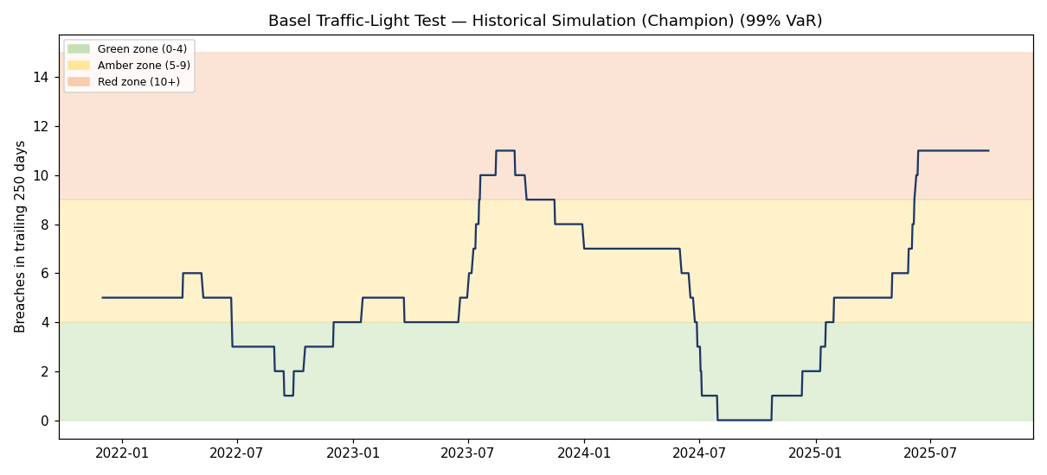

HIGH SEVERITY - Finding 3 - Champion Model Currently in Basel Red Zone
The champion model currently shows 11 breaches in the trailing 250-day window, placing it in the Red Zone and triggering the maximum capital multiplier add-on (1.00) under the Basel framework. The exhibit above shows this is not an isolated event: the model also spent an extended period in the Red Zone during 2023-2024 following the stress event. This has a direct and material capital cost: at the current add-on, regulatory market risk capital for this trading book is effectively double what it would be under a Green Zone model.
Recommendation: This finding alone should trigger an immediate model remediation request, independent of the statistical findings in Sections 4-5, given the direct capital impact.

7. Challenger Model Benchmarking
Two challenger models were benchmarked against the champion: EWMA (RiskMetrics-style parametric VaR with exponentially weighted volatility) and Filtered Historical Simulation (FHS), which combines empirical return distributions with EWMA volatility rescaling to capture fat tails while reacting quickly to volatility regime changes.

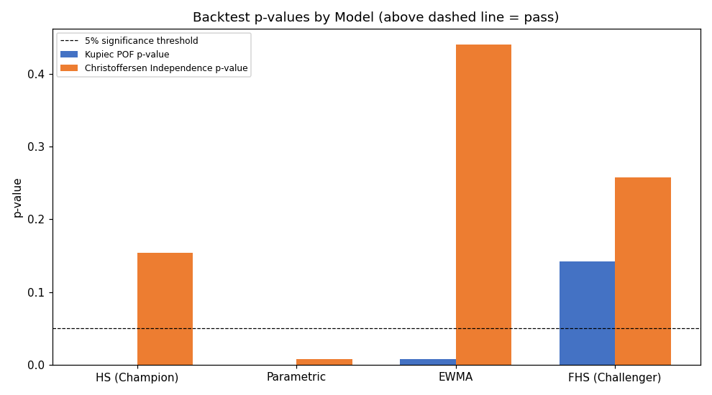

FHS is the only model that passes both the Kupiec and Christoffersen tests and shows the lowest current trailing breach count (6, vs. the champion’s 11). This indicates FHS would likely resolve both Finding 1 and Finding 3 if adopted, while EWMA—though an improvement over the champion—still fails the Kupiec unconditional coverage test and would not by itself bring the model out of the Amber/Red zone reliably.

8. Summary of Findings

# | Severity | Finding | Owner
1 | High | Champion model significantly understates tail risk (Kupiec rejects, 28 vs 12.5 expected breaches) | Market Risk / Quant
2 | Medium | Parametric alternative shows statistically significant breach clustering - not a viable remediation path | Market Risk / Quant
3 | High | Champion model currently in Basel Red Zone - maximum capital multiplier add-on in effect | Market Risk / Quant

9. Recommendations and Conditions for Approval
Based on the findings above, the validation recommends the following conditions of approval:
- Condition 1 (tied to Finding 1 and 3): The champion Historical Simulation model should be replaced or supplemented with the Filtered Historical Simulation challenger, which passes all backtests in this report and shows materially better current-state Red/Amber zone standing.
- Condition 2 (tied to Finding 2): Parametric VaR is explicitly NOT recommended as a remediation path despite superficially similar Kupiec performance to the champion, due to its additional independence test failure.
- Condition 3: Pending model replacement, the trading desk and Treasury should be notified of the current Red Zone status and its capital implications immediately, independent of the model remediation timeline.
- Condition 4: Following any model change, a minimum 6-month parallel run and re-backtest is required before full production cutover, consistent with standard model change governance.

Final Status: NOT APPROVED FOR CONTINUED UNCONDITIONAL USE.
The model may continue in production only under enhanced monitoring (weekly breach review) while remediation proceeds, given the immediate capital and risk-management implications of the Red Zone finding.

