CCAR STRESS TESTING MODEL VALIDATION REPORT
Retail Credit Loss Satellite Model - 9-Quarter Stress Horizon
Model ID: CCAR-SAT-2026-001
Validation Cycle: Annual CCAR Submission Review - FY2026

Prepared by: Rohan Mukherjee

Table of Contents

1. Executive Summary 3
2. Scope and Methodology Overview 4
3. Satellite Model Overview 5
4. Conceptual Soundness: Multicollinearity Finding 6
5. Scenario Construction and Extrapolation Risk 7
6. Projected Losses by Scenario 9
7. Sensitivity Analysis: Specification Risk 10
8. Summary of Findings 11
9. Recommendations and Conditions for Approval 12

1. Executive Summary
This report presents the independent validation of the retail credit loss satellite model (Model ID: CCAR-SAT-2026-001) used to project portfolio losses under Federal Reserve-style CCAR macroeconomic scenarios over a 9-quarter stress horizon. The model regresses quarterly portfolio loss rate against lagged unemployment, GDP growth, and home price index (HPI) growth, fitting on 10 years of historical data.

Validation Conclusion: APPROVED WITH CONDITIONS

The model fits historical data well (R² = 0.986) and produces directionally sensible loss projections that scale appropriately across Baseline, Adverse, and Severely Adverse scenarios. However, the validation team identified a high-severity conceptual soundness issue (severe multicollinearity between unemployment and HPI growth) and a high-severity extrapolation risk: the Severely Adverse scenario requires the model to predict losses using macroeconomic inputs that fall outside its historical training range in 8 of 9 quarters. A sensitivity analysis further shows that a defensible alternative specification (a quadratic unemployment term) produces 14.5% higher cumulative losses in the Severely Adverse scenario specifically—the scenario in which accuracy matters most for capital adequacy conclusions.

Summary of Key Results

Scenario | 9Q Cumulative Loss | Quarters Extrapolated | Peak Unemployment
Baseline | 4.31% | 0 of 9 | 4.60%
Adverse | 11.48% | 4 of 9 | 7.50%
Severely Adverse | 17.36% | 8 of 9 | 10.00%

2. Scope and Methodology Overview
This validation assesses the satellite model used to translate Fed-style macroeconomic scenarios into projected retail credit portfolio losses for CCAR capital planning purposes. The review covers:
- Conceptual soundness of the satellite model specification and variable selection
- Extrapolation risk: whether scenario inputs fall within the model's historical training range
- Quantitative results: projected losses across Baseline, Adverse, and Severely Adverse scenarios
- Sensitivity analysis: specification risk under reasonable alternative modeling choices

All statistics in this report were independently re-derived from the underlying historical macroeconomic and loss data; none are taken from model owner reporting.

3. Satellite Model Overview
The model is a linear regression of quarterly portfolio net charge-off rate against three macroeconomic drivers, fit on 39 quarters of historical data (2015Q2-2024Q4, after applying a 1-quarter lag to unemployment):
- Unemployment rate (lagged 1 quarter): coefficient +0.354
- GDP growth (contemporaneous): coefficient +0.018
- HPI growth (contemporaneous): coefficient -0.055

The model achieves an R² of 0.986 on the historical sample, indicating a strong in-sample fit. The unemployment and HPI coefficients have economically intuitive signs (higher unemployment and weaker home price growth both increase projected losses). The GDP growth coefficient is positive, which is mildly counterintuitive (stronger GDP growth would typically be expected to reduce, not increase, credit losses, all else equal)—this is investigated further in Section 4.

4. Conceptual Soundness: Multicollinearity Finding
The validation team examined pairwise correlations among the three explanatory variables in the historical training sample:
Variable Pair | Correlation | Assessment
Unemployment (lag1) vs. HPI growth | -0.95 | Severe
Unemployment (lag1) vs. GDP growth | +0.05 | Negligible
GDP growth vs. HPI growth | +0.09 | Negligible

HIGH SEVERITY - Finding 1 - Severe Multicollinearity Between Unemployment and HPI Growth
Unemployment and HPI growth are correlated at -0.95 in the historical training sample, indicating these two variables have moved almost in lockstep historically (as unemployment rose during the downturn, home price growth fell roughly proportionally). This is a high-severity conceptual soundness concern for two reasons. First, it makes the individual coefficient estimates on these two variables statistically unstable—the model cannot cleanly separate 'the effect of unemployment' from 'the effect of HPI' when they have only ever moved together. Second, and more importantly for stress testing specifically, Fed CCAR scenarios are not required to preserve this historical relationship: a scenario could plausibly specify a sharp unemployment rise with a smaller HPI decline (or vice versa) than historically observed, in which case the model's coefficients -- estimated under near-perfect collinearity -- provide little assurance about how losses would actually respond to that decoupled combination. The counterintuitive positive sign on GDP growth (Section 3) is a secondary symptom of this same instability.
Recommendation: The development team should consider a more parsimonious specification (e.g., dropping one of the two collinear variables or using a combined macro stress index) and should explicitly test model behavior under scenarios where unemployment and HPI movements are decoupled from their historical relationship.

5. Scenario Construction and Extrapolation Risk
The validation team compared each CCAR scenario's quarterly macroeconomic inputs against the satellite model's historical training range to determine whether the model is being asked to extrapolate beyond the data it was estimated on.
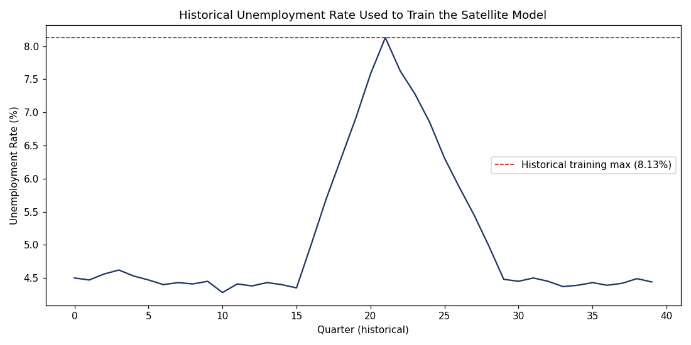
The historical training sample spans 39 quarters (2015Q2-2024Q4) and includes one moderate downturn, with unemployment peaking at 8.13%. This is the highest unemployment level the model has ever been estimated on.
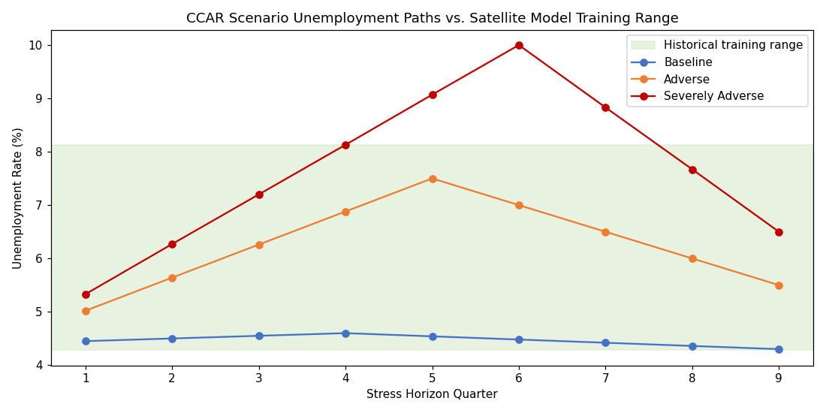

HIGH SEVERITY - Finding 2 - Severely Adverse Scenario Requires Extrapolation in 8 of 9 Quarters
The Severely Adverse scenario's unemployment path peaks at 10.00% in Quarter 6, exceeding the model's historical training maximum of 8.13% in Quarters 4 through 8. GDP growth in the Severely Adverse scenario falls below the historical training minimum (0.22%) in every quarter except Q8-Q9, and HPI growth falls below the historical training minimum (-6.89%) in Quarters 4-7. In total, 8 of the 9 stress horizon quarters require the model to predict outside its historical training range on at least one variable, and the Adverse scenario requires extrapolation in 4 of 9 quarters. This means the loss projections in the quarters that matter most for capital adequacy conclusions rely on the model's linear functional form continuing to hold well beyond any combination of macroeconomic conditions it has ever been fit on—an assumption that cannot be empirically validated against this bank's own historical experience.
Recommendation: Supplement this single-bank model with benchmarking against industry-wide or regulatory stress period data (e.g., 2008-2010 system-wide loss rates) that includes more severe historical episodes to provide some empirical grounding for the extrapolated region.

6. Projected Losses by Scenario
Applying the satellite model to each scenario produces the following 9-quarter cumulative loss rate projections:
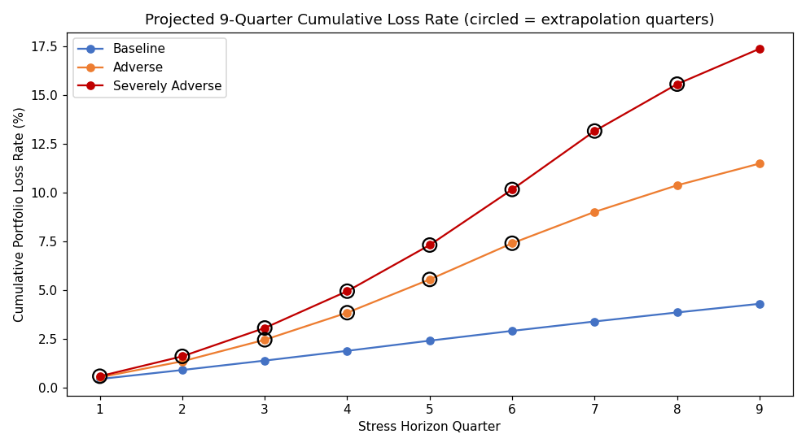
Cumulative losses scale sensibly across scenarios: Severely Adverse losses (17.36%) are approximately 4x Baseline (4.31%) and roughly 1.5x Adverse (11.48%), consistent with the relative severity of the underlying macroeconomic shocks. However, as shown by the circled markers, the great majority of the Severely Adverse loss curve -- and a meaningful portion of the Adverse curve -- is built on extrapolated model inputs per Finding 2, meaning confidence in the precise magnitude of these projections should be calibrated accordingly, even though the directional story (more severe scenario -> more severe losses) is robust.

7. Sensitivity Analysis: Specification Risk
To assess how much model specification choices affect the loss projections, the validation team independently fit an alternative specification adding a quadratic unemployment term to test whether a convex (accelerating) loss response to unemployment—a pattern documented in academic credit risk literature—would change conclusions materially.
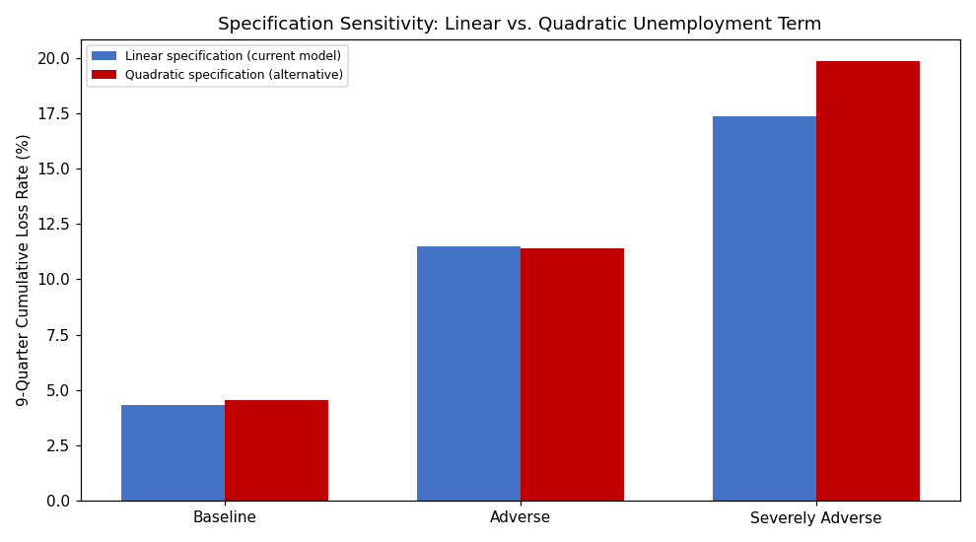

Scenario | Linear Model | Quadratic Model | % Difference
Baseline | 4.31% | 4.53% | +5.1%
Adverse | 11.48% | 11.39% | -0.8%
Severely Adverse | 17.36% | 19.87% | +14.5%

MEDIUM SEVERITY - Finding 3 - Specification Risk Concentrated in the Severely Adverse Scenario
The choice between a linear and quadratic unemployment specification produces a negligible difference in Baseline (+5.1%) and Adverse (-0.8%) projected losses, but a 14.5% difference in the Severely Adverse scenario specifically. This is a meaningful finding: model specification uncertainty is smallest in the scenarios the model was effectively trained closest to, and largest in precisely the scenario regulators scrutinize most closely for capital adequacy purposes. This is conceptually consistent with Finding 2—specification choices matter most exactly where the model is extrapolating most heavily.
Recommendation: The development team should treat the Severely Adverse loss projection as having a wider band of model uncertainty than the point estimate suggests, and should consider presenting a range (e.g., informed by the linear-vs-quadratic spread) to the Model Risk Committee and in the CCAR submission narrative, rather than a single point estimate.

8. Summary of Findings

# | Severity | Finding | Owner
1 | High | Severe multicollinearity (-0.95) between unemployment and HPI growth destabilizes coefficient estimates | Model development
2 | High | Severely Adverse scenario requires extrapolation beyond the historical training range in 8 of 9 quarters | Model development
3 | Medium | Specification risk (linear vs. quadratic) is concentrated in the Severely Adverse scenario (+14.5%) | Model development

9. Recommendations and Conditions for Approval
Based on the findings above, the validation team recommends the following conditions of approval:
- Condition 1 (tied to Finding 1): The development team must investigate alternative specifications that address the unemployment/HPI multicollinearity (e.g., a combined macro stress index, or dropping one variable) prior to the next CCAR cycle, and document model behavior under scenarios where the two variables decouple from their historical relationship.
- Condition 2 (tied to Finding 2): The CCAR submission narrative must explicitly disclose that Severely Adverse loss projections rely on substantial extrapolation beyond the institution's own historical loss experience and should reference industry/regulatory benchmark data where available to provide additional grounding.
- Condition 3 (tied to Finding 3): Severely Adverse loss estimates should be presented with an explicit model uncertainty range informed by the specification sensitivity analysis, rather than as a single point estimate, in materials presented to the Model Risk Committee and senior management.
- Condition 4: This model should be prioritized for enhancement (e.g., incorporating a longer historical window spanning a more severe downturn, if available from industry data sources) at the earliest practicable model redevelopment cycle.

Final Status: APPROVED WITH CONDITIONS. The model may continue to be used for the current CCAR submission cycle given the directionally sound and reasonably scaled loss projections, subject to the disclosure and uncertainty-range conditions above being incorporated into the submission materials immediately and the specification and multicollinearity findings being remediated prior to the next annual cycle.

