MODEL INVENTORY GOVERNANCE REPORT
Annual Review - FY2026

Prepared by: Rohan Mukherjee

Table of Contents

1. Executive Summary 3
2. Inventory Composition by Business Line 4
3. Validation Workload and Capacity Planning 5
4. Notable Tier Assignments 6
4.1 Models Tiered Higher than their Primary Financial Impact Might Suggest 6
4.2 Models Tiered Lower Despite Touching Customer Outcomes 6
5. Summary of Recommendations 7

1. Executive Summary
This report presents the FY2026 annual review of the bank’s model inventory and risk tiering, covering 18 models spanning credit risk, market risk, liquidity, compliance, operational risk, and supporting business functions. Tiering was performed using the methodology set out in MRM-POL-003 (Model Risk Tiering Methodology), applying weighted scoring across materiality, complexity, usage/reliance and data quality risk.
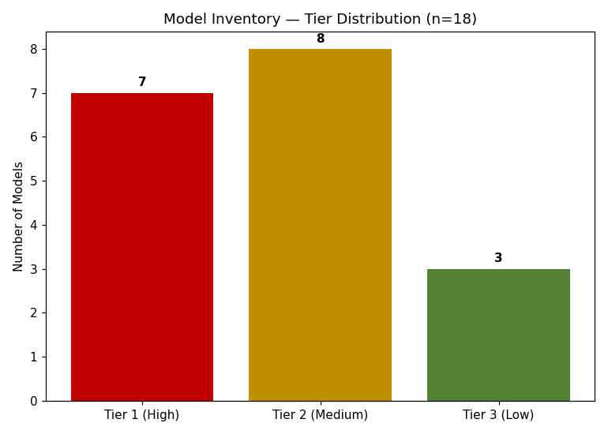
Seven models (39%) are classified Tier 1 (High), requiring annual independent validation and monthly monitoring. Eight models (44%) are Tier 2 (Medium), and three (17%) are Tier 3 (Low). This distribution set of high-materiality models in Finance and Markets functions, with a longer tail of lower-impact models across other business lines.

2. Inventory Composition by Business Line
Tier concentration varies meaningfully by business line. Finance and Markets carry the highest concentration of Tier 1 models, reflecting their role in regulatory capital and financial reporting; Corporate Functions and Treasury models are concentrated in Tier 2-3, reflecting their more internally focused use cases.

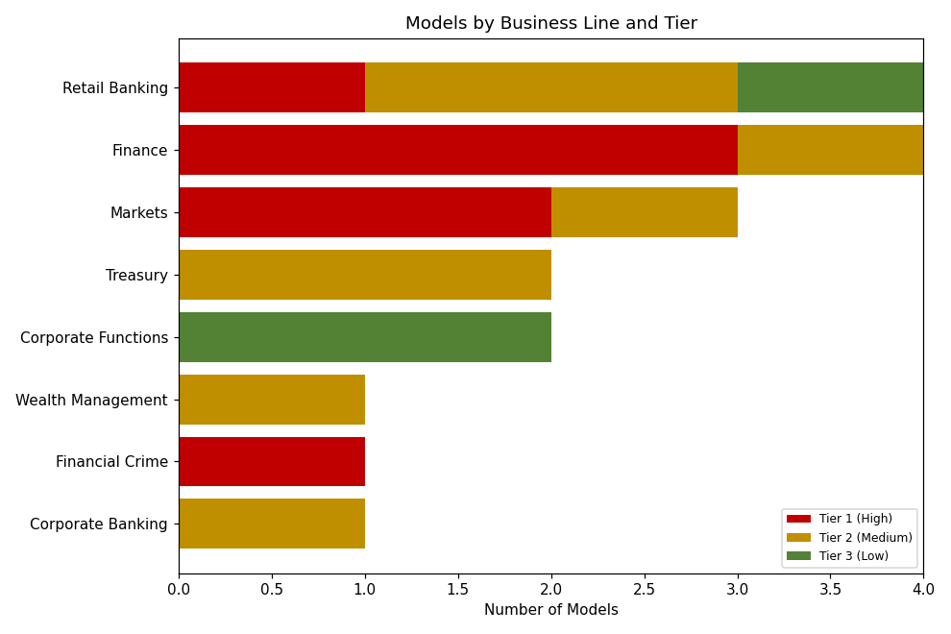

MEDIUM PRIORITY - Observation 1 - Concentration Risk in Finance Function

Three of the four models owned by the Finance function (IFRS 9/CECL ECL Model, CCAR Stress Testing Model, and the Economic Capital Allocation Model) are Tier 1. This concentration means a single resourcing shortfall in the Finance-aligned validation team could create a disproportionate backlog risk.
Recommendation: Model Risk Management should confirm validation team capacity is explicitly allocated to avoid a single point of failure across these three annual-cycle models.

3. Validation Workload and Capacity Planning
Based on tier-specific validation cycles (Tier 1: annual; Tier 2: 18 months; Tier 3: 36 months), the estimated validation workload for FY2026 is 13 models—7 Tier 1 (all due annually), an estimated 5 of 8 Tier 2 models (accounting for staggered 18-month cycles), and 1 of 3 Tier 3 models (staggered 36-month cycle).

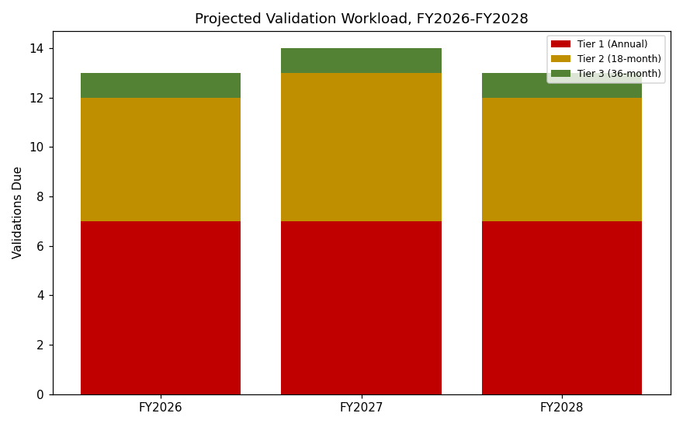

This workload is projected to remain stable at 13-14 validations per year through FY2028, assuming no material change to the inventory. New models added to the inventory (e.g., through new product launches or AI/ML adoption) will increase this workload and should be factored into MRM headcount planning at the time of model onboarding, not retroactively.

4. Notable Tier Assignments

4.1 Models Tiered Higher than their Primary Financial Impact Might Suggest
The Fraud Detection Model (Tier 1, score 4.50) is a useful illustration of why complexity and automation matter independently of materiality: its direct financial materiality (4) is below several other Tier 1 models, but its high complexity (5 - black-box gradient boosting) and high automation (5 - near real-time decisioning with minimal override) combine to place it solidly in Tier 1. This reflects a deliberate methodology design choice: a highly automated, hard-to-interpret model deserves the same validation rigor as a more directly material one, because errors are both more likely to occur undetected and more likely to affect a large volume of customers before being caught.

4.2 Models Tiered Lower Despite Touching Customer Outcomes
The Robo-Advisor Portfolio Allocation Model (Tier 2, score 2.90) touches individual client outcomes directly but is tiered below several enterprise-wide models because its blast radius is bounded to retail wealth clients rather than balance-sheet-wide exposure, and its underlying methodology (mean-variance optimization) is well-established and interpretable. The Model Risk Committee should periodically sanity-check that the inventory’s largest customer-facing models are not systematically under-tiered relative to enterprise-wide models simply because their financial exposure per instance is smaller—aggregate customer impact across a large client base is itself a materiality consideration the current scoring rubric captures only partially via the qualitative rationale field.

LOW PRIORITY - Observation 2 - Aggregate Customer Impact Not Fully Captured in Materiality Scoring

The current materiality rubric (Section 3.1 of MRM-POL-003) emphasizes balance sheet/P&L exposure and regulatory capital impact but does not explicitly score for aggregate customer impact across a large client base for models with smaller per-instance exposure (e.g., retail wealth, marketing).
Recommendation: Consider whether the methodology should be enhanced with an explicit ‘scale of customer impact’ sub-factor at the next annual methodology review, rather than relying on qualitative rationale alone.

5. Summary of Recommendations

# | Priority | Recommendation | Owner
1 | Medium | Confirm validation team capacity explicitly covers the 3 Tier 1 Finance models to avoid concentration/backlog risk | Model Risk Management
2 | Low | Evaluate adding an explicit aggregate customer-impact sub-factor to the materiality scoring rubric | Model Risk Management
3 | Low | Re-affirm that any new model onboarded mid-year is scored and tiered before go-live, not retroactively | Model Owners / MRM

This report and the underlying Model Inventory (.xlsx file) are recommended for approval by the Model Risk Committee, with the above recommendations tracked to closure at the next quarterly committee meeting.

