MONTHLY MONITORING REPORT
Month 12 - Escalation Report
Model ID: PD-RETAIL-2026-001 | Retail Credit PD Scorecard
Status: RED - Escalation per Ongoing Monitoring Framework (MRM-POL-004)

Prepared by: Rohan Mukherjee

Table of Contents

1. Escalation Summary 3
2. Discriminatory Power Trend 4
3. Override Rate Trend 5
4. Root Cause Assessment 6
5. Recommended Actions 7

1. Escalation Summary
Per the Ongoing Monitoring Framework (MRM-POL-004), this report is triggered because the Month 12 overall monitoring status for Model PD-RETAIL-2026-001 is RED. Two of the three monitored metrics—discriminatory power retained and override rate—breached their Red thresholds in Month 12. This report documents the deterioration trend over the full 12-month monitoring period, the current-month breach detail, and recommended remediation actions for Model Risk Committee review.

Metric | Month 12 Value | Threshold Breached | Status
PSI | 0.0897 | None (Green ≤ 0.10) | Green
Gini retained vs. baseline | 73.9% | Red (< 80%) | Red
Override rate | 13.1% | Red (> 10%) | Red

2. Discriminatory Power Trend
The model's Gini coefficient, measured monthly against realized outcomes, has declined from 122.98% of its launch baseline in Month 1 to 73.9% in Month 12 — a steady, near-monotonic erosion over the full monitoring period rather than a single anomalous month. This pattern is consistent with model staleness: the model has not been refreshed since launch, and its risk drivers' relationship to actual default outcomes appears to be weakening over time.
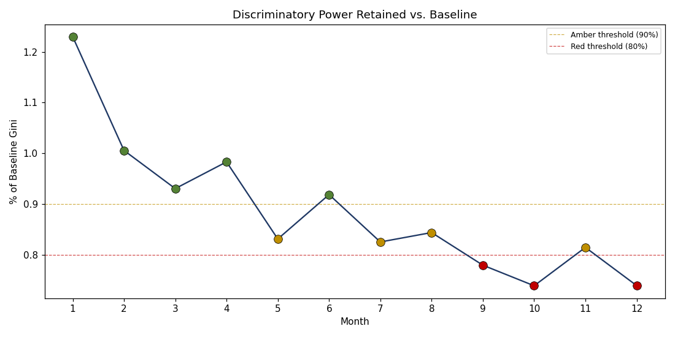

HIGH PRIORITY
The model first breached the Amber threshold (90% of baseline Gini) in Month 5 and has not sustained Green status since. It first breached Red (80% of baseline) in Month 9, recovered briefly to Amber in Month 11, and breached Red again in Month 12. Per Section 4 of MRM-POL-004, sustained Amber status for 3+ consecutive months should itself have triggered escalation to Model Risk Management -- the fact that this did not occur until the Red threshold was breached in Month 9 suggests a gap in how the Amber escalation rule was being operationally enforced, which should be addressed independently of the model's own remediation.

3. Override Rate Trend
The underwriter override rate has risen from 2.0% in Month 1 to 13.1% in Month 12, with the sharpest increase in the final two months. A rising override rate during a period of declining model discriminatory power is a particularly concerning combination: it suggests underwriters may be (correctly) sensing that the model's decline recommendations are becoming less reliable, and compensating with manual judgment -- which is a reasonable short-term response, but is not a sustainable substitute for a well-functioning model, and introduces its own inconsistency and key-person risk into the credit decisioning process.
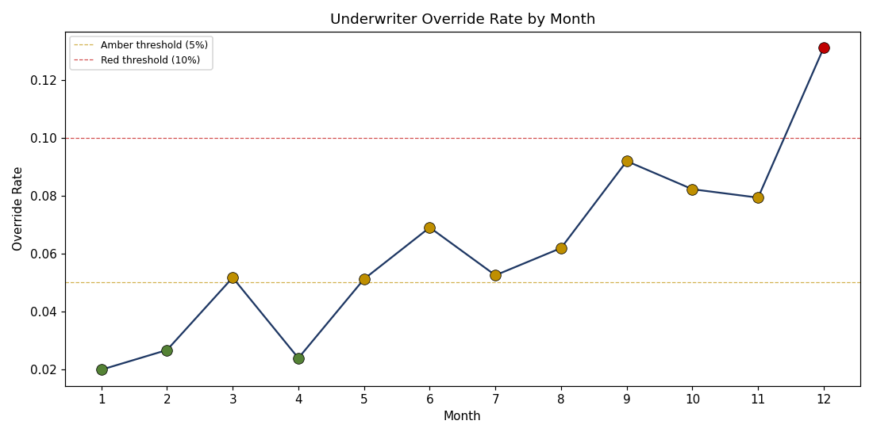

MEDIUM PRIORITY
This monitoring framework tracks the override RATE but does not currently track whether overridden decisions perform better or worse than the model's original recommendation would have. Without this, it is not possible to confirm whether rising overrides reflect underwriters correctly compensating for model weakness or introducing a new source of inconsistent risk-taking.
Recommendation: Establish a parallel monitoring metric tracking realized performance of overridden vs. non-overridden decisions, to be incorporated into the next Ongoing Monitoring Framework review.

4. Root Cause Assessment
The combination of steadily declining discriminatory power and a rising override rate, with population stability (PSI) remaining Green throughout, points toward a root cause of MODEL STALENESS rather than a sudden population shift or data quality break. The model's risk drivers and their estimated relationships to default were calibrated at launch and have not been refreshed; as underlying credit behavior patterns evolve over a 12-month period, a static model's discriminatory power will typically erode even if the overall population it's scoring remains compositionally similar -- exactly the pattern observed here.
This is also consistent with the broader lesson from this bank's VaR and credit PD validation work (see prior Model Risk Management validation reports): population-stability metrics like PSI are necessary but not sufficient for monitoring overall model health, since they cannot detect a deteriorating relationship between scores and outcomes if the score distribution itself happens to remain stable.

5. Recommended Actions
- Immediate (within 5 business days): Present this report to the Model Risk Committee for formal acknowledgment of Red status, per MRM-POL-004 Section 4.
- Short-term (within 30 days): Model owner to propose a remediation plan—either an accelerated model refresh/redevelopment timeline, or documented compensating controls (e.g., a temporary manual review overlay) if redevelopment cannot be completed quickly.
- Short-term (within 30 days): Model Risk Management to review and close the gap identified in Section 2 regarding enforcement of the 3-consecutive-month Amber escalation rule.
- Medium-term (within 90 days): Establish override performance monitoring as recommended in Section 3, and incorporate it into the next revision of the Ongoing Monitoring Framework (MRM-POL-004).

Escalation Status: OPEN - pending Model Risk Committee review and model owner remediation plan.

