**Project Details :-**

Project_Name is a Web App for providing the course materials to college students in a well structured, organised manner, all at one place. Course materials will be uploaded by students only in their college domain after they have registered on the site and other students can access the data uploaded by other fellow students. Instead of searching and asking everyone for links, pdfs, notes and other materials they just need to login here and get the data that they need.

**Tech Stacks** : -

**FrontEnd :**

* HTML
* CSS
* ReactJs
* Material UI

**BackEnd :**

* NodeJs
* ExpressJs
* MongoDB

**Abstract/Project Idea :-**

* We will have a separate model for each college.
* A user after registering will be associated with a college domain, in which he/she can add/view course materials.
* Every user will have a profile overview providing them details of their contribution.
* If a user wants to contribute to other college’s materials then he/she can add the material but the material will be added after approval of the 3 users from the other college.

**Workflow:**

* Wireframing.
* Designing all the pages.
* Completing the coding part for all the pages and making models of the backend part.
* Completing the backend part and connecting the frontend with the backend.

Implementation:

Frontend:

1. Landing Page:

Landing page will as the name suggests will be the first page to be displayed when the site is opened. This component will have the overview of the site for what it is and why everyone should use. We can implement it very easily using reactJs and material UI.

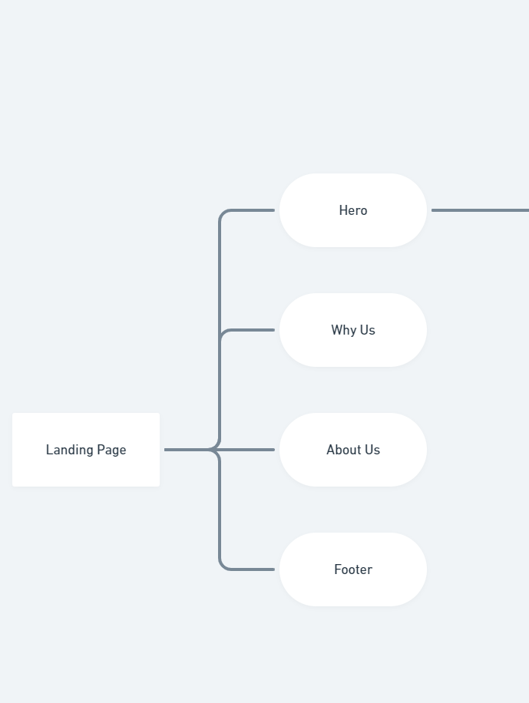

1. SignUp/Login Page :

SignUp/Login will be done in the backend part by using Javascript web tokens. The workflow for the same is :

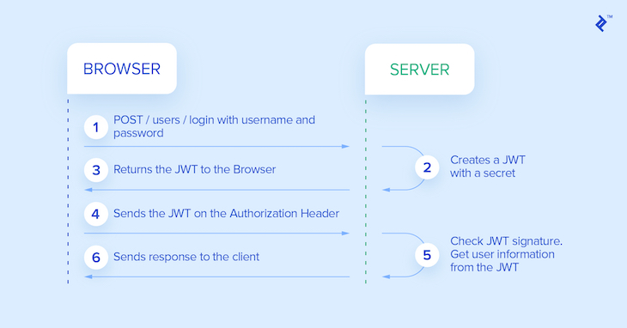

3. Home Page:

After the user is logged in, the user will be redirected to the home page which will have Navbar, sidebar, DashBoard and footer, and will fetch the data in the dashboard from the api provided in the backend.

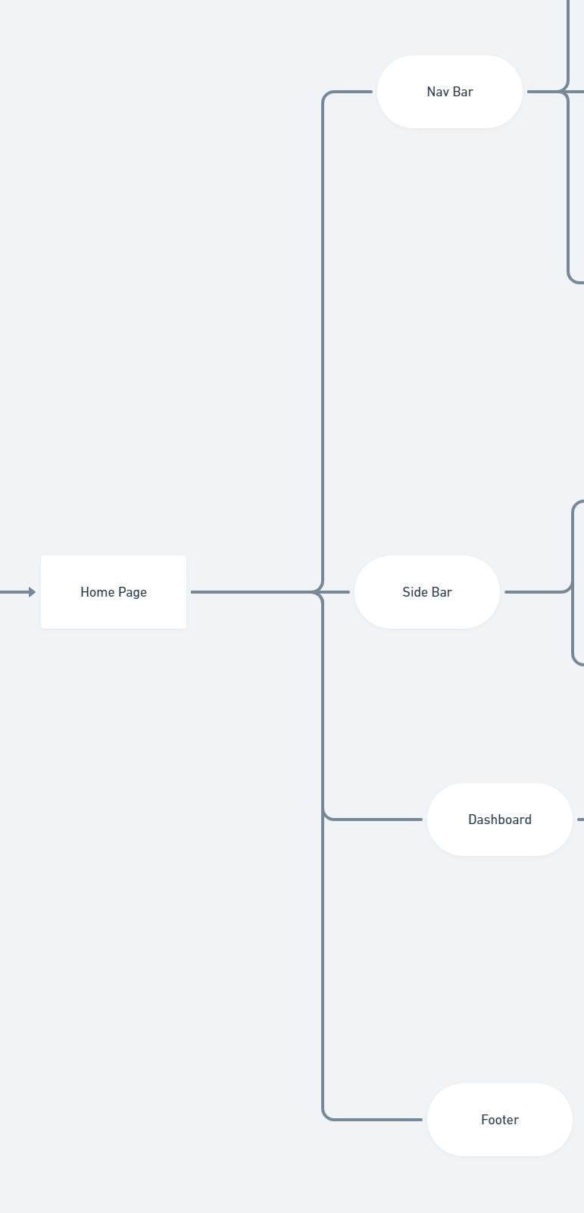

4. SideBar :

Sidebar has mainly two features. One to filter the content appearing on the dashboard and other to search the content and search results will be shown in the dashboard.

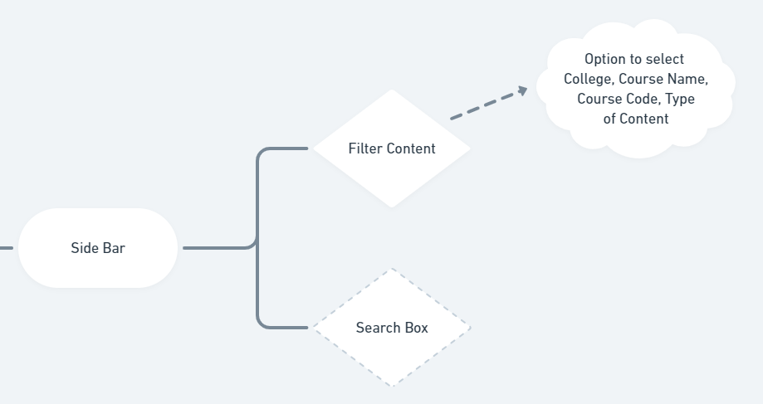

5. Navbar and Upload Content:

Navbar will have links to two parts, Profile and Upload content part. Upload content component will have the option to select type of content, course details like course name, course code.

Extra Part(If the time persists): We will add a leaderboard containing the list of users showing their contributions in the college course material.

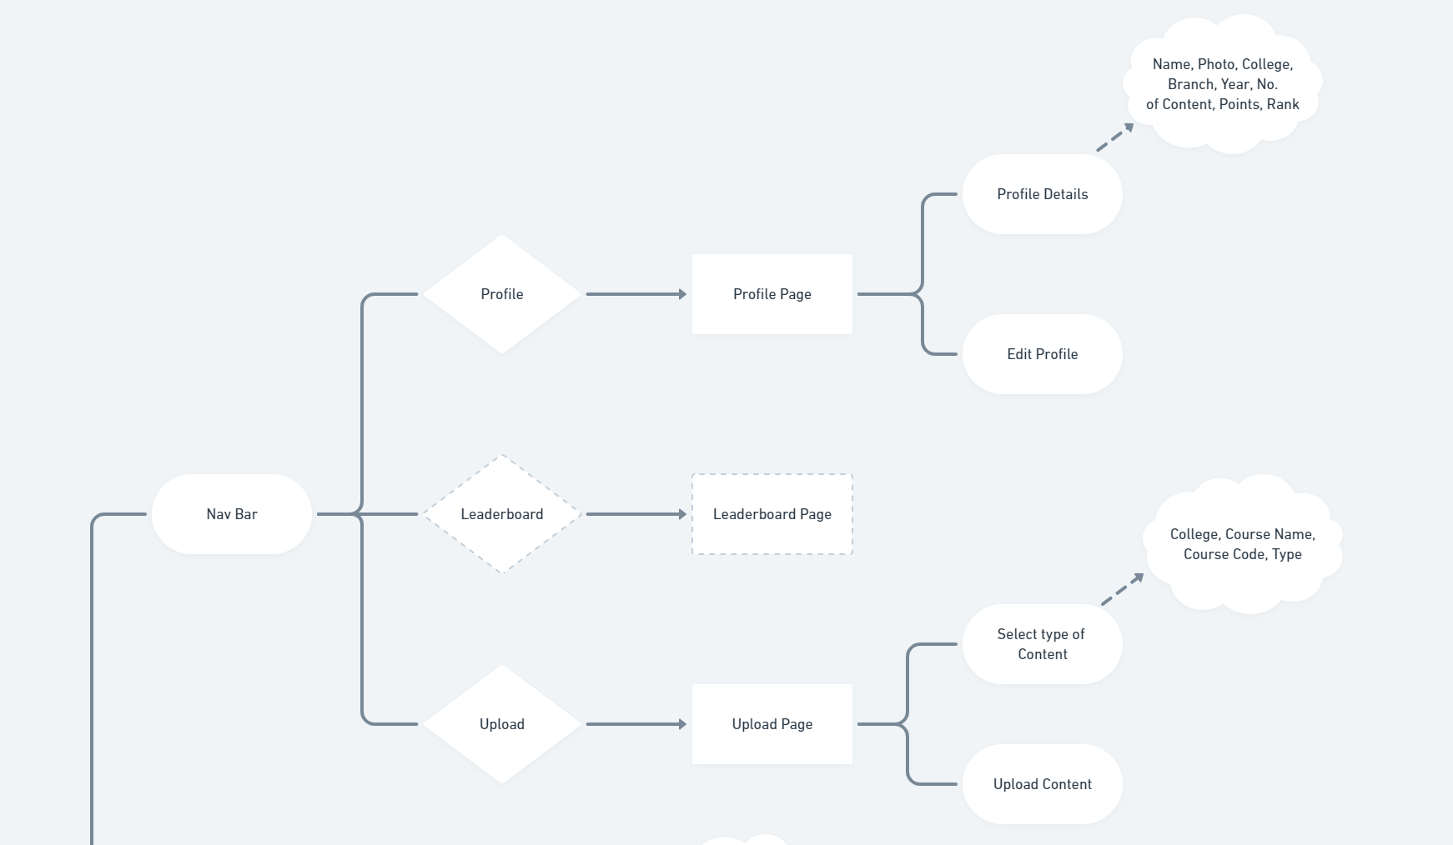

Project Timeline:

Week 1:

* Wireframing and Designing different components.
* Setting up the basic structure of the backend part and defining models.

Week 2:

* Completing the frontend coding part of signup,login dashboard and upload content pages.

Week 3:

* Connecting the backend with the frontend.
* Adding functionality to upload content pages.
* Adding functionality to filter content components.

Week 4:

* Completing the components parts and final touches to the project.