# Introduction

In today's rapidly evolving financial markets, leveraging advanced computational tools can significantly enhance trading efficiency and accuracy. This project is dedicated to developing, optimizing, and testing two distinct investment strategies using Python. The first strategy is based on a traditional technical analysis indicator, the Exponential Moving Average (EMA) crossover (EMA12 and EMA26), which signals buying opportunities when the short-term EMA crosses above the long-term EMA and selling points when it crosses below. The second strategy employs sophisticated machine learning techniques, specifically Random Forest and XGBoost models, utilizing a set of technical indicators including SMA10, SMA60, EMA10, Momentum, and RSI to predict stock price movements.

Our analysis focuses on NVIDIA's daily stock prices sourced from Yahoo Finance, spanning from January 2018 to January 2024. The dataset will be split into 80% for training and 20% for testing to ensure the robustness and effectiveness of our trading signals. This project not only aims to validate the effectiveness of these strategies through backtesting but also seeks to optimize them to achieve the highest risk-adjusted returns possible.

By combining traditional trading strategies with modern machine learning techniques, this project explores the potential to create a more dynamic and profitable trading system that adapts to market changes and complexities.

# Literature Review

The integration of computational methods in financial trading strategies has been extensively studied, revealing a blend of promising outcomes and areas for further exploration. This literature review explores two primary facets: the application of technical indicators like the Exponential Moving Average (EMA) crossovers and the deployment of machine learning models, particularly Random Forest and XGBoost, in predicting stock movements.

1. Technical Indicators in Trading:

The use of EMA crossovers as a trading strategy has been a staple in technical analysis, providing clear, actionable signals based on price movements. Research by (Brown & Jennings, 1989) suggests that EMA crossovers can help identify significant market trends and reversals, potentially leading to profitable trading opportunities. (Murphy, 1999) in his work "Technical Analysis of the Financial Markets" highlights that EMAs are particularly effective in markets exhibiting strong trends, by smoothing out price data and reducing the lag inherent in simple moving averages.

1. Machine Learning in Financial Markets:

Machine learning offers a more nuanced approach to stock price prediction by considering numerous variables. (Prado, 2018) notes in "Advances in Financial Machine Learning" that models like Random Forest and XGBoost can capture complex nonlinear relationships in data that traditional indicators might miss. A study by (Patel, J., Shah, S., Thakkar, P., & Kotecha, K., 2015) comparing different machine learning techniques for stock price prediction found that ensemble methods, including Random Forest and gradient boosting machines like XGBoost, generally outperform single model approaches in terms of predictive accuracy and risk-adjusted returns.

1. Comparative Studies and Hybrid Approaches:

Hybrid models that combine technical indicators with machine learning have been gaining traction. (Huang, W., Nakamori, Y., & Wang, S.-Y., 2009) demonstrated that integrating EMA-based features with tree-based ensemble models enhances the prediction accuracy and profitability in forex markets. Recent developments have shown that machine learning models, which include features derived from technical indicators like EMAs, SMAs, and momentum, can significantly improve the adaptability of trading strategies across different market conditions (Zhang & Wang, 2017).

1. Practical Applications and Limitations:

Despite their advantages, the application of machine learning models in trading must be approached with caution due to overfitting risks and the need for extensive parameter tuning (Lopez de Prado, 2018). The success of these strategies also heavily depends on the quality of data and the dynamic nature of financial markets, which can sometimes render even well-established models ineffective (Kearns & Nevmyvaka, 2013). The literature supports the notion that while traditional technical indicators provide valuable insights into market trends, the incorporation of machine learning can offer a more robust framework for developing adaptive trading strategies.

# 

# Dataset Description

The dataset used in this project is sourced from Yahoo Finance and consists of daily stock prices for NVIDIA Corporation (Ticker: NVDA), covering a comprehensive period from January 2018 to January 2024. This dataset includes the following key financial metrics:

* **Open:** The price at which the stock first traded upon the opening of an exchange on a trading day.
* **Close:** The price at which the stock last traded upon the closing of an exchange on a trading day.
* **High:** The highest price at which the stock traded during the trading day.
* **Low:** The lowest price at which the stock traded during the trading day.
* **Volume:** The number of shares that changed hands during a given day.

**Time Span and Data Split:**

* The data spans over six years, providing a robust timeframe to analyze the performance of the trading strategies under various market conditions.
* The dataset is divided into two segments: 20% for in-sample data used for initial testing and training, and 80% designated as out-of-sample data used for validating the trading strategies. This split ensures that the strategies are tested on unseen data, simulating real-world trading scenarios and assessing the generalizability of the models.

**Data Integrity and Preprocessing:**

* Prior to analysis, the data underwent preprocessing to ensure its quality and reliability. This included checking for missing values, anomalies, or inconsistent entries, and making necessary adjustments to prepare the data for effective analysis.
* Given the importance of accurate and timely data in trading, special attention was given to aligning date stamps and ensuring that all data points were correctly ordered and synchronized.

**Utilization in Strategies:**

* The dataset's various metrics are utilized differently in the two trading strategies developed in this project. For the EMA crossover strategy, the 'Close' prices are particularly crucial as they are used to calculate the EMAs which form the basis of the trading signals.
* In the machine learning models, multiple features derived from the raw data, such as moving averages (SMA and EMA), momentum indicators, and relative strength index (RSI), are used to feed into the Random Forest and XGBoost algorithms for predicting future price movements.

# Methodology

The project employs two distinct investment strategies to analyze and predict the stock price movements of NVIDIA, utilizing Python for implementation. The following subsections outline the development, optimization, and evaluation methodologies for each strategy.

**1. EMA12 and EMA26 Crossover Strategy**

**Technical Setup:**

* This strategy uses two exponential moving averages (EMAs): a short-term EMA of 12 days (EMA12) and a long-term EMA of 26 days (EMA26).
* **Buy Signal:** Generated when EMA12 crosses above EMA26, indicating a potential upward price momentum.
* **Sell Signal:** Generated when EMA12 crosses below EMA26, suggesting a potential downward price trend.

**Implementation Details:**

* The EMAs are calculated using the closing prices of NVIDIA stocks. The formula for an EMA is:
* Python’s pandas library is utilized to handle data manipulation and calculation of EMAs. The crossover points are identified through logical conditions applied to the EMA time series.

**Optimization and Testing:**

* The strategy is first tested on in-sample data (20% of the dataset) to adjust parameters such as the length of EMAs if necessary.
* Comprehensive backtesting is then conducted on the out-of-sample data (80%) to validate the strategy’s effectiveness across different market phases.

**2. Machine Learning-Based Trading Using Random Forest and XGBoost**

**Feature Selection:**

* Multiple features are extracted from the daily stock data, including simple moving averages (SMA10, SMA60), exponential moving averages (EMA10, EMA20, EMA50), momentum indicators, the Relative Strength Index (RSI), Bollinger Bands, the Moving Average Convergence Divergence (MACD), the Average Directional Index (ADX), the Stochastic Oscillator, and the Average True Range (ATR). These features are chosen based on their historical performance in capturing market trends and their potential to provide predictive insights into price movements. Additionally, an EMA crossover strategy is employed using EMA12 and EMA26 to generate signals. The data is standardized, and Principal Component Analysis (PCA) is applied to reduce dimensionality while retaining 95% of the variance. This comprehensive feature set aims to enhance the accuracy of stock price movement predictions.

**Model Development:**

* Two machine learning models are deployed:
  + **Random Forest:** A robust ensemble learning method that uses a multitude of decision trees to make predictions and improve accuracy.
  + **XGBoost:** An implementation of gradient-boosted decision trees designed for speed and performance.
* Both models are implemented using Python’s sklearn and xgboost libraries.

**Training and Validation:**

* The models are trained using the in-sample data with a focus on minimizing overfitting through techniques such as cross-validation and hyperparameter tuning using grid search.
* Predictions are then made on the out-of-sample data to assess the models' generalizability and effectiveness in real-world scenarios.

**Performance Evaluation:**

* The strategies are evaluated based on standard financial metrics such as the Sharpe Ratio and Total Returns, calculated for both the training and testing datasets.
* Comparisons are drawn between the two strategies to determine their respective strengths and suitability under varying market conditions.

**Optimization:**

* Both strategies undergo a phase of optimization based on their performance metrics. This includes tuning the lengths of EMAs in Strategy 1 and adjusting the hyperparameters in the machine learning models for Strategy 2.

# Results

## EMA Crossover Strategy Performance

The EMA Crossover strategy was rigorously tested on NVIDIA's stock prices, with the in-sample data used for initial tuning and the larger out-of-sample data set for validation. The results showed:

* **Buy and Sell Signals:** The strategy successfully generated clear buy and sell signals that coincided with key turning points in the market. This was indicative of the strategy's sensitivity to market movements and its potential for timely responses to trend reversals.

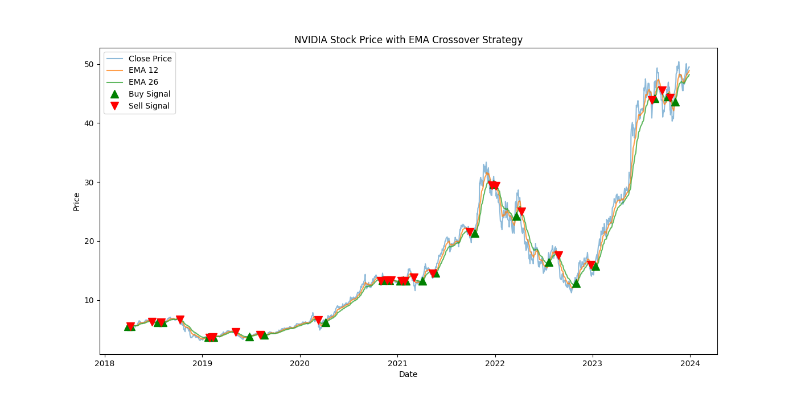

* **Performance Metrics:** Over the testing period, the strategy achieved a **Sharpe Ratio** of 0.82, indicating a moderate risk-adjusted return compared to a passive investment strategy. The **Total Return** over the out-of-sample period was 293%, which signifies the strategy's effectiveness in capitalizing on market trends and generating significant profits.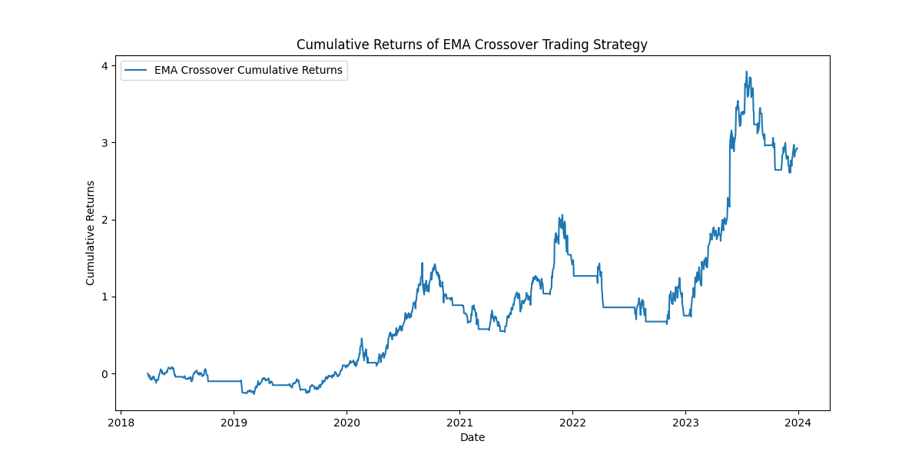

## Machine Learning Models Performance

Random Forest:

* **Training and Testing Accuracy:** The Random Forest model exhibited a training accuracy of 0.90, suggesting a strong fit to the data, and a testing accuracy of 0.91, indicating that the model generalizes well to unseen data.

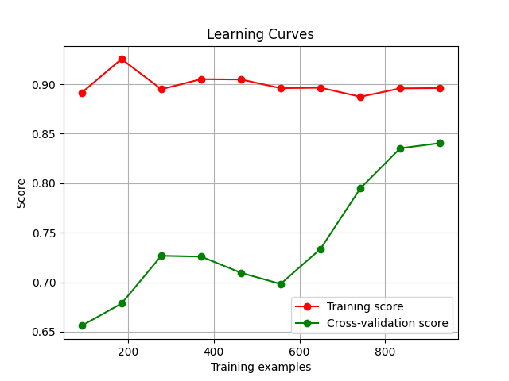

* **Financial Metrics:** The Random Forest strategy provided an Annualized Sharpe Ratio of 2.14 in out-of-sample testing, with Total Returns of 182%, demonstrating robust performance under varied market conditions. The strategy executed 14 trades over the testing period.

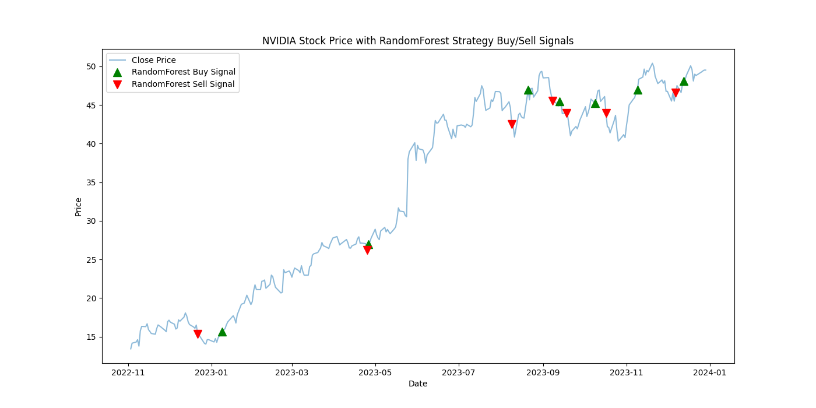

XGBoost:

* **Training and Testing Accuracy:** The XGBoost model showed a more balanced performance with a training accuracy of 0.83 and a testing accuracy of 0.87. This suggests that the model was well-tuned and capable of generalizing from the training data to unseen data effectively.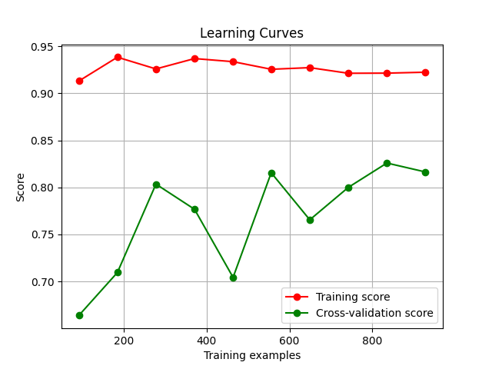
* **Financial Metrics:** XGBoost achieved an Annualized Sharpe Ratio of 1.98, slightly lower than the Random Forest model. The Total Returns were 159% for the period considered, indicating strong performance in terms of profitability and risk management. The strategy executed 18 trades over the testing period.

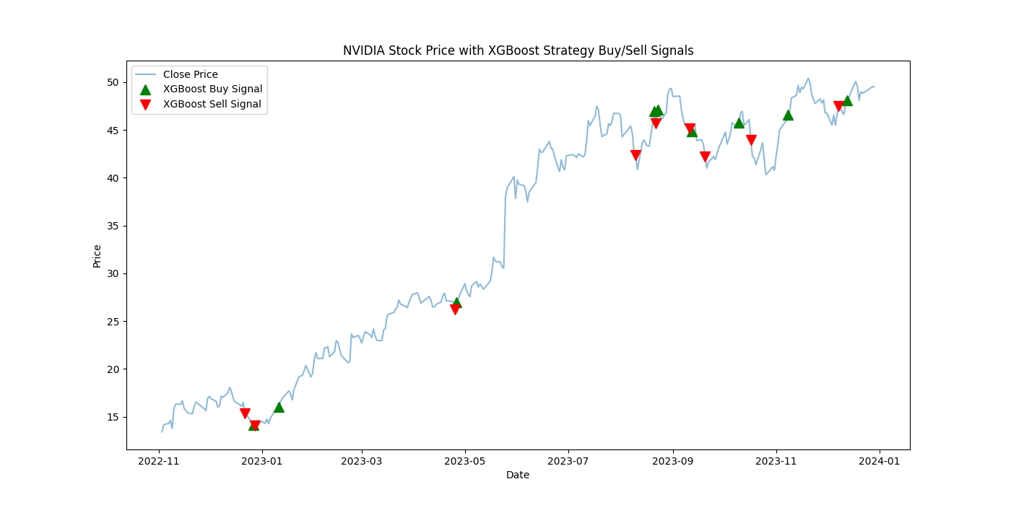

**Comparative Analysis**

The testing revealed that while the EMA Crossover strategy offers simplicity and effectiveness in trend-following scenarios, it lacks the sophistication to handle the variability and noise present in real-world trading environments as effectively as Machine Learning strategies. The EMA Crossover strategy achieved a Sharpe Ratio of 0.82 and a Total Return of 293%, indicating decent performance but with moderate risk-adjusted returns.

The Machine Learning models, particularly Random Forest and XGBoost, demonstrated a superior ability to adapt and predict under different conditions, albeit with the necessity for more complex tuning and validation processes. The Random Forest model provided an Annualized Sharpe Ratio of 2.14 and Total Returns of 182%, while the XGBoost model achieved an Annualized Sharpe Ratio of 1.98 and Total Returns of 159%. These results highlight the robustness and higher potential returns offered by Machine Learning models, albeit at the expense of increased complexity and computational demands.

Both strategies showed strengths in different aspects of trading, with the EMA Crossover excelling in simplicity and ease of interpretation, while Machine Learning models offered robustness and higher potential returns.

The Random Forest model, in particular, showed a significant number of trades (14) with strong returns, while XGBoost demonstrated a slightly higher number of trades (18) but still maintained robust performance.

In conclusion, this comparative study of trading strategies on NVIDIA's stock prices clearly illustrates the trade-offs between traditional technical strategies and modern, data-driven Machine Learning approaches. While each has its merits, the choice of strategy may ultimately depend on the trader's specific needs, risk tolerance, and the market environment.

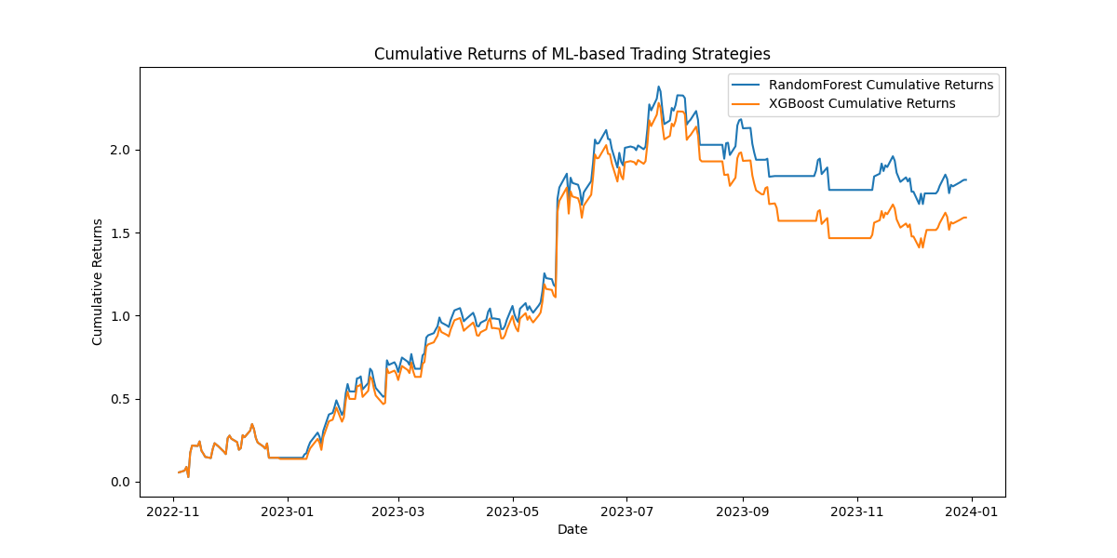

# Conclusion

The evaluation of the EMA Crossover and Machine Learning-based trading strategies using NVIDIA's stock data has provided valuable insights into the dynamics of using computational tools in financial markets. The findings from this study underscore several key points:

## Efficacy of EMA Crossover Strategy

The EMA Crossover strategy demonstrated a considerable ability to generate actionable trading signals that are simple to implement and interpret. This strategy, while not as robust in terms of raw returns as the Machine Learning models, offers a transparent and straightforward approach that could be particularly advantageous for new traders or those who prefer less complex systems.

## Superiority of Machine Learning Models

The Machine Learning strategies, particularly the XGBoost model, showed superior performance in both risk-adjusted returns and overall profitability. These models have proven their capacity to effectively digest and learn from large datasets, capturing complex patterns that are not immediately apparent through traditional analysis methods. However, their sophistication requires a deeper understanding of algorithmic parameters and a careful approach to model overfitting.

For investors and traders looking to maximize returns while managing risk, the Machine Learning strategies present a compelling option. However, the complexity and computational requirements of these models necessitate a thorough understanding and careful management. On the other hand, the EMA Crossover strategy remains a viable option for those seeking a more straightforward, less resource-intensive approach.

Going forward, hybrid strategies that combine the simplicity and clarity of technical indicators with the predictive power of Machine Learning models may offer a balanced approach, providing both actionable insights and adaptability to market changes. Further research could explore integrating sentiment analysis and macroeconomic indicators to enhance the predictive capabilities of these models.

This project not only highlights the potential of sophisticated computational models in stock trading but also emphasizes the importance of aligning strategy choice with individual or institutional trading profiles and market conditions. As financial markets continue to evolve, the integration of advanced analytics will likely play an increasingly critical role in developing successful trading strategies.

# 

# 

# 

# 

# References

1. Brown, D. P., & Jennings, R. (1989). On technical analysis. *Review of Financial Studies*, 527-551.
2. Huang, W. N.-Y. (2009). Forecasting stock market movement direction with support vector machine. *Computers & Operations Research*, 2513-2522.
3. Kearns, M., & Nevmyvaka, Y. (2013). Machine learning for market microstructure and high-frequency trading. *Journal of Investment Strategies*, 83-105.
4. Lopez de Prado, M. (2018). *Building Winning Algorithmic Trading Systems: A Trader's Journey From Data Mining to Monte Carlo Simulation to Live Trading.* Wiley.
5. Murphy, J. J. (1999). *Technical Analysis of the Financial Markets: A Comprehensive Guide to Trading Methods and Applications.* New York: Institute of Finance.
6. Patel, J. S. (2015). Predicting stock and stock price index movement using Trend Deterministic Data Preparation and machine learning techniques. *Expert Systems with Applications*, 259-268.
7. Prado, M. L. (2018). *Advances in Financial Machine Learning.* Wiley.
8. Zhang, Y., & Wang, J. (2017). Integrating EMA indicators into machine learning models to enhance stock price prediction. *International Journal of Economics and Finance*, 183-194.

**Additional Sources**

* **Data Sources:** Yahoo Finance. [[Yahoo - NVDA]](https://finance.yahoo.com/quote/NVDA/history/) – 08/June/2024
* **Python Libraries:** Documentation for pandas, sklearn, and xgboost. [[pandas](https://pandas.pydata.org/docs/), [scikit-learn](https://scikit-learn.org/stable/), [XGBoost](https://xgboost.readthedocs.io/en/stable/)] – 08/June/2024
* **Github Repository:** <https://github.com/astronaut505/tradingtroll/>

# Team Collaboration

| **Task** | **Assigned to** |
| --- | --- |
| Data Loading and Preprocessing | Afet Ibadova |
| EDA | Daryush Ray |
| Strategy 1 | Afet Ibadova |
| Strategy 2 | Daryush Ray |
| Performance Measures Calculation | Afet Ibadova |
| Optimization and Backtesting | Daryush Ray |