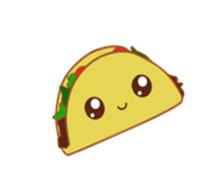

**Let’s Taco ‘Bout It**

By: Cutie Foodies

*Isabell Evans, Katrina Kerrick, Mary La Dine, Catherine Ling, Jerry Qiu*

**Table of Contents**

|  |  |
| --- | --- |
| OVERVIEW | 3 |
| BACKROUND | 3 |
| TARGET AUDIENCE | 4 |
| GAMEPLAY AND CONTENT | 5 |
| DESIGN DECISION | 7 |
| LERNING OBJECTIVES | 9 |
| ASSET BREAKDOWN | 9 |
| MOVING FORWARD | 10 |

**OVERVIEW**

Surveys find that a huge portion of people lack basic nutrition information and there is a need to know more about the nutrients and the calories. Let’s Taco ‘Bout It is a quiz game with colorful content that enables people to answer questions related to different kinds of food. It also enables people to make healthier decisions about the foods they eat. The targeted audience of this game is young adults who would be interested in learning more about the nutrition in their food. The gameplay consists of simple quiz questions which ask the player to identify a trait about a specific type of food or to select which food better fills the criteria listed.

**BACKGROUND**

**Surveys find that people lack basic nutrition information.**

Research from the Physicians Committee for Responsible Medicine shows that people know less about food nutrition than they might think. Only seven percent of individuals in this study living in households with children between the ages 13 and 17 knew that skim milk and Coca-Cola contain approximately the same number of calories.[1] Families who lack this type of nutritional knowledge are more likely to eat unhealthy meals because they may not realize that the meal is unbalanced.

|  |  |  |
| --- | --- | --- |
| **Nutrients** | **% of participant who answered correctly (n=1015)** | **Facts** |
| Fat | 18% | 70% of the calories in cheese come from fat. |
| Calcium | 22% | beans, broccoli, and milk are high in calcium |
| Fiber | 36% | fish = beef  there is no fiber in animal products |

**People do not know how many calories are in the food they consume.**

People are not only misinformed about the nutrients in their food, they are often incorrect when estimating how many calories they consume. The error in people’s calorie estimates grows proportionally with the number of calories present in the food. For example, people tend to estimate that cheese fries with ranch dressing has a just under 1000 calories, while it actually contains approximately 3000 calories.[2] These errors in estimation cause people to consume more calories per day than intended.

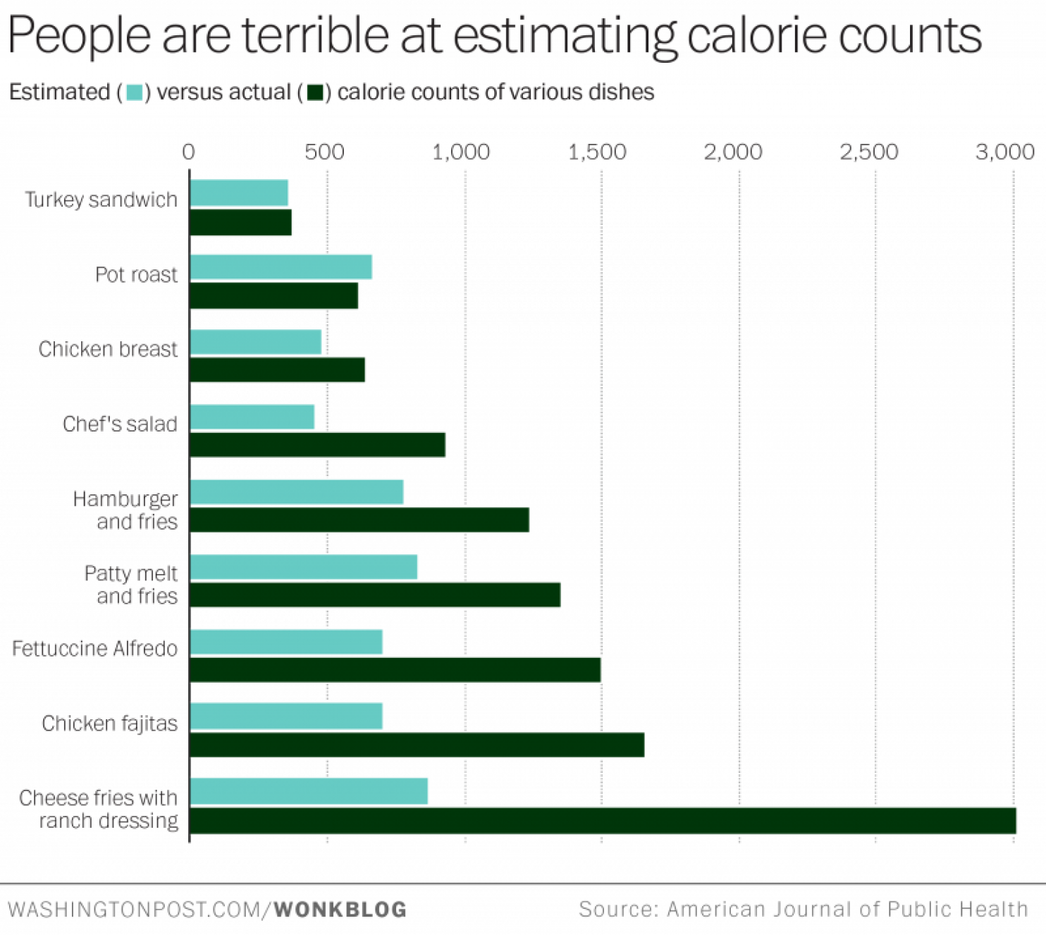

**People want to know different nutrient information about their food.**

Although only half of Americans are interested in exercising, 94% of Americans want to eat healthy and balanced meals.[3] Current online resources and mobile apps are focused on a combination of exercise and calorie control.

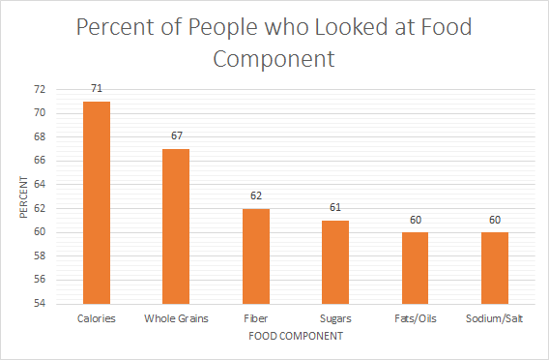

**People use mobile apps to eat healthier.**

Nearly 6 out of 10 Americans believe that online and mobile tools can help them live healthful lifestyles. People want to have more interactive ways to get healthful information. Let’s Taco ‘Bout It is designed to target this huge potential player group.

**LEARNING OBJECTIVES**

**The trivia model reinforces retention of food facts**

Let’s Taco ‘Bout It focuses on teaching you facts about food. By gradually exploring new rounds of food trivia, you will learn about the necessary nutrients to eat in order to stay healthy. After you answer questions, pop-ups will appear to give additional fun facts about the food that you saw. Each round of the game consists of five questions, and after you have completed all five, you will be presented with your score and the ability to share it. After you complete enough questions of that difficulty, the questions start to get harder. The game’s trivia consists of three modes, each described in detail below.

- Enable you to learn more about the nutrients in their food. This objective is accomplished by asking you to answer questions about food in both the food facts mode and the food comparison mode.

- Encourage you to lead healthier lifestyles. This objective is accomplished through Let’s Taco ‘Bout It’s educational tips. These tips include sayings like “eating bananas can relieve stress”.

- Promote conscious snacking habits. This objective is accomplished by informing players what nutrients are in the food they eat and providing them ideas for alternative snacks.

- Help people think about nutrition in a holistic way. This objective is met through the broad range of nutritional questions.

**TARGET AUDIENCE**

**A variety of nutrition facts serves the needs for potential players. (?)**

People’s motives for the nutrition information vary. Some people want to know more about the calories contained in food in order to keep track of the calories and lose weight. Some people are more interested in knowing about the protein content in food in order to gain muscle. Others may be cautious about different kinds of Vitamin for health reasons. This leads to a need for a variety of questions about a multitude of nutrition facts which the app provides.

**College students care about nutrition and leading healthy lifestyles.**

Rose Polly is a 20-year-old college student (Figure 1). She leads a very active lifestyle. She likes taking walks with her dog and is on the lacrosse team. Eating energy rich, high protein snacks is very important to her. Because she is a college student, there is always the temptation to grab whatever quick and unhealthy snack is available. She would like to make more informed, healthier decisions without putting in too much effort. She is currently pursuing an Environmental Engineering Minor which causes her to be more conscientious about her health and consuming healthy foods. Rose is slightly allergic to bananas so she does not want suggestions that include them. She does not know much about food and the repercussions it has on her body. She has encountered setbacks in the past which have prevented her from achieving her goal of eating healthier. In prior years, she hasn’t wanted to taco ‘bout it, but recently she has realized how important food is to her energy levels and well-being so she has started wanting to taco ‘bout it.

Rose uses Let’s Taco ‘Bout It to help her understand what she is eating. When she snacks she tends to gravitate towards chips and she wants to explore what alternative snacks are out there. She wants to use the food facts section to help her understand how many calories she is consuming when she just grabs a pudding from the fridge. She would also use the food facts game to learn what food items would give her more protein or energy as she plays sports.

**Here is an example of when Rose might use Let’s Taco ’Bout It**

Rose got out of one of her classes on Monday 10 minutes early. As she sat outside of her next class she pulled out her phone looking for something to pass the time. She opened up the Let’s Taco ‘Bout It app and started playing the food comparison game. She first selected the dietary restrictions button and noted that she was allergic to bananas ensuring that she would not be given information about bananas as she played the game. She also took the Eating Habits quiz stating that she loves snack foods and is interested in snacks like chips, pudding, and apples. As she went through the different questions she was surprised to learn that popcorn has fewer calories than chips. She found this interesting and then continued playing the game and using other features of the app, until the bell rang.

She finally got out of classes after a long day and prepared herself for another long night of studying. She made it through to dinner and went to the school cafeteria to eat. When she got there she was craving Macaroni and Cheese. She remembered that she had found out that Macaroni and Cheese has a lot more calories than she had realized earlier when she was playing Let’s Taco ‘Bout It. She decided to get a smaller portion than she had originally intended and filled the rest of her plate with a salad.

Later that night, Rose was still busy studying at 1:00 am. She was craving a snack to keep her going. Usually, she would just reach for a bag of potato chips or two without thinking. But tonight was different; she stopped herself before chipping. She decided to eat a bag of popcorn instead. She was so proud of herself and was motivated and ready to do homework and study for the next 3 hours.

**GAMEPLAY AND CONTENT**

Let’s Taco ‘Bout It enables players to build healthier options instead of the snacks they would normally eat. The direct comparison of foods is designed to open their eyes to new food alternatives and helps them expand the types of foods they are consuming. The quiz questions asking players to identify specific traits about food enables them to learn new information about the foods they consume. This new knowledge the players gain will help them to think daily about what they are consuming and will encourage them to have self-restraint.

**“Food Comparison” mode allows you to compare two foods.**

In Food Comparison, players are shown five questions that each have two possible food choices shown. Players are then asked questions such as “Which has less protein?”, which contains information about types of nutrients in food. You can then select the name of the food you think is correct. If you guess correctly, the text box becomes green and a new question pops up. If you guess incorrectly, the text box becomes red and you get another chance, although you won’t earn any points for the question. Once you answer all five questions, your score is displayed out of five, showing how many questions you got right on the first try.

**“Food Facts” mode allows you to play a game to learn more about food**

In Food Facts, you are shown five questions; each has a picture of a snack. The player is then asked a question such as “How much protein is in this quarter pound hamburger?”. This category contains questions about types of nutrients in food. Three options appear at the bottom and you select which you think best describes the criteria. If you guess incorrectly, the text box becomes red and you get another chance, although you won’t earn any points for the question. You may continue guessing until you select the correct answer. Once you answer all five questions, your score is displayed out of five, showing how many questions you got right on the first try.

**“Go Random!” enables you to experience a mixture of questions**

In this game mode, you experience a mix of Food Comparison questions and Food Facts questions. Each question is randomly chosen to be a Food Comparison or Food Facts question and functions according to the rules of each. At the end of the five question round, the score is displayed out of five, with options to share and replay shown.

**Dietary Restriction Settings**

On the game selection page, there is a dietary restrictions button that allows you to customize what type of questions you see. If you have one or more food allergies or intolerances, this setting feature will allow you to enter these and avoid seeing questions or tips about these food types. For example, if you indicated that you were allergic to bananas, you would not receive any questions or tips mentioning bananas. This type of restriction also works for special diets including vegetarian, vegan, gluten free, and dairy free. Once you have finished entering you restrictions, you will be redirected back to the game selection page.

**Let’s Taco ‘Bout It includes questions about the following nutrients**

|  |  |
| --- | --- |
| **NUTRIENT** | **IMPORTANCE** |
| Calcium | Present in dairy products and leafy greens |
| Vitamin A | Sweet potatoes, carrots, dark leafy greens |
| Vitimin C | Citrus fruits |
| Fiber | Grains, especially wheat and corn |
| Calorie content | Every food |
| Protein content | Meat and beans |
| Potassium | Yogurt, fish, bananas |

**A Database will contain many trivia questions**

|  |  |  |
| --- | --- | --- |
|  |  |  |

Players will be able to access a multitude of questions from a database which will contain both styles of questions from each nutrition category. Below are a sample of questions.

**ASSET BREAKDOWN**

**On-screen features include navigation buttons, button answers to trivia, and fun facts**

- Action Buttons allow the player to be able to select answers.

- Back Buttons allow the player to go back to the home page.

- Game mode buttons allow the player to select which game mode they would like to experience.

- Answer selection buttons allow the player to select the answer to the question.

- Colored Feedback on question results lets players easily identify if they have gotten the question correct or incorrect.

**DESIGN DECISIONS**

**Potential players are attracted by our concept art and theme**

Let’s Taco ‘Bout It had an identity crisis in the middle of production. The original app was called Cutie Foodies and featured a lime green background and a sparkly, smiling orange named Ollie as its mascot (Figure 5). The combination of the name, color, and mascot, unintentionally targeted our app towards a female audience. This limited our potential players unnecessarily. The feedback we received from our reviewers indicated that males also have the desire to learn nutrition information, which our app was overlooking. We decided to do a makeover of our app which included expanding the types of questions we asked, changing the name of the app, designing an alternate color scheme, and selecting a new mascot. Now the app is designed to appeal to a broader range of players. The new name of our game, Let’s Taco ‘Bout It, is energetic and helps create the fun atmosphere our app strives to produce, especially with the help of our encouraging and delightful Tally the Talking Taco.

**Varying questions based on different nutrients better serves our player**

Our original questions about calorie and protein content have been expanded to encompass nutrition information more holistically in order to better serve our players. People don’t just want to learn about one aspect of nutrition, they want to learn about nutrition in a more holistic manner. This leads us to change from games based on category of question to games based on the style of question asked. These styles include questions about many different types of nutrition. This way of designing our games differentiates Let’s Taco ‘Bout it from many other fitness apps which focus exclusively on calorie counting and water consumption. This diversity of questions will help players to feel less stress when navigating the world of healthy eating.

|  |  |
| --- | --- |
|  |  |

**Tally the talking Taco appears on every screen to make the game more lively**

Questions will be chosen randomly from the table corresponding to the player’s level in a pre-made database of questions, then served to the player one at a time.

|  |  |  |  |  |  |
| --- | --- | --- | --- | --- | --- |
| **Participant** | **Age** | **Gender** | **Wish to eat healthier?** | **Track Calories?** | **Commonly eat snacks** |
| A | 20 | Female | yes | no | Granola bar, fruit snacks, yogurt |
| B | 22 | Female | yes | no | Sandwich, fruit snacks |
| C | 20 | Male | yes | a little | chips, beef jerky |
| D | 21 | Female | yes | Not so often, read calorie signs | Brownie, cookie and chocolate |
| E | 21 | Female | yes | Not particularly | Cheese rips, yogurt, granola bar |

**MOVING FORWARD**

As Let’s Taco ‘Bout it grows and develops, here are some features to look forward to.

**Question Categories:** We will create categories of questions based on specific health needs (i.e. protein category, dessert category, or low carb category). This will allow players to learn more about items for their main interests or health needs. If someone is a vegetarian and was told that they need to eat more iron, they will be able to look up a section for questions about the iron content in food in order to be guided to better health decisions.

**Eating Habits Quiz:** When a player registers in the app, there will be a quiz that they will take in order to gauge their eating habits. The quiz will ask questions about if the player likes to snack and how much, and it will also ask for common foods that they like to eat. This will enable us to show the player questions more specific and unique to their lifestyle which will keep the app relevant.

**Pop-up Educational Tips:** We will include pop-up educational tips to encourage healthy eating. These tips will be player specific again and will provide additional information about food that might not be quantifiable, for example, how a type of food can affect your mood.

**Different Levels**: We will implement a leveling system of difficulty for trivia questions. Easier questions such as “Which has more protein, a pouch of fruit snacks or ¼ cup of cashews?” will be placed in lower levels while more difficult questions like “Which has more protein, 1 cup of chocolate almond milk or 1 cup of chocolate milk?” will be placed in more difficult levels. By adding varying levels of difficulty, we will be able to have the player complete easier decks and then level up as they learn more information about food and its nutritional content. This system also allows younger players enjoy the game as well. We also believe that it will make the game less frustrating with will help to more effectively reinforce healthy eating habits and ideas.

|  |  |  |  |
| --- | --- | --- | --- |
|  | |  |  | | --- | --- | | |  | | --- | | Figure 7. Left: Easy Question. Right: More difficult question | | |

As future upgrades and ideas that enhance the quality of the app are developed, we will release future editions of the app.

[1]"Survey Finds Americans Lack Basic Nutrition Information", *The Physicians Committee*, 2012. [Online]. Available: <http://www.pcrm.org/health/reports/survey-americans-lack-basic-nutrition-info>. [Accessed: 30- Apr- 2016].

[2]J. Block, S. Condon, K. Kleinman, J. Mullen, S. Linakis, S. Rifas-Shiman and M. Gillman, "Consumers' estimation of calorie content at fast food restaurants: cross sectional observational study", BMJ, vol. 346, no. 233, pp. f2907-f2907, 2013.

[3]F. Insight, "2012 Food & Health Survey: Consumer Attitudes toward Food Safety, Nutrition and Health", *FoodInsight.org*, 2012. [Online]. Available: <http://www.foodinsight.org/2012_Food_Health_Survey_Consumer_Attitudes_toward_Food_Safety_Nutrition_and>

_Health. [Accessed: 30- Apr- 2016].