# **1.1** Assumption

The main purpose of this task is to implement a website for a broadcasting company with the service of schedule of programmes, latest news, weather forecasting, contact US and about us. To complete this task we decided to duplicate the design of channel 4 news website. To develop this website at first scrum master describe the product backlog and sprint backlog along with the planning. Then developer will create the burn down chart. After that analyst have to analyse all the possible outcome that can be done. Analyse will describe the user stories based on all the feature that will be developed. Then a use case diagram will created to define user and admin access to the system. A workflow diagram, initial class diagram and an ERD model will be created by the analyst. Then the designer will make some sketches of all the pages and turn those sketches into the wireframe and after that the main website will be design the designer. After finishing the designer design developer will develop the website by develop all the functionality of this website. Lastly the tester will test all the functionality of the website to check there are any error in any functionality and if there are any error developer will resolve those error.

# **1.2** User Stories

## User prospective

1. As a user I could have able to see all the programme schedule from the schedule page of the website. I cloud see the name of the programme the date and time when the programme will be started and the duration of the programme
2. As a user I cloud have view all the latest news publish by the news site. All types of latest news can be seen.
3. As a user I could have seen the weather forecast from the weather page of the website.
4. As a user I could have able to enquire and submit complains of any problem I face using the website from the contact us page of the website.
5. As a user I want to see every detail of the website from the about us page of the website.

## **Admin prospective**

1. As an admin I want to publish all the latest news in the latest news page. Where all the latest news of all sector will be published.
2. As an admin I could manage the programme schedule. I want to post all the programme according the name, time, date and duration of the programme.
3. As an admin I want to see user complain. All the user complain that user will give in the contact us page I want see those all.

**1.3** Use case

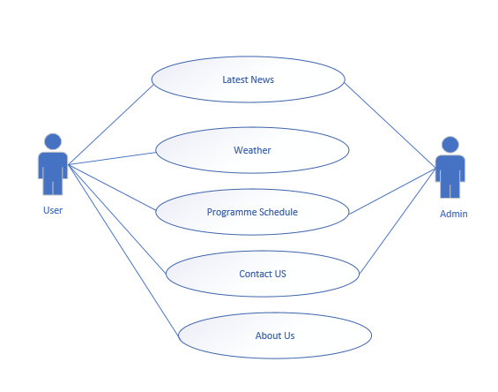

Figure Use case diagram

# **1.4** Workflow

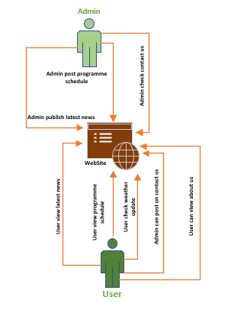

Figure Workflow diagram

# 1.5 Initial Class Diagram

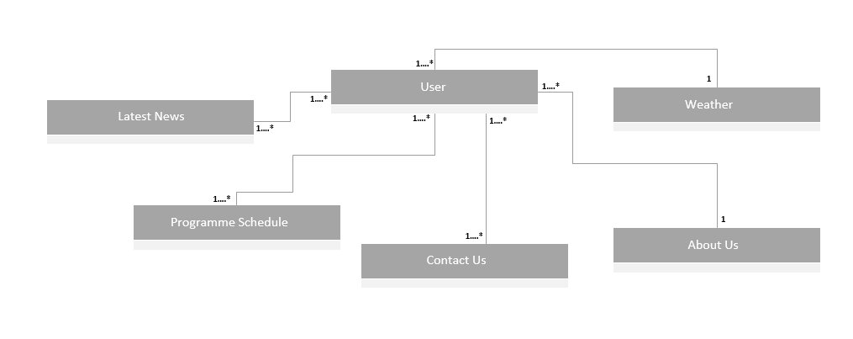

Figure Initial Class diagram

# 1.6 ERD

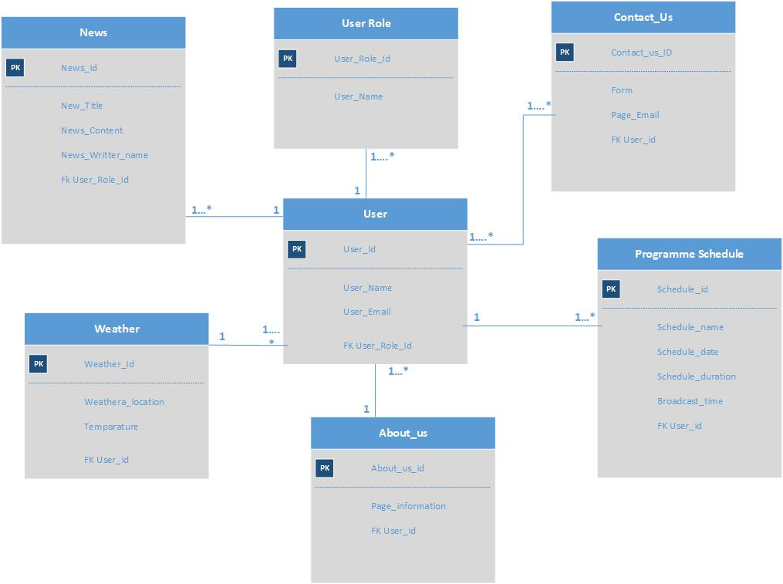

Figure ERD