Country Code | Student Code

PROBLEM

Figure 1 shows a part of the southern sky chart for August 21, 2008 at 07.00 p.m. local time. Unfortunately, a number of bright stars in Capricorn and Scorpio constellations are missing. Now, you have to find those missing bright stars in both constellations by looking at the sky directly. To help you remember, the common names of many bright stars are listed in Table 1. Draw small circles on the locations of the missing bright stars in the Capricorn and Scorpio constellations (Point: 60) and identify them by putting the numbers on the sky chart, as many as possible based on the Table 1 (Point: 60). Afterwards, draw on the sky chart, the border of Scorpio constellation (Point: 15) and Capricorn constellation (Point: 15).

Table 1: The number and common name of bright stars

Number | Common Names | Number | Common Names
1 | Rukbat (α Sgr) | 18 | Albali (ε Aqr)
2 | Graffias (β Sco) | 19 | Altair (α Aql)
3 | Nunki (σ Sgr) | 20 | Shaula (λ Sco)
4 | Deneb (α Cyg) | 21 | Vrischika (π Sco)
5 | Zaniah (η Vir) | 22 | Arich (γ Vir)
6 | Tarazed (γ Aql) | 23 | Deneb Algedi (δ Cap)
7 | Dabih (β Cap) | 24 | Heze (ζ Vir)
8 | Girtab (κ Sco) | 25 | Nusakan (β CrB)
9 | Spica (α Vir) | 26 | Wei (ε Sco)
10 | Sabik (η Oph) | 27 | Syrma (ι Vir)
11 | Dschubba (δ Sco) | 28 | Nashira (γ Cap)
12 | Kaus Australis (ε Sgr) | 29 | Lesath (υ Sco)
13 | Algiedi (α Cap) | 30 | Zavijava (β Vir)
14 | Sadr (γ Cyg) | 31 | Arcturus (α Boo)
15 | Vindemiatrix (ε Vir) | 32 | Megrez (δ UMa)
16 | Antares (α Sco) | 33 | Chara (β CVn)
17 | Yen (ζ Cap) | 34 | Sargas (θ Sco)

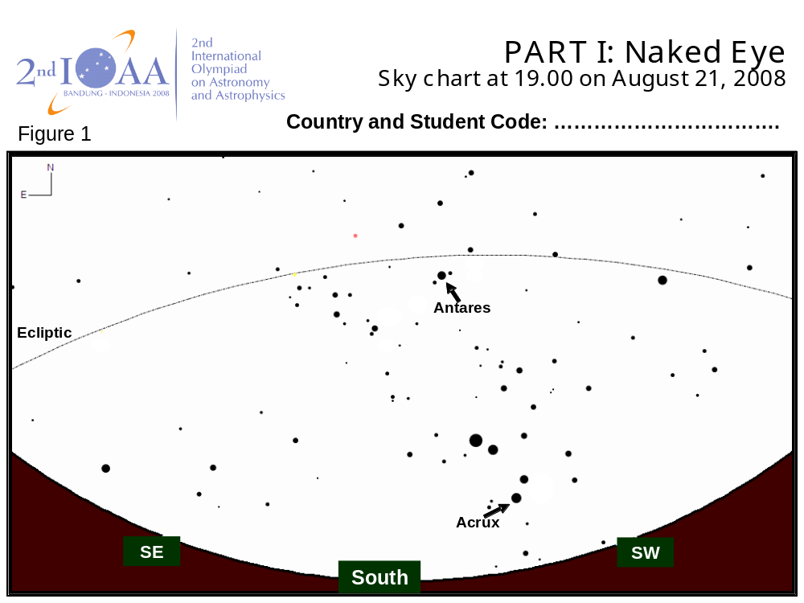
Figure 1

