THEORETICAL PART 2

(300 points for 3 Theoretical Part-2, 100 points for each question)
Show your method of solution step by step in the answer sheets completely as your final answer. The scratch sheet is to be used for your personal calculation and will not be marked. Partial credits will be given for answers without showing method of solution.

- An eclipsing binary star system has a period of 30 days. The light curve in the figure below shows that the secondary star eclipses the primary star (from point A to point D) in 8 hours (measured from the time of first contact to final contact), whereas from point B to point C, the total eclipse period is 1 hour and 18 minutes. The spectral analysis yields the maximum radial velocity of the primary star to be 30 km/s and of the secondary star to be 40 km/s. If we assume that the orbits are circular and has an inclination of i = 90º, determine the radii and the masses of both stars in unit of solar radius and solar mass.

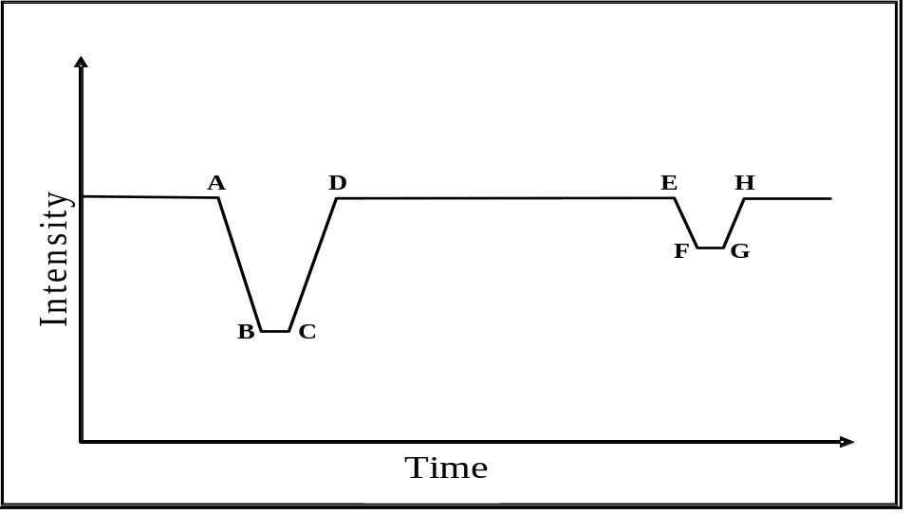

- A UBV photometric (UBV Johnson’s) observation of a star gives U = 8.15, B = 8.50, and V = 8.14. Based on the spectral class, one gets the intrinsic color (U – B)_{o} = -0.45. If the star is known to have radius of 2.3 R, absolute bolometric magnitude of -0.25, and bolometric correction (BC) of -0.15, determine:
a. the intrinsic magnitudes U, B, and V of the star (take, for the typical interstellar matters, the ratio of total to selective extinction (color excess) R_{V} = 3.2),
b. the effective temperature of the star,
c. the distance to the star in pc.
Note: The relation between color excess of U - B and of B – V is E(U – B) = 0.72 E(B – V).
Let A_{v} be the interstellar extinction and R = 3.2, then A_{v} = 3.2 E(B-V).

- Measurement of the cosmic microwave background radiation (CMB) shows that its temperature is practically the same at every point in the sky to a very high degree of accuracy. Let us assume that light emitted at the moment of recombination (T_{r} ≈ 3000 K, t_{r} ≈ 300000 years) is only reaching us now (T_{o} ≈ 3 K, t_{o} ≈1.5 x 10¹⁰ years). Scale factor S is defined as such S₀=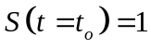 and 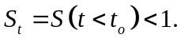 Note that the radiation dominated period was between the time when the inflation stopped (t = 10⁻³² seconds) and the time when the recombination took place, while the matter dominated period started at the recombination time. During the radiation dominated period S is proportional to t^{1/2}, while during the matter dominated period S is proportional to t^{2/3}.
- Estimate the horizon distances when recombination took place. Assume that temperature T is proportional to 1/S, where S is a scale factor of the size of the Universe.
- Note: Horizon distance in degrees is defined as maximum separation between the two points in CMBR imprint such that the points could “see” each other at the time when the CMBR was emitted.
- Consider two points in CMBR imprint which are currently observed at a separation angle α = 5°. Could the two points communicate with each other using photon? (Answer with “YES” or “NO” and give the reason mathematically)
- Estimate the size of our Universe at the end of inflation period.

