 | 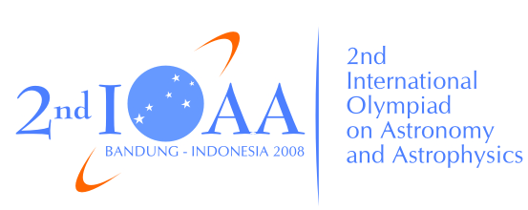 | 

The 2nd International Olympiad on Astronomy and Astrophysics
Bandung, Indonesia
Thursday, August 21, 2008

Practical Competition: Observations

PART II: Using Telescope and CCD

Instructions:

- Part II consists of four steps: distributions of problem sheets in examination room, using telescope and CCD observations on the observing ground (20 minutes), print images and return to the examination room to answer questions (10 minutes). Bell ring will indicate the beginning and the end of each step. Works completed after the allocated time will not be considered.
- All participants will be guided by assistants to go to the observing ground until return to the examination room. Assistants will collect the answer sheets from your table.
- Never forget to fill in the boxes at the top of each answer sheet with your country and your student codes. Otherwise, it will be ignored.

