 | 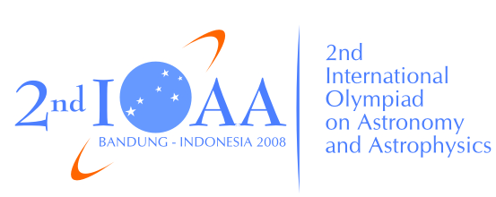 | 

The 2nd International Olympiad on Astronomy and Astrophysics
Bandung, Indonesia
Thursday, August 21, 2008

Practical Competition: Observations

PART I: Naked Eye

Instructions:

- All participants will receive a naked-eye observation problem set, a writing board, a pen, a ruler and a flash light at the examination room.
- Part I consists of three steps: distribution of problem sheets in examination room, naked eye observation on the observing ground (7 minutes), and returning to the examination room to answer questions (8 minutes). Bell ring will indicate the beginning and the end of each step.
- All participants will be guided by assistants to go to the observing ground until return to the examination room. Assistants will collect the answer sheets from your table, after the 8 minute time is up.
- Never forget to fill in the boxes at the top of each answer sheet with your country and your student codes. Otherwise, it will be ignored.

