 | 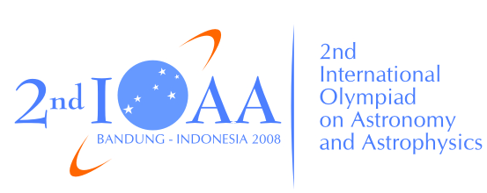 | 

The 2nd International Olympiad on Astronomy and Astrophysics
Bandung, Indonesia
Friday, August 22, 2008

Practical Competition: Observation

Sky Simulator

Instructions:

- All participants will receive a problem set, a writing board, and a pen at the examination room.
- The time available is 15 minutes. Bell ring will indicate the beginning and the end of this session.
- Assistants will collect the answer sheets from your table.
- Never forget to fill in the boxes at the top of each answer sheet with your country and your student codes. Otherwise, it will be ignored.

