4-th IOAA

Short Problem
Note: 10 points for each problem

1) In a binary system, the apparent magnitude of the primary star is 1.0 and that of the secondary star is 2.0
Find the maximum combined magnitude of this system.

2) If the escape velocity from a solar mass object’s surface exceeds the speed of light, what would be its radius ?

3) The observed redshift of a QSO is z = 0.20, estimate its distance. The Hubble constant is 72 km s⁻¹Mpc⁻¹.

4) A binary system is 10 pc away, the largest angular separation between the components is 7.0", the smallest is 1.0". Assume that the orbital period is 100 years, and that the orbital plane is perpendicular to the line of sight. If the semi-major axis of the orbit of one component corresponds to 3.0", that is a₁=3.0", estimate the mass of each component of the binary system, in terms of solar mass.

5) If 0.8% of the initial total solar mass could be transformed into energy during the whole life of the Sun, estimate the maximum possible life time for the Sun. Assume that the solar luminosity remains constant.

6) A spacecraft landed on the surface of a spherical asteroid with negligible rotation, whose diameter is
2.2 km, and its average density is 2.2 g/cm³. Can the astronaut complete a circle along the equator of the asteroid on foot within 2.2 hours? Write your answer "YES" or "NO" on the answer sheet and explain why with formulae and numbers.

7) We are interested in finding habitable exoplanets. One way to achieve this is through the dimming of the star, when the exoplanet transits across the stellar disk and blocks a fraction of the light. Estimate the maximum luminosity ratio change for an Earth-like planet orbiting a star similar to the Sun.

8) The Galactic Center is believed to contain a super-massive black hole with a mass M=4 ×10⁶ M􀁾. The astronomy community is trying to resolve its event horizon, which is a challenging task. For a non-rotating black hole, this is the Schwarzschild radius, Rs = 3(M/M􀁾) km. Assume that we have an Earth-sized telescope (using Very Long Baseline Interferometry). What wavelengths should we adopt in order to resolve the event horizon of the black hole? The Sun is located at 8.5 kpc from the Galactic Center.

9) A star has a measured I-band magnitude of 22.0. How many photons per second are detected from this star by the Gemini Telescope(8m diameter)? Assume that the overall quantum efficiency is 40% and the filter passband is flat.

Filter λo(nm) ∆λ(nm) Fvega(Wm⁻²nm⁻¹)

I 8.00 x 10² 24.0 8.30 x 10⁻¹²

10) Assuming that the G-type main-sequence stars (such as the Sun) in the disc of the Milky Way obey a vertical exponential density profile with a scale height of 300pc, by what factor does the density of these stars change at 0.5 and 1.5 kpc from the mid-plane relative to the density in the mid-plane?

11) Mars arrived at its great opposition at UT 17^{h} 56^{m} Aug.28, 2003. The next great opposition of Mars will be in 2018, estimate the date of that opposition. The semi-major axis of the orbit of Mars is 1.524 AU.

12) The difference in brightness between two main sequence stars in an open cluster is 2 magnitudes. Their effective temperatures are 6000K and 5000K respectively. Estimate the ratio of their radii.

13) Estimate the effective temperature of the photosphere of the Sun using the naked eye colour of the Sun.

14) An observer observed a transit of Venus near the North Pole of the Earth. The transit path of Venus is shown in the picture below. A, B, C, D are all on the path of transit and marking the center of the Venus disk. At A and B, the center of Venus is superposed on the limb of the Sun disk; C corresponds to the first contact while D to the fourth contact, ∠AOB = 90°, MN is parallel to AB. The first contact occured at 9:00 UT. Calculate the time of the fourth contact.

T_{venus} = 224.70days , T _{eath} = 365.25days, a_{venus} = 0.723 AU , r_{venus} = 0.949 r_{eath}

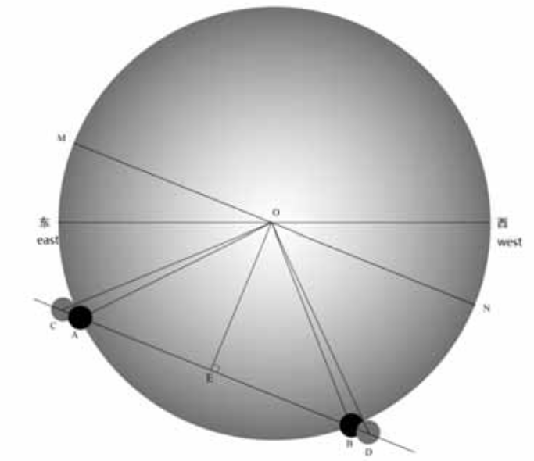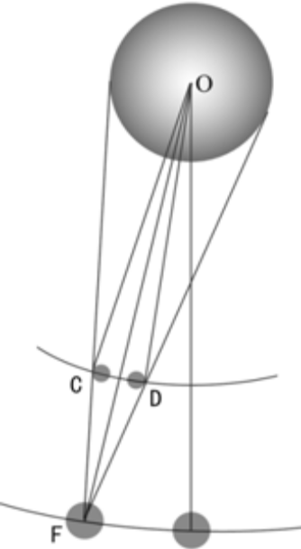

15) On average, the visual diameter of the Moon is slightly less than that of the Sun, so the frequency of annular solar eclipses is slightly higher than total solar eclipses. For an observer on the Earth, the longest total solar eclipse duration is about 7.5 minutes, and the longest annular eclipse duration is about 12.5 minutes. Here, the longest duration is the time interval from the second contact to the third contact. Suppose we count the occurrences of both types of solar eclipses for a very long time, estimate the ratio of the occurrences of annular solar eclipses and total solar eclipses. Assume the orbit of the
Earth to be circular and the eccentricity of the Moon's orbit is 0.0549. Count all hybrid eclipses as annular eclipses.

Long Problem
Note: 30 points for each problem

16) A spacecraft is launched from the Earth and it is quickly accelerated to its maximum velocity in the direction of the heliocentric orbit of the Earth, such that its orbit is a parabola with the Sun at its focus point, and grazes the Earth orbit. Take the orbit of the Earth and Mars as circles on the same plane, with radius of r_{E} = 1AU and r_{M} = 1.5AU, respectively. Make the following approximation: during most of the flight only the gravity from the Sun needs to be considered.

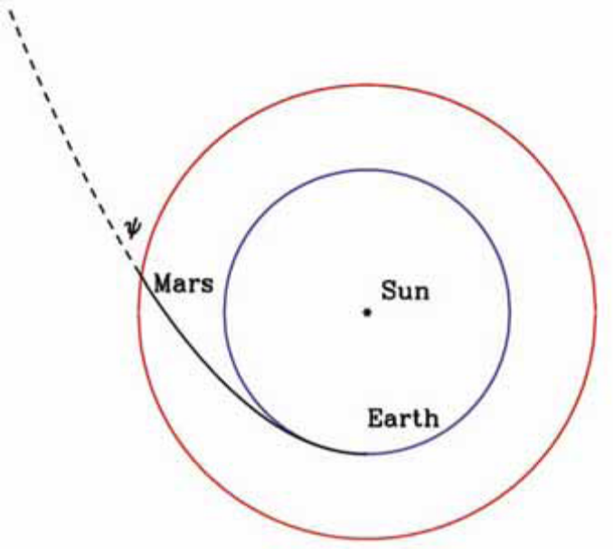
Figure 1:

The trajectory of the spacecraft (not in scale). The inner circle is the orbit of the Earth, the outer circle is the orbit of Mars.

Questions:
- What is the angle Ψ between the path of the spacecraft and the orbit of the Mars (see Fig. 1) as it crosses the orbit of the Mars, without considering the gravity effect of the Mars?

- Suppose the Mars happens to be very close to the crossing point at the time of the crossing, from the point of view of an observer on Mars, what is the approaching velocity and direction of approach (with respect to the Sun) of the spacecraft before it is significantly affected by the gravity of the Mars?

17) The planet Taris is the home of the Korribian civilization. The Korribian species is a highly intelligent alien life form. They speak Korribianese language. The Korribianese-English dictionary is shown in Table 1; read it carefully! Korriban astronomers have been studying the heavens for thousands of years. Their knowledge can be summarized as follows:
􀂮 Taris orbits its host star Sola in a circular orbit, at a distance of 1 Tarislength.

􀂮 Taris orbits Sola in 1 Tarisyear.
􀂮 The inclination of Taris’s equator to its orbital plane is 3°.
􀂮 There are exactly 10 Tarisdays in 1 Tarisyear.
􀂮 Taris has two moons, named Endor and Extor. Both have circular orbits.
􀂮 The sidereal orbital period of Endor (around Taris) is exactly 0.2 Tarisdays.
􀂮 The sidereal orbital period of Extor (around Taris) is exactly 1.6 Tarisdays.
􀂮 The distance between Taris and Endor is 1 Endorlength.
􀂮 Corulus, another planet, also orbits Sola in a circular orbit. Corulus has one moon.
􀂮 The distance between Sola and Corulus is 9 Tarislengths.
􀂮 The tarisyear begins when Solaptic longitude of the Sola is zero.

Korribianese English Translation
Corulus A planet orbiting Sola
Endor (i) Goddess of the night; (ii) a moon of Taris
Endorlength The distance between Taris and Endor
Extor (i) God of peace; (ii) a moon of Taris
Sola (i) God of life; (ii) the star which Taris and Corulus orbit
Solaptic Apparent path of Sola and Corulus as viewed from Taris
Taris A planet orbiting the star Sola, home of the Korribians
Tarisday The time between successive midnights on the planet Taris
Tarislength The distance between Sola and Taris
Tarisyear Time taken by Taris to make one revolution around Sola

Questions:
(a) Draw the Sola-system, and indicate all planets and moons.
(b) How often does Taris rotate around its axis during one Tarisyear?
(c) What is the distance between Taris and Extor, in Endorlengths?
(d) What is the orbital period of Corulus, in Tarisyears?
(e) What is the distance between Taris and Corulus when Corulus is in opposition?
(f) If at the beginning of a particular tarisyear, Corulus and taris were in opposition, what would be Solaptic longitude (as observed from Taris) of Corulus n tarisdays from the start of that year?
(g) What would be the area of the triangle formed by Sola, Taris and Corulus exactly one tarisday after the opposition?

(a) 5 points
(b) 5 points
(c) 3 points
(d) 2 points
(e) 5 points
(f) 5 points
(g) 5 points

