Theoretical Exam - Short Questions

- What would be the temperature on the Earth’s surface if we ignore the greenhouse effect but take into account its non-vanishing albedo? Assume that the Earth’s orbit around the Sun is circular.
Answer : 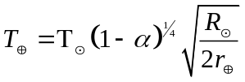= 255 Κ or T⊕ = ‒19^{ο} C
(Note: r⊕ = average Earth-Sun distance, the albedo, a = 0.39 is given in the additional material).
- Let us assume that we observe a Jupiter-like planet orbiting around a star at an average distance d = 5 AU. It has been found that the distance of this system from us is r = 250 pc. What is the minimum diameter, D, that a telescope should have to be able to resolve the two objects (star and planet)? We assume that the observation is done in the optical part of the electromagnetic spectrum (λ~500nm), outside the Earth’s atmosphere and that the telescope optics are perfect (diffraction limited).
Answer: From the figure we have:
ω
d
r
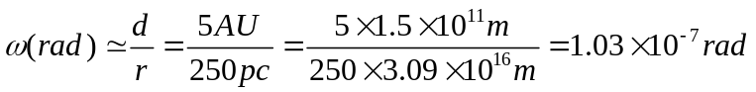
Let us assume that D is the minimum diameter of our space telescope.
Its angular resolution is 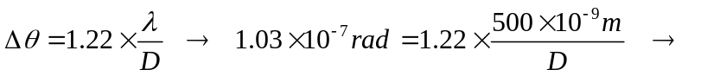D = 6 m

- It is estimated that the Sun will have spent a total of about t₁ = 10 billion years on the main sequence before evolving away from it. Estimate the corresponding amount of time, t₂, if the Sun were 5 times more massive.
Answer: For the average luminosity of a main sequence star we have: 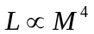(where M the initial mass of the star). We assume that the total energy E that the star produces is proportional to its mass 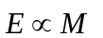. Therefore the amount of time that the star spends on the main sequence is approximately 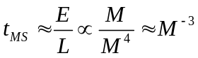. Therefore, 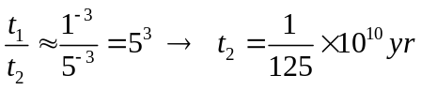 or t₂ = 8×10⁷ yr.

- Figure 1 shows the relation between absolute magnitude and period for classical cepheids. Figure 2 shows the light curve (apparent magnitude versus time in days) of a classical cepheid in the Small Magellanic Cloud. (a) Using these two figures estimate the distance of the cepheid from us. (b) Revise your estimate assuming that the interstellar extinction towards the cepheid is A = 0.25 mag.
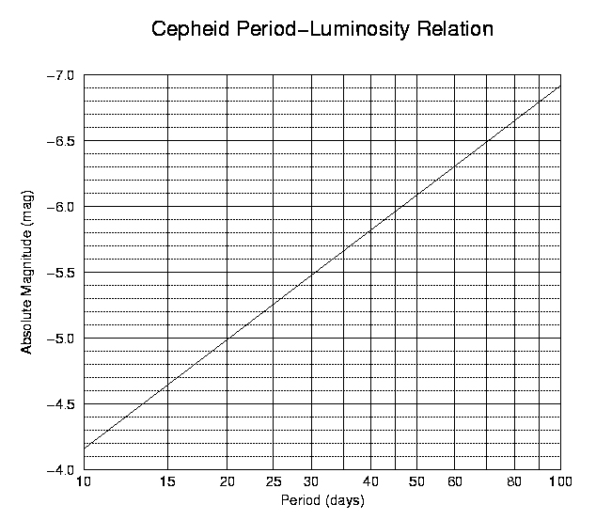
Figure 1
m
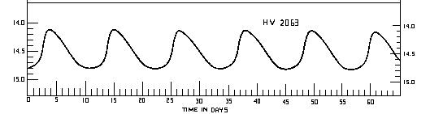
Figure 1
Answer : (a) From Figure 2, the period of the cepheid is P ~ 11 days and its average apparent magnitude is ~(14.8+14.1)/2 mag, i.e. m = 14.45 mag. (1 point)
[A careful student will notice that the graph is not upside-down symmetrical so he/she choose some value closer to the bottom; that is m=14.5 mag. (3 point)]
From Figure 1, we derive that for a period of 11 days the expected absolute magnitude of the cepheid is Μ ≈ ‒4.2. (1 point)
[A careful student will notice that the graph is logarithmic so he/she choose a value closer to 4.3] (3 point)]
Using the formula m ‒ M = ‒5 + 5logr, where r is the distance of the cepheid, we get
logr = (14.45 + 4.2 +5 )/5 = 4.73, thence r = 10^{4.73} ≈57500 pc or r = 57.5 kpc (3 points)
(b) Assuming Α = 0.25, then logr = (14.45+4.2+5+0.25)/5 = 4.78, thence r = 10^{4.78} ~53000 pc or
r = 64.5 kpc. (1 point)

- The optical spectrum of a galaxy, whose distance has been measured to be 41.67 Mpc, shows the Balmer Ha line (λ_{ο} = 656.3 nm) redshifted to λ = 662.9 nm. (a) Use this to calculate the value of the Hubble constant, H_{o}. (b) Using your results, estimate the age of the Universe.
Answer: (a) 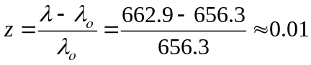. This is small enough that we can use the classical equation for the expansion of the Universe. 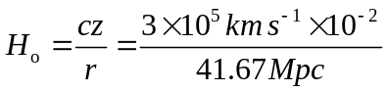 or H_{o} = 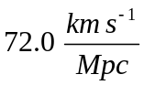
(b) t_{H ≈} 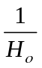 or t_{H} = 13.9 Gyr

- A star has an effective temperature T_{eff} = 8700 K, absolute magnitude M = 1.6 mag and apparent magnitude m = 7.2 mag. Find (a) the star’s distance, r, (b) its luminosity, L, and (c) its radius, R. (Ignore absorption).

Answer : (a) Its distance is calculated from equation: m – M = 5 log (r) – 5,
or 7.2 – 1.6 + 5 =5log(r) → log (r) = 2.12 and r = 132 pc
(b) Its Luminosity is calculated from equation: M – M = 2.5 log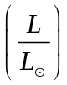 or
4.8 – 1.6 = 2.5 log or log = 1.28 → = 19.05 or L = 19.15×L = 19.15×3.9×10³³ and L = 7.4×10³⁴ erg sec⁻¹
(c) Its radius can be easily calculated from equation: L = 4πσR² T⁴_{eff} , from which
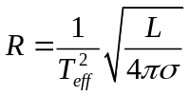 from which we get: R = 1.35×10¹¹ cm

- A star has visual apparent magnitude m_{v} = 12.2 mag, parallax π = 0″.001 and effective temperature T_{eff} = 4000 K. Its bolometric correction is B.C. = ‒0.6 mag. (a) Find its luminosity as a function of the solar luminosity. (b) What type of star is it? (i) a red giant? (ii) a blue giant? or (iii) a red dwarf? Please write (i), (ii) or (iii) in your answer sheet.

Answer : (a) First its bolometric magnitude is calculated from equation: M_{V} – m_{V} = 5 ‒ 5 log (r) or equivalent: M_{V} – m_{V} = 5 + 5 log π → M_{V} = 12.2 + 5 + 5log (0″.001) = 12.2 + 5 – 15 = 2.2 mag. Its barycentric correction is: B.C. = M_{bol} – M_{V} and M_{bol} = B.C. + M_{V} or M_{bol} = –0.6 + 2.2 or M_{bol} = 1.6 mag . Then its Luminosity is calculated from:
M – M_{bol} = 2.5 log, or 4.8 – 1.6 = 2.5 log or log= 1.28 and L = 19.1 L
(b) Type of star: A star with M_{bol} = 1.6 mag, L = 19.1 L and T_{eff =} 4000 K is much brighter and much cooler than the Sun (see Table of constants). Therefore it is (i) a red giant star.

- A binary system of stars consists of star (a) and star (b) with brightness ratio 2. The binary system is difficult to resolve and is observed from the Earth as one star of 5th magnitude. Find the apparent magnitude of each of the two stars (m_{a}, m_{b} ).

Answer : The apparent magnitude of star (a) is m_{a}, of star (b) is m_{b} and that of the system as a whole is m_{a+b} . The corresponding apparent brightnesses are ℓ_{a} , ℓ_{b} and ℓ_{a+b} = ℓ_{a} + ℓ_{b}.
For star (a) :
m_{a+b} – m_{a} = –2.5log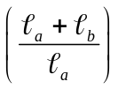 and because 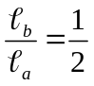, we get m_{a} = m_{a+b} + 2.5 log (1+ ½ ) or
m_{a} = 5 + 2.5 log (3/2) and finally m_{a} = 5.44 mag . Similarly for star (b):
m_{a+b} – m_{b} = –2.5log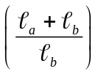 and because 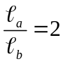, we get m_{b} = m_{a+b} + 2.5 log (3 ) or
m_{b} = 5 + 2.5 log (3) and finally m_{b} = 6.19 mag.

- Find the equatorial coordinates (hour angle and declination) of a star at Madrid, geographic latitude φ = 40º , when the star has zenith angle z = 30º and azimuth A = 50º

Answer : From the position triangle ΠZ_{ν}Σ (Figure 3) of the star, Σ, we get, by using the cosine law for a spherical triangle:
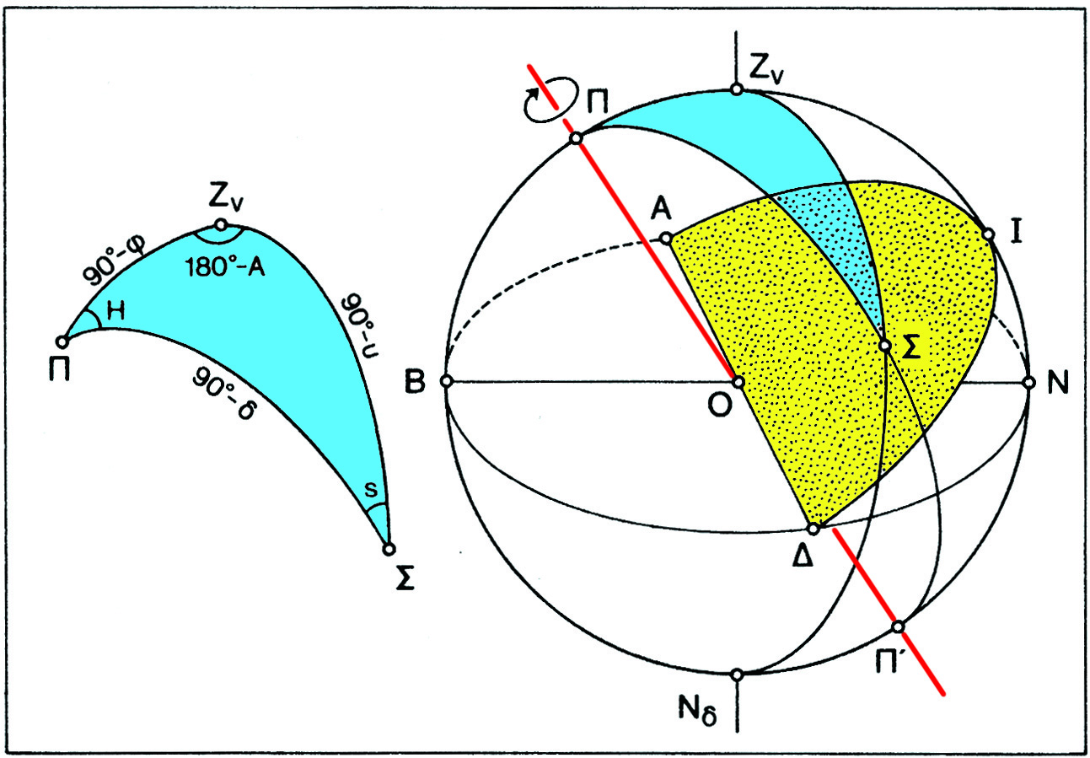
Figure 3. The position triangle

cos (90 – δ) = cos(90 – a)×cos(90 – φ) + sin (90 – a)×sin(90 – φ)×cos (180 – A)

where δ is the star’s declination, a its altitude (a = 90° – z), φ the geographical latitude of the observer, Η the stars hour angle and A the star’s azimuth.
This can be written as:

sinδ = cos z×sin φ – sin z×cosφ×cos A or
sinδ = cos30º×sin40º – sin30º×cos40º×cos50º
or
sin δ =0.866×0.643 – 0.500×0.766×0.643 = 0.311. δ = 18° 07′

Using the sine law for the spherical triangle, we get:
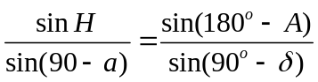 or 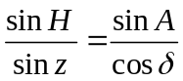 → 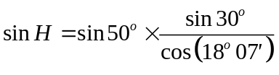= 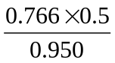 or
sin H = 0.403. Therefore: H = 23° 46′ or H = 1^{h} 35^{m} 04^{s}.

- In the centre of our Galaxy, in the intense radio source Sgr A*, there is a black hole with large mass. A team of astronomers measured the angular distance of a star from Sgr A* and its orbital period around it. The angular distance was 0.12″ (arcsec) and the period was 15 years. The distance of our solar system from the centre of the Galaxy is 8 kpc[Put it in Constants]. Calculate the mass of the black hole in solar masses.
Answer: 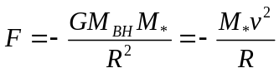
But 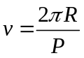. Therefore 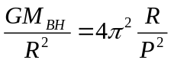 or 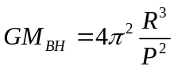
Similarly:
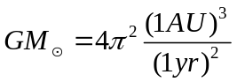 ή 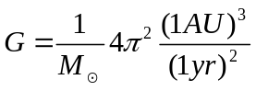
From Kepler’s 3rd law we get: 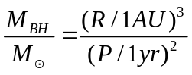
Inserting the given data we find the distance of the star from the black hole:
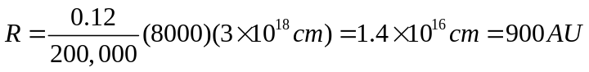
Therefore: 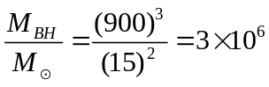 form which we calculate the mass of the black hole:


- What is the maximum altitude, a_{M}(max), that the Full Moon can be observed from Thessaloniki? The geographical latitude of Thessaloniki is φ_{Θ} = 40°37ʹ.

Answer: In order to have Full Moon, the Moon should be diametrically opposite the Sun, i.e. the three bodies, Sun – Earth – Moon should be on a straight line. If the orbital plane of the Moon coincided with the ecliptic, the maximum altitude of the Full Moon would be 90° – φ_{Θ} + 23.5°. Because the orbital plane of the Moon is inclined by 5.14° (5°18ʹ) to the plane of the ecliptic, the maximum angle is larger: 90° – 40°37ʹ + 23.5° + 5°18ʹ, or
α_{M}(max) = 79°49ʹ

- Sirius A, with visual magnitude m_{V} = ‒1.47 (the brighter star on the sky) and with stellar radius R_{A} = 1.7R, is the primary star of a binary system. The existence of its companion, Sirius B, was deduced from astrometry in 1844 by the well known mathematician and astronomer Friedrich Bessel, before it was directly observed. Assuming that both stars were of the same spectral type and that Sirius B is fainter by 10 mags (Δm = 10), calculate the radius of Sirius B.

Answer: The distance of the two stars from our solar system is the same. Therefore
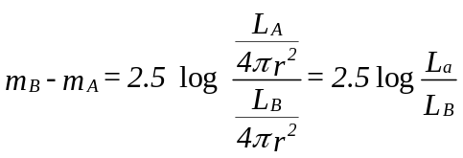
From which we get L_{A} = 10⁴ L_{B}. From equation L = 4πR²σT_{eff}⁴ βwe get
L_{A}/L_{B} = (R_{A}/R_{B})² (T_{A}/T_{B})⁴
Assuming that the two stars belong to the same spectral type (and therefore T_{A} = T_{B}) we get
R_{B} = 0.01R_{A} = 0.01×1.7×696000 km or R_{B} = 11832 km

- Recently in London, because of a very thick layer of fog, the visual magnitude of the Sun, became equal to the (usual – as observed during cloudless nights) magnitude of the full Moon. Assuming that the reduction of the intensity of light due to the fog is given by an exponential equation, calculate the exponential coefficient, τ, which is usually called optical depth.

Answer: The absorption due to the fog in London is obviously
A = –26.8 – (–12.5) = –14.3 mag.
Rearranging the equation I_{ν}(r) = I_{ν}(0) × e^{-τ}, we get 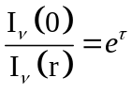, or
Α = Δm = 2.5 × lοg(e) × (-τ) or τ = (–Α)/(2.5 × lοge) = 14.3/1.08 ή τ = 13.2

- What is the hour angle, H, and the zenith angle, z, of Vega in Thessaloniki (λ₁ = 1^{h}32^{m}, b₁ = 40°37^{m}), at the moment it culminates at the local meridian of Lisbon (λ₂ = +00^{h}36^{m}, b₂ = +39°43′)?

Answer: By definition at the moment when the star culminates in Lisbon, its hour angle is exactly 0°. Therefore its hour angle in Thessaloniki is 0º + (λ₁ – λ₂) or H = 00^{h}56^{m}.
The zenith distance at Lisbon (90° – b₁ + d)
Using the cosine law equation cos z = cos(90-φ)×cos(90-d) + sin(90-φ)×sin(90-d) ×cos H, the zenith distance at Thessaloniki can be calculated.

- The Doppler shift of three remote galaxies has been measured with the help of Spectral observations:
Galaxy | Redshift, z
3C 279 | 0.536
3C 245 | 1.029
4C41.17 | 3.8
(a) Calculate their recession velocity. (b) At what percentage of the speed of light they recede? (c) What is the present distance of each galaxy?

Answer: The recession velocity is calculated by either the classical relation, v_{c} = z×c, or the relativistic relation,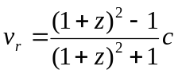. The calculations for the three galaxies are summarized in the following Table:
Galaxy | v_{c} (km/s) | v_{r} (km/s) | v_{r}/c×100 | r = v_{r}/H_{o} (Mpc)
3C279 | 160800 | 121390 | 40% | 1660
3C245 | 308700 | 182740 | 61% | 2500
4C41.17 | 1140000 | 275040 | 92% | 3770
 |  | (α) | (β) | (γ)

From columns 2 and 3 it is obvious that the relativistic relation should be used. It should be noted that for 3C245 και 4C41.17 the classical relation gives velocities larger than the speed of light. It is also noted that the difference between the distance calculated by the classical relation and the relativistic relation it is about 30%, even for the “nearby” galaxy, 3C 279.
The answers to the questions are given in columns 3, 4 and 5.

- The absolute visual magnitude of a white dwarf star is M_{V} = 10 mag and its effective temperature T_{eff} = 10000 K. Its bolometric correction is B.C. = 0.6 mag. Find its radius R as a function of the solar radius.
Answer : The bolometric correction is given by: B.C. = M_{bol} ‒ M_{V} , therefore the white dwarf’s bolometric magnitude is M_{bol} = B.C. + M_{V} or M_{bol} = 0.6 + 10 = 10.6 mag
Using the equation: M ‒ M_{bol} = 2.5 log 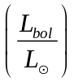 we get:
4.8 – 10.6 = 2.5 log → log = ‒2.32
But : 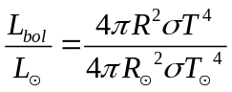 or 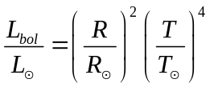
Therefore : 2 log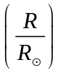 + 4 log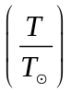 = ‒2.32 or log + 2 log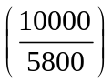 = ‒1.16 or
log = ‒1.64 and = 0.023 and finally R = 0.023 R
(Note: If the student uses the old definition B.C. = M_{V} – M_{bol}, accept it as correct)

- Find the velocity with which a rocket needs to be launched from Earth in order to escape from the gravitational field of (a) the Earth and (b) the Sun. Assume that the Earth’s orbit around the Sun is circular. Ignore the influence of other planets.
Find the minimum launch velocity of the rocket, in order to escape the gravitational field of the Sun, if the launch is performed from the Earth, tangentially to the Earth’s orbit around the Sun?

Answer:
(1). (a) The escape velocity 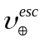of a body from the gravitational field of the Earth, when it is located at the Earth’s surface, is given by
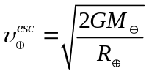, where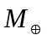 is the mass of the Earth, 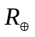 is the radius of the Earth and G is the gravitational constant.
Using the values given in the Table of Constants, we derive 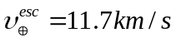 (2 points)
(b) The escape velocity 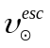of a body, located on the Earth’s orbit, from the gravitational field of the Sun, is given by
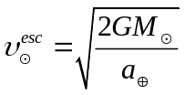, where 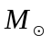 is the Sun’s mass, 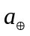 is the average Earth-Sun distance and G is the gravitational constant.
(Proof: 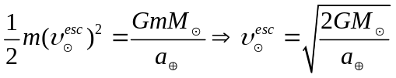)
Using the values given in the Table of Constants, we derive 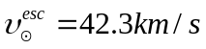 (2 points)
The magnitude of the total escape velocity is given by (note that the two components are perpendicular) 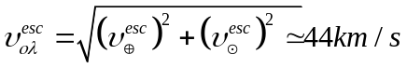 (4 points)
(2). The magnitude of the rotational velocity of the Earth around the Sun,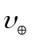 , is approximately
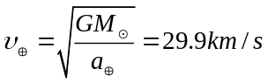 (2 points)
(Proof: 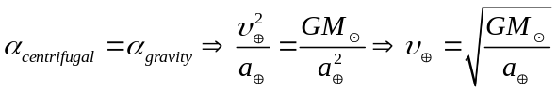)
Therefore if the rocket is launched tangentially to the Earth’s orbit, the escape velocity from the gravitational pull of the sun will differ, from 42.3km/s to (42.3 – 29.9) km/s, i.e. 12.4km/s.(2 points)

Marking scheme for deduction of points for decimal point, etc
(I(r) = I(0) × e^{-τ})

