Observational test

When you arrive at the telescope, you will be provided with suitable equipment and shown how to use it. You will also be given the answer form. Fill in your student code number before starting the questions.

Question 1. (penalty if student kicks the telescope)

- Chose one of the two eyepieces of the Olympiad telescope and using a suitable, bright object measure the field of view of the telescope. Give your answer and working on the answer form.

Answer: The attendant will provide a chronometer (his cell phone) and asks the student to get familiar with the stopwatch function.

The student should select and observe any star from the “Bright Stars catalogue visible from Greece” that is provided by the attendant. The name of the star and its declination is written on the data sheet. (1 point)
(Note: If the student selects α UMi the attendant should not warn him).

The student measures and writes down the crossing time of the star that he/she has selected.
(Marking scheme: ±4 s: 100%, ±6 s: 80%, ±8 s: 60%, ±12 s: 40%, ≥ 12 s: 0). (5 points)
The field of view is then calculated by the student on the spot, by using the formula:
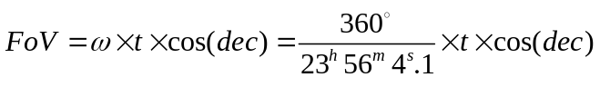 (4 points)

(Example: for Capella [dec = 46°.0, cos (46.0) = 0.6947] and transit time t = 3^{m}31^{s} = 3.53 min we get: 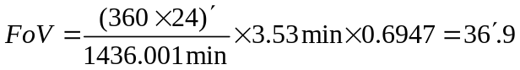)
[Maximum allowed time 10 minutes]

Question 2.
Without using the setting circles of the telescope, complete the following tasks:
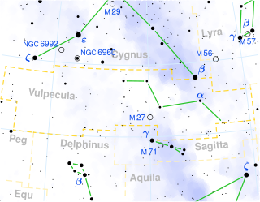
The field in the vicinity of the Dumbell Nebula
(a) bring the bright star (m = 3.51 mag) γ Sagitta (RA = 19^{h} 58^{m} 45.39^{s}, Dec = +19° 29′ 31.5″) to the centre of view of the telescope. Ask the attendant to verify the observation.
(b) bring the famous Dumbell Nebula, Μ27 (RA = 19^{h} 59^{m} 36.34^{s}, +22° 43′ 16.09″) to the center of the field of view. Ask the attendant to verify the observation.

Answer: (1) The student should recognize the constellation of Sagitta and point the telescope at γ Sagitta, which is the brightest star of the constellation. (3 point)
(2) The students should notice that the two targets have very similar Right Ascension. Therefore given the RA and Dec of the bright star γ Sagitta (m = 3.51 mag), should be able to quickly locate M27 as the equatorial mounting is already aligned. Then should keep the RA axis locked, release the Dec knob and turn the telescope by about 3.25 degrees towards Polaris. The Dumbell Nebula will appear in the field of view. (5 point)
[Marking scheme: Points given according to time spent. Total time required: ≤4 min: 100%, ≤5 min: 80%, ≤6 min: 50%.
[Maximum allowed time 6 minutes]
(Note: If the student fails to locate M27 and complains, the attendant does it 30 s and he notes this down)

Question 3:

At 14 o’clock local time at day time of the spring equinox a rare transit of Mercury is going to take place. A team of astronomers reaches a mountain top, early in the morning, in order to align his telescope and then observe the transit. The site is new and they do not know the geographical coordinates. Unfortunately the sky is covered with clouds. No stars are visible. The telescope cannot be aligned. The sky is overcast until 11 o’clock. The Sun becomes visible. An experienced astronomer manages to roughly align the telescope in less than 2 minutes! He only uses a water bubble.

You are given the telescope of the 7th IOAA and a water level. Assume that it is vernal equinox and that the (simulated) Sun is at its maximum elevation. Align the telescope.
(Note: Obviously for this exercise, a telescope tube is not necessary, therefore, for the sake of convenience, the telescope will be equipped with a rough paper-tube and without counter weights.

Answer: First the student levels the tripod with the help of the water bubble. Then he/she adapts the equatorial mount on the tripod. Because it is spring equinox, the declination of the Sun is 0°. At this point the student should immediately set the Declination circle of the telescope at 0° and secures the locking knob. The declination axis is calibrated. Then he/she rotates the Hour Angle axis and, by using the water bubble, makes the tube of the telescope horizontal. Then he/she rotates again by 90° the Hour Angle axis. Obviously, if the azimuth axis had been correctly set, at this point the telescope should be pointing somewhere on the local meridian. Then, as he/she knows that the sun crosses the meridian, he turns the azimuthal axis of the telescope until he observes the Sun above or below the direction where the telescope is pointing. Now the telescope is pointing toward the local meridian. Finally he turns the latitude (altitude) axis of the telescope, up or down, until he/she aims the sun. The polar axis of the telescope is immediately aligned!
(Note: This is an indoors exercise). [Maximum allowed time 16 minutes]

