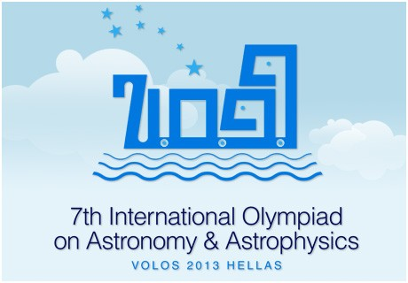
THE TELESCOPE OF THE 7TH INTERNATIONAL OLYMPIAD ON ASTRONOMY & ASTROPHYSICS

SkyWatcher 150/750 Black Diamond EQ3-2
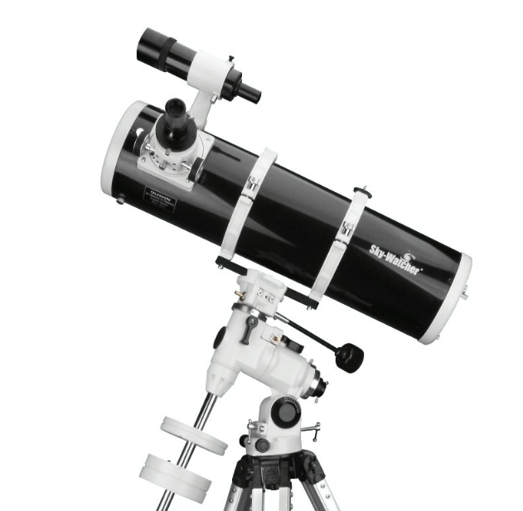
SPECIFICATIONS
The telescope of the 7th International Olympiad on Astronomy & Astrophysics
will be a Newtonian reflector telescope on equatorial mount
constructed by the SkyWatcher company.

SUMMARY
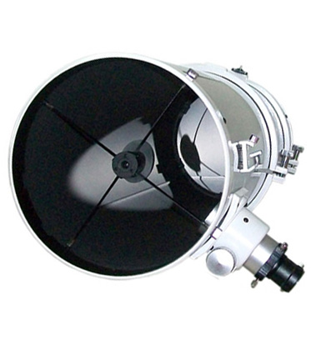

- Type: Reflector telescope
- Optical design: Newtonian
- Diameter: 150 mm (5.91″) (parabolic)
- Focal length: F 750 mm
- Focal Ratio: f / 5
- Focuser: rack and pinion type (with 1.25″ adapter)
- Mount: EQ3-2 Equatorial with 2 knobs for manual
movement in RA and Dec and calibrated position
circles.
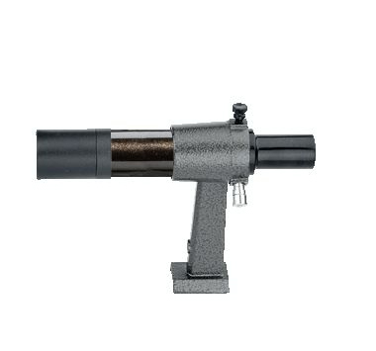
- Tripod: Aluminum legs with adjustable height
(71–123 cm) and leveling bubble
- Finder: achromatic 6×30 (inverted image)
- Eyepieces: SUPER Plossl 25mm (30×) WA, LE
and SUPER Plossl 10mm (75×), Ø31.8mm
- Barlow: 2×, achromatic
- Maximum Usable Magnification: 300 ×
- Minimum Star Magnitude Size: m_{V} = 13.6
- Theoretical Resolution: 0.8 arc sec

