Theoretical Exam - Long Questions

Question 1

In a homogeneous and isotropic universe, the baryon density parameter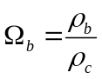 = 5%, where ρ_{b} is the baryon density and ρ_{c} is the critical density of the Universe. Calculate the average baryon density in our local neighbourhood and the escape velocity of a galaxy 100 Mpc away from us. Note that the recession velocity of galaxies in Hubble's law equals the corresponding escape velocity at that distance, for the critical density of the Universe that we observe.

Answer:
If ρ_{b} is the average density of matter in a spherical volume of 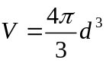, where d is the distance of a galaxy away from us, then the escape velocity is 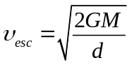 (2 points)
From the above equations we get 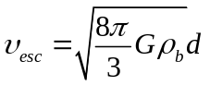 (2 points)
(the galaxy only feels the gravitational pull of the mass enclosed within distance d, as if the latter were a point mass at the centre of the volume).
Using Hubble’s law of expansion, υ = H₀ d (1 point)
or 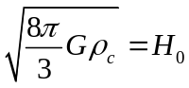 (2 points)
we get the critical density 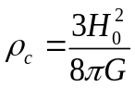 (2 points)
If the baryon density parameter is 5% and the latest estimate of H₀ = 67.8 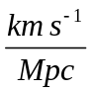 we obtain
ρ_{b} = 0.05ρ_{c} or 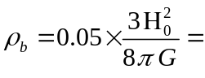 ?? (2 points)

Within d = 100 Mpc the escape velocity is then
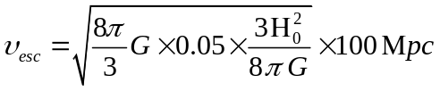
= ?? (2 points)

Question 2

A spacecraft is orbiting the Near Earth Asteroid (2608) Seneca (staying continuously
very close to the asteroid), transmitting pulsed data to the Earth. Due to the relative motion of the two bodies (the asteroid and the Earth) around the Sun, the time it takes for a pulse to arrive at the ground station varies approximately between 2 and 39 minutes. Assuming that the Earth moves around the Sun on a circular orbit (with radius a_{Earth} = 1 AU and period T_{Earth} = 1 yr) and that the orbit of Seneca does not intersect the orbit of the Earth, calculate:
(1) the semi-major axis, a_{Sen} the eccentricity, e_{Sen} of Seneca's orbit around the Sun
(2) the period of Seneca's orbit, T_{Sen} and the synodic period, T_{syn} of the Earth-Seneca couple
(3) an approximate value for the mass of the planet Jupiter, M_{Jup} (assuming this is the only planet of our Solar system with non-negligible mass compared to the Sun).

Answer :
(1) For Δt_{b} = 2 min = 120 sec, the distance travelled by a light pulse is R₁ = c×Δt or R₁ = 0.24 AU, while for Δt_{a} = 39 min the maximum distance is R₂ = c×Δt or R₂ = 4.67 AU. (2 points)

Since the orbits do not intersect and the R₂ exceeds by far 1 AU, the orbit of Seneca is exterior to that of the Earth. R₁ corresponds to the minimum relative distance of the two bodies (i.e. at opposition), while R₂ corresponds to the maximum relative distance (i.e. at conjunction).

If q = a×(1‒e) is the perihelion and Q = a×(1+e) the aphelion distance of Seneca, then R₁ = q‒1 AU (the minimum distance of Seneca from the Sun minus the semi-major axis of the Earth's orbit), while R₂ = Q+1 AU (the maximum distance of Seneca from the Sun plus the semi-major axis of the Earth's orbit). (3 points)
Thus,
a_{Sen} (1‒e_{Sen}) = 1+R₁ = 1.24 AU
a_{Sen} (1+e_{Sen}) = R₂‒1 = 3.67 AU from which one finds a_{Sen} ~ 2.46 AU (1 point)
and e_{Sen} ~ 0.50 (1 points)
(figures rounded to 2 dec. digits)

(2) The period, T_{Sen}, of Seneca's orbit can be found by using Kepler's 3rd law for Seneca and the Earth (ignoring their small masses, compared to the Sun's):
a_{Sen} ³ / T_{Sen} ² = a_{Earth}³ / T_{Earth} ² =1 (3 points)
from which one finds T_{Sen} ~ 3.86 yr (1 point)

(Alternatively one can use Kepler's law for Seneca only and use natural units for the mass of the Sun and G, i.e. [mass] = 1 M_{Sun}, [t ]= 1 yr and [r] = 1 AU, in which case T_{Sen} = a_{Sen}^{3/2} = 3.86 yr)
(4 points)

The synodic period, T_{syn} of Seneca and Earth is given by

1/T_{syn} = 1/T_{Earh} – 1/T_{Sen} (Seneca is superior) (3 points)

which gives T_{syn} = 1.35 yr (1 point)

(3) From Kepler's law, we can calculate the mass of the Sun

4π² a_{Sen} ³ / T_{Sen} ² = G M_{Sun}, i.e. M_{Sun} ~ 1.988×10³⁰ kg (depending on accuracy) (2 points)

Then, using Kepler's 3rd law for Seneca and Jupiter, one gets

(a_{Jup} ³ / T_{Jup} ²) / (a_{Sen}³ / T_{Sen} ²) = (M_{Sun} + M_{Jup}) / M_{Sun} = 1 + x (2 points)

where x = is the mass ratio of Jupiter to the Sun. Then, solving for x we get (depending on the accuracy used in determining the elements of Seneca's orbit)

x = 1.0 ‒ 2.5×10⁻³ M_{Sun} → M_{Jup} = ??

which can then be given in (kg), using the above calculated value of M_{Sun} .

Question 3

(1) Using the virial theorem for an isolated, spherical system, i.e, that ‒2<Κ>=<U>, where “K” is the kinetic energy and “U” is the potential energy of the system, explain how we can measure the total mass of a cluster of galaxies if we know the radial velocity dispersion of the cluster’s galaxy members and the cluster’s radius. Assume that the cluster is isolated, spherical, has a homogeneous density and that it consists of N galaxies of mass m each.
(2) Find the virial mass, i.e. the mass calculated from the virial theorem, of the Coma cluster, which lies at a distance of 90 Mpc from us, if you know that the radial velocity dispersion of its member galaxies is 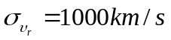 and that its angular diameter (on the sky) is about 4^{ο}.
(3) From observations, the total luminosity of the galaxies comprising the cluster is approximately L = 5×10¹² L. If the mass to luminosity ratio, M/L, of the cluster is ~1 (all the mass of the cluster is visible mass), this should correspond to a total mass M ~ 5×10¹² M for the mass of the cluster. Compare this value to the total mass of the cluster you derived in question (2).
Answer:
(1) Using the virial theorem for our isolated, spherical system of N galaxies of mass m, each, we get
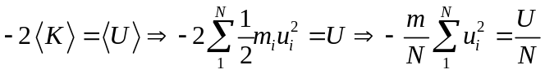 (1 point)
where 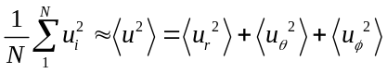, where u_{r}, u_{θ} and u_{φ} are the radial velocity and the two perpendicular velocities on the plane of the sky of the members of the cluster. (2 points)
Assuming that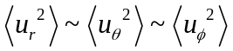, we have 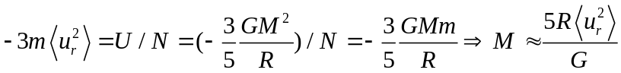 (4 points)
(where we used the gravitational potential of a mass M enclosed within a radius R)
Alternatively the student can give a rougher order of magnitude estimate 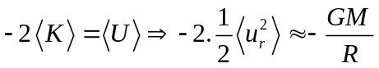 etc (3 points)
(2) From the result of the previous question we have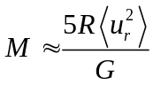, where
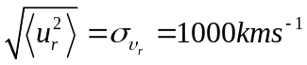
The angular diameter of the cluster is φ = 4^{ο} at a distance of d = 90 Mpc. Therefore the diameter D of the cluster in Mpc is calculated from: (4 points)
Therefore 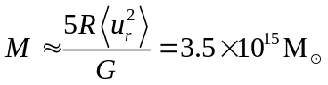 (1 point)
(3) 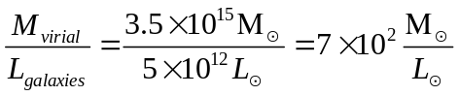 This is obviously much larger from 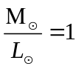which is found from the visible mass of the cluster. (2 points)

[Should we give 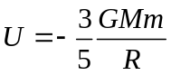? My suggestion is “No”]

