**Name ________________________**

**PHY2049C, Quiz 5**

**A- Read all the quiz once, or twice, before beginning to write. Make sure to comprehend all questions and start with those you fell most confident.**

**B – Be clear and concise. There are no extra points for being verbose or writing extra.**

**C –Only use the white pages that I will provide. You have 60 minutes to answer the quiz.**

**---------------------------------------------------------------------------------------------------------------------------**

**Problem 1**

In the figure, a wire that carries a current consists of three sections with different radii. Rank

the sections according to the following quantities, greatest first: (a) current, (b) magnitude of current density, and (c) magnitude of electric field.

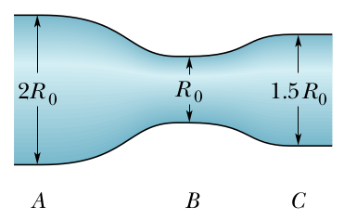

**Problem 2**

In the figure, C1 = 10.0 μF, C2 = 20.0 μF, and C3 = 25.0 μF. If no capacitor can withstand a potential difference of more than 100 V without failure and you apply a voltage that increases with time with the function VAB = 2*t Volts with t in seconds which capacitor blows up first and why?

e

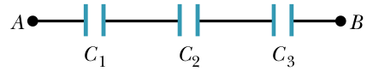

**Problem 3**

The figure shows three 20.0 Ohm resistors. Find the equivalent resistance between points (a) A and B, (b) B and C

