**Name ________________________**

**PHY2049C, Quiz 5**

**A- Read all the quiz once, or twice, before beginning to write. Make sure to comprehend all questions and start with those you fell most confident.**

**B – Be clear and concise. There are no extra points for being verbose or writing extra.**

**C –Only use the white pages that I will provide. You have 50 minutes to answer the quiz.**

**---------------------------------------------------------------------------------------------------------------------------**

**Problem 1**

The figure on the left gives the drift speed vd of conduction electrons in a copper wire versus position

x along the wire. The wire consists of three sections that differ A, B, C in radius. Rank the three sections according to the following quantities, greatest first: (a) radius, (b) number of conduction electrons per cubic meter, (c) conductivity

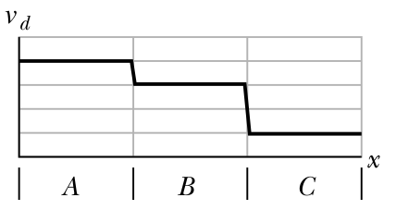

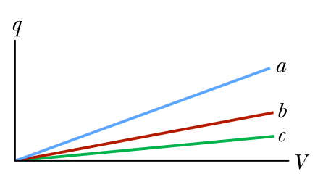

**Problem 2a**

The figure on the right shows plots of charge versus potential difference for three parallel-plate capacitors that have the plate areas and separations given in the table. Which plot goes with which capacitor?

**Problem 2b**

Consider these capacitors are charged and disconnected from everything; the plates are perfectly isolated. All capacitors charged to a charge q0. You then start separating the plates of each capacitor at a constant speed v (increasing the plate distance *d*). Draw a plot q vs. V like the one above for this situation for each capacitor, a, b and c.

**Problem 3**

On Day 1, there were 490 kids in two groups. Group A consistent only of boys, and B only of girls. There were 2 and a half more girls than boys. On Day 2, more girls joined group B and more boys joined group A. For each 4 boys in group A, 32 girls joined group B and 2 boys joined group A. Express the number of girls that joined group B in terms of a fraction of the boys that joined group A on Day 2.