**Name ________________________ PHY2049C, Quiz 6**

**A- Read all the quiz once, or twice, before beginning to write. Make sure to comprehend all questions and start with those you fell most confident.**

**B – Be clear and concise. There are no extra points for being verbose or writing extra.**

**C –Only use the white pages that I will provide. You have 60 minutes to answer the quiz.**

**---------------------------------------------------------------------------------------------------------------------------**

**Problem 1** (Wolfson and Passachoff)

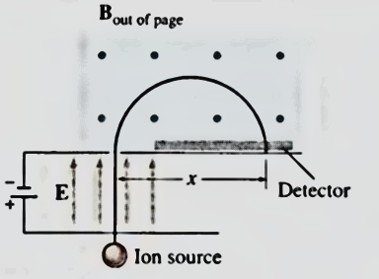Figure 1 shows a simple mass spectrometer, designed to analyze and separate atomic and molecular ions with different charge-to-mass ratios. In the design shown, ions are accelerated through a potential difference V, after which they enter a region containing a uniform magnetic field. They describe semicircular paths in the magnetic field, and land on a detector a lateral distance x from where they entered the field region, as shown. Show that x is given by:

$$x=\frac{2}{B}\sqrt{\frac{2V}{q/m}}$$

where B is the magnetic field strength, V the accelerating potential, and q/m the charge-to-mass ratio of the ion. By counting the number of ions accumulated at different positions x, one can determine the relative abundances of different atomic or molecular species in a sample.

Figure 1

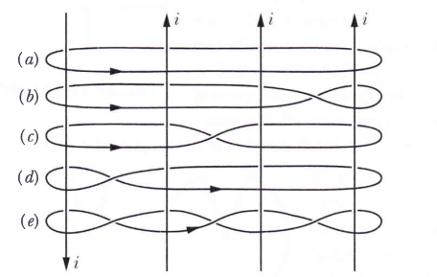

**Problem 2** (Halliday, Resnik)

The figure on the right shows four identical currents i and five Amperian paths encircling them. Rank the paths according to the value of f B, most positive first.

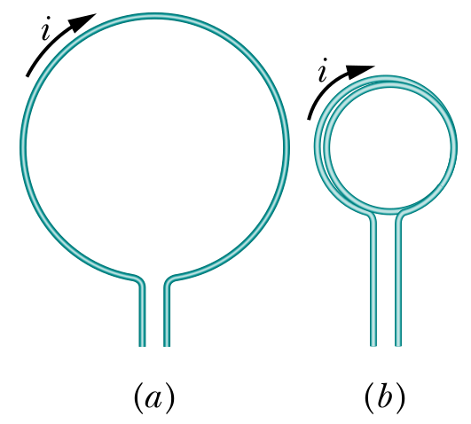

**Problem 3** (Halliday, Resnik)

The Figure on the left shows a length of wire bent into a circular coil of one turn (on the left), and the same length of wire bent into to give a coil of two turns, each of half the original radius. (on the right). They both have the same current i flowing. What is the ratio the dipole moment magnitudes?