**Name ________________________**

**PHY2049C, Quiz 6**

**A- Read all the quiz once, or twice, before beginning to write. Make sure to comprehend all questions and start with those you fell most confident.**

**B – Be clear and concise. There are no extra points for being verbose or writing extra.**

**C –Only use the white pages that I will provide. You have 60 minutes to answer the quiz.**

**---------------------------------------------------------------------------------------------------------------------------**

**Problem 1**

Which circuit(s) cannot by analyze using a series or parallel combination?

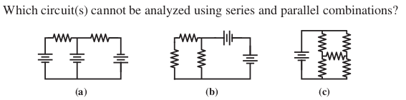

**Problem 2**

Rank in terms of equivalent resistance between points A and B.   
All R1 resistors are identical and R2 = 2R1.

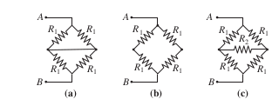

**Problem 3**

In the figure, let V = 54 V, R1 = 4Ω, R2 = 5Ω, R3 = 1Ω, C = 10F. At t = 0 assume switch S has been closed for a very long time. (a) What is I3, the current flowing through R3? (b) If at t = 0 the switch is opened what is I(t=0), the current flowing through R2 and R3 right after the switch is closed?

