**Name ________________________**

**PHY2049C, Quiz 6**

**A- Read all the quiz once, or twice, before beginning to write. Make sure to comprehend all questions and start with those you fell most confident.**

**B – Be clear and concise. There are no extra points for being verbose or writing extra.**

**C –Only use the white pages that I will provide. You have 60 minutes to answer the quiz.**

**---------------------------------------------------------------------------------------------------------------------------**

**Problem 1**

All batteries and resistors are identical. Rank according to the power supplied by the leftmost battery.

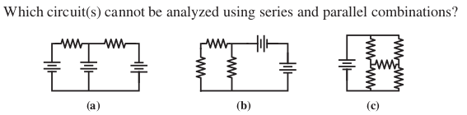

**Problem 2**

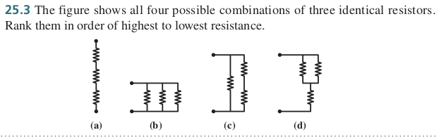

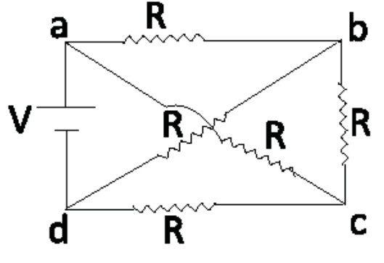**Problem 3**

Find the current through the upper resistor. Hint: Assign 3 independent currents on three branches (rest of the current will follow from charge and energy conservation)

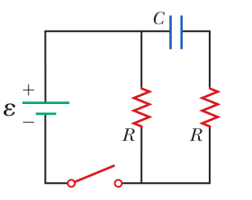**Problem 4**

The capacitor is initially discharged. R=1Ω and C=1pF, ε=12V. At t=0, the switch is closed, and at t=60s it is opened and it stays opened forever. Rank according to the current through the leftmost resistance at (a) t=0, (b) t=1s, (c) t=60s, (d) t=infinity