**Name ________________________**

**PHY2049C, Quiz 6**

**A- Read all the quiz once, or twice, before beginning to write. Make sure to comprehend all questions and start with those you fell most confident.**

**B – Be clear and concise. There are no extra points for being verbose or writing extra.**

**C –Only use the white pages that I will provide. You have 60 minutes to answer the quiz.**

**---------------------------------------------------------------------------------------------------------------------------**

**Problem 1**

The Figure shows a circuit of four resistors that are connected to a larger circuit. The graph below the circuit shows the electric potential V(x) as a function of position x along the lower branch of the circuit, through resistor 4; the potential VA is 12.0 V.

The graph above the circuit shows the electric potential V(x) versus position x along the upper branch of the circuit, through resistors 1, 2, and 3; the potential differences are ΔVB = 2.00 V and ΔVC = 5.00 V. Resistor 3 has a resistance of 200 Ω. What is the resistance of (a) resistor 1 and (b) resistor 2?

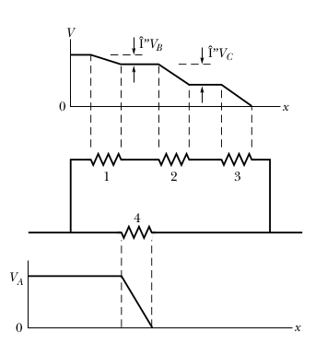

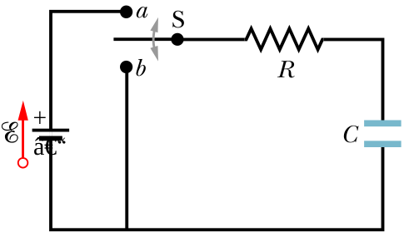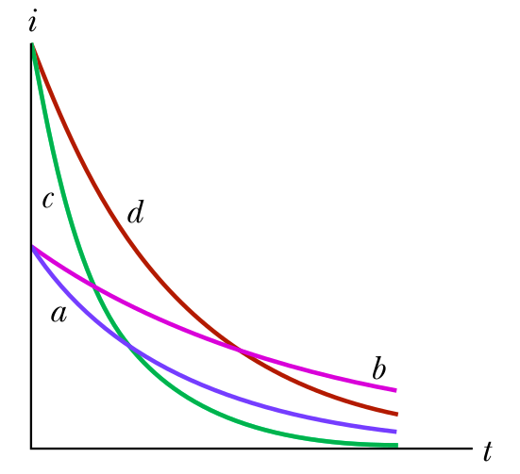

**Figure 1 Figure 2 Figure 3**

**Problem 2**

After the switch in Figure 1 is closed on point a, there is current i through resistance R. Figure 3 gives that current for four sets of values of R and capacitance C: (1) R and C, (2) 2R and C, (3) R and 2C, (4)

2R and 2C. Which set goes with which curve?

**Problem 3**

If you had 10 grams of copper, what is the maximum capacitance you can get? The minimum allowed plate separation is 1mm. The thickness of the plates must be 1mm. The density of copper is 8.96 g/cm³ (Consider the three different capacitor shapes we discussed in class, what would give you the maximum capacitance?)