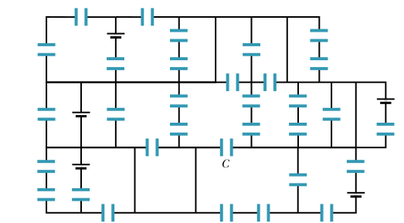
Name ________________________ Quiz 9, PHY2049C

A- Read all the exam once, or twice, before beginning to write. Make sure to comprehend all questions and start with those you feel most confident in.
B – Be clear and concise. There are no extra points for being verbose or writing extra.
C –Only use the white pages that I will provide. You have 170 minutes to answer the exam.
---------------------------------------------------------------------------------------------------------------------------

Problem 1 Cap-Kong Circuit. All the capacitors have a capacitance of 6.0 F, and all the batteries have an emf of 10 V. What is the charge on capacitor C?

Problem 2

The chocolate crumb mystery. Explosions ignited by electrostatic discharges (sparks) constitute a serious danger in facilities handling grain or powder. Such an explosion occurred in chocolate crumb powder at a biscuit factory in the1970s. Workers usually emptied newly delivered sacks of the powder into a loading bin, from which it was blown through electriclly grounded plastic pipes to a silo for storage. Somewhere along this route, two conditions for an explosion were met: (1) The magnitude of an electric field became 3.0 × 106 N/C or greater, so that electrical breakdown and thus sparking could occur. (2) The energy of a spark was 150 mJ or greater so that it could ignite the powder explosively. Let us check for the first condition in the powder flow through the plastic pipes.

Suppose a stream of negatively charged powder was blown through a cylindrical pipe of radius R = 5.0 cm. Assume that the powder and its charge were spread uniformly through the pipe with a volume charge density (a) Using Gauss’ law (infinite wire), find an expression for the magnitude of the electric field E in the pipe as a function of radial distance r from the pipe center. (b) Does E increase or decrease with increasing r? (c) Is E directed radially inward or outward? (d) For = 1.1 × 10−3 C/m^3 (a typical value at the factory), find the maximum E and determine where that maximum field occurs. (The story continuous in Problem 3)

Problem 3

As part of the investigation of the biscuit factory explosion, the electric potentials of the workers were measured as they emptied sacks of chocolate crumb powder into the loading bin, stirring up a cloud of the powder around themselves. Each worker had an electric potential of about 7.0 kV relative to the ground, which was taken as zero potential. (a) Assuming that each worker was effectively a capacitor with a typical capacitance of 200 pF, find the energy stored in that effective capacitor. If a single spark between the worker and any conducting object connected to the ground neutralized the worker, that energy would be transferred to the spark. According to measurements, a spark that could ignite a cloud of chocolate crumb powder, and thus to set off an explosion it had to have an energy of at least 150 mJ. (b) Could a spark from a worker have set off an explosion in the cloud of powder in the loading bin?
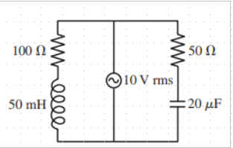
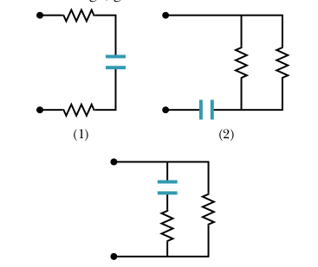
Name ________________________ Quiz 10, PHY2049C

A- Read all the exam once, or twice, before beginning to write. Make sure to comprehend all questions and start with those you feel most confident in.
B – Be clear and concise. There are no extra points for being verbose or writing extra.
C –Only use the white pages that I will provide. You have 170 minutes to answer the exam.
---------------------------------------------------------------------------------------------------------------------------

Problem 4

The figure (rigth) shows three sections of circuit that are to be connected in turn to the same battery via a switch. The resistors are all identical, as are the capacitors. Rank the sections according to the time required for the capacitor to reach 50% of its final charge, greatest first.

Problem 5

Consider the circuit shown in the figure below. With switch S1 closed and the other two switches open, the circuit has a time constant τ_{C}. With switch S2 closed and the other two switches open, the circuit has a time constant τ_{L}. With switch S3 closed and the other two switches open, the circuit oscillates with a period T. Show that

T = 2π √(τ_{L} τ_{C})
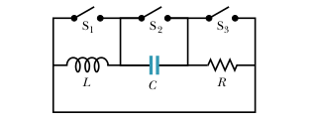

Problem 6
What is the current supplied by the emf when the frequency is very large compared to 2π/(L/R) (where L is the inductance and R the resistance of the left resistor).

