Name ________________________
PHY2048C, Quiz 7

A- Read all the quiz once, or twice, before beginning to write. Make sure to comprehend all questions and start with those you feel most confident in.
B – Be clear and concise. There are no extra points for being verbose or writing extra.
C –Only use the white pages that I will provide. You have 50 minutes to answer the quiz.
---------------------------------------------------------------------------------------------------------------------------
Problem 1

At the beach you see the crests of the waves are 3m apart and 8 of them pass you in 12s. What is the wave velocity?

Problem 2
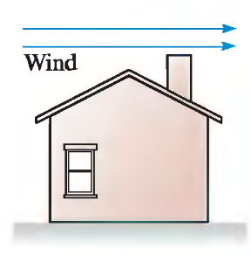
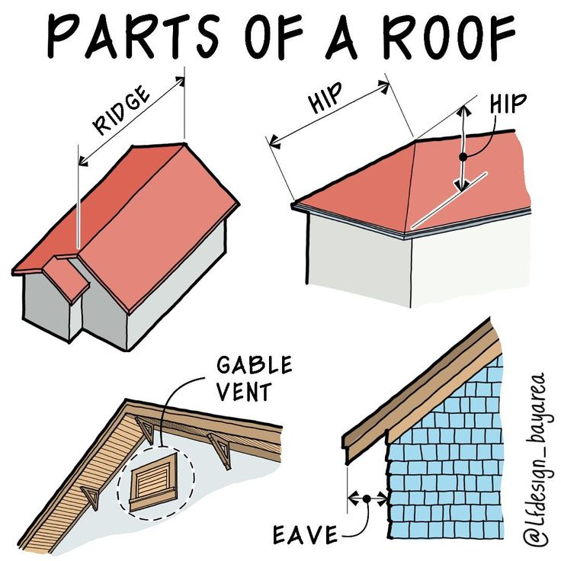
A wind of 25 mi per hour blows over the house in the figure. The window is closed and the air inside the house is stagnant. The angle of the roof σ =150°. The house is a 30 m by 30 m square. You can ignore the length of the eaves. Compute the net force on the roof due to the pressure difference. Ignore the effects of the gravitational force.

Problem 3
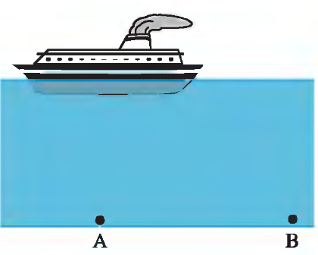
Rank the pressures at points a to d from largest to smallest.
D

C

