Name ________________________
PHY2048C, Quiz 7

A- Read all the quiz once, or twice, before beginning to write. Make sure to comprehend all questions and start with those you feel most confident in.
B – Be clear and concise. There are no extra points for being verbose or writing extra.
C –Only use the white pages that I will provide. You have 60 minutes to answer the quiz.
---------------------------------------------------------------------------------------------------------------------------
Problem 1
The three wave pulses in the figure travel along the same stretched string. Rank in order, from largest to smallest, their wave speeds va, vb, and vc.

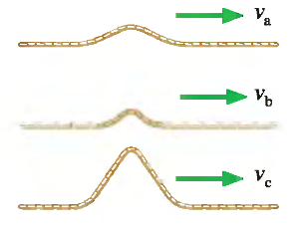

Problem 2
(a) What are the amplitude, wavelength, frequency, and phase constant of the traveling wave below.
(b) Rank in terms of their wave speeds v1, v2, and v3.
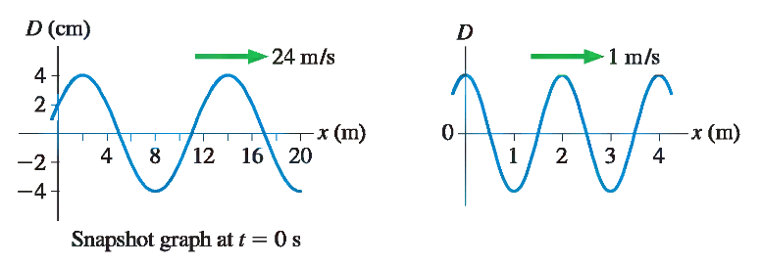
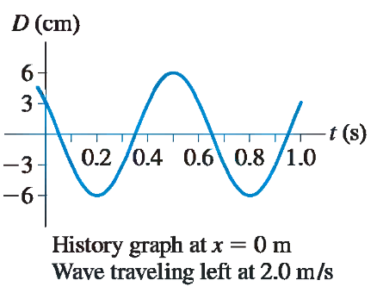

Problem 3
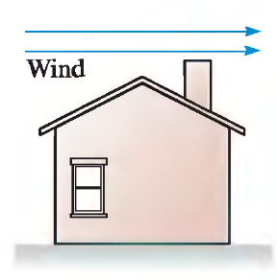
Wind blows over the house in the figure. A window on the ground floor is open. (a) Is there an airflow through the house? If so, does the air flow in the window and out the chimney, or in the chimney and out the window? (b) Imagine the window is closed and the air inside the house is stagnant. Moreover, the Area of the roof is A=200 m^2 and assume the roof is flat and thin. The wind blows at 22 miles per hour. What is the force due to the air on the roof?

