Name ________________________ PHY2048C, Quiz 8

A- Read all the quiz once, or twice, before beginning to write. Make sure to comprehend all questions and start with those you feel most confident in.
B – Be clear and concise. There are no extra points for being verbose or writing extra.
C –Only use the white pages that I will provide. You have 50 minutes to answer the quiz.
---------------------------------------------------------------------------------------------------------------------------
Problem 1
(a) What are the amplitude, wavelength, frequency, and phase constant of the traveling wave below.

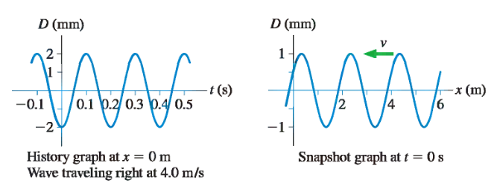
Problem 2
A wire has a tension equal to its weight. What is the velocity of waves?

Problem 3
A vertical tube of radius 1cm, open at the top to the atmosphere,
contains 2cm of oil (ρ_oil = 0.82 ρ_water ) floating on 3cm of water. What is the gauge
pressure (i.e., pressure in excess of the atmospheric) at the bottom?

Problem 4
A wall of an outdoor pool is 10m long and 2m deep. What force
is needed to keep it in place?

