Name ________________________
PHY2048C, Quiz 2

A- Read all the quiz once, or twice, before beginning to write. Make sure to comprehend all questions and start with those you feel most confident.
B – Be clear and concise. There are no extra points for being verbose or writing extra.
C –Only use the white pages that I will provide. You have 60 minutes to answer the quiz.
---------------------------------------------------------------------------------------------------------------------------

Problem 1

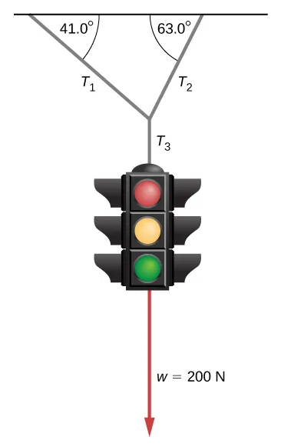
(a) Tara, Nico, and Alex have 500 B./ between the three of them. Tara spent 2/5 of her money. Nico spent 40 B./, and Alex spent twice the amount Tara spent. If all three friends end with the same amount of money each, how much money did Alex have at the beginning?
(b) The traffic light hangs from the cables as shown.
Draw the free-body diagram of the traffic light.

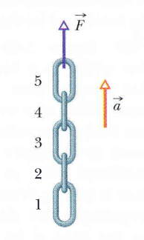
Problem 2 (From Halliday, Resnik, Walker)

In Fig. 1., a chain consisting of five links, each of mass 0.100 kg, is lifted vertically with constant acceleration of magnitude a = 2.50 m/s2. Find the magnitude of the force on link 4 from link 3

Figure 1

Problem 3 (Sears and Zemansky)

A 40 kg skier skis directly down a frictionless slope with an angle of 10° from the horizontal. Assume the skier moves in the negative direction of an x’ axis along the slope. A wind force with component Fx’, acts on the skier. What is Fx’ if the magnitude of the skier's velocity is constant?

