Name ________________________
PHY2049C, Quiz 8

A- Read all the quiz once, or twice, before beginning to write. Make sure to comprehend all questions and start with those you feel most confident in.
B – Be clear and concise. There are no extra points for being verbose or writing extra.
C –Only use the white pages that I will provide. You have 50 minutes to answer the quiz.
---------------------------------------------------------------------------------------------------------------------------

Problem 1

The wire loop in Figure (a) lies in the x-y plane and it is subjected to six uniform magnetic fields, each directed parallel to the z axis. Figure (b) gives the z components of the fields versus time t. Rank the six plots according to the emf induced in the loop, greatest clockwise emf first, greatest counterclockwise emf last.
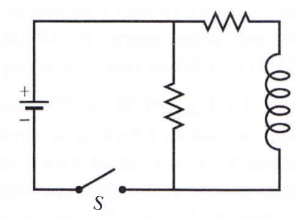
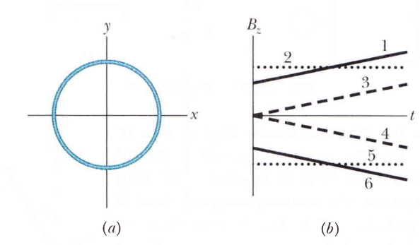

Problem 2

The figure on top (rightmost) shows a circuit with two identical resistors and an ideal inductor. Rank the current through the central resistor in this 4 scenarios (a) just after the closing of switch S, (b) a long time after that, (c) just after S is reopened after a long time, and (d) a long time after S is reopened

Problem 3

The figure shows four wire loops, with edge of lengths either L or 2L. The loops will move through a region of uniform magnetic field B (directed out of the page) at the indicated constant velocities. Rank the four loops according to the maximum magnitude of the emf induced as they move through the field , greatest first.

