Name ________________________
PHY2048C, Quiz 1

A- Read all the quiz once, or twice, before beginning to write. Make sure to comprehend all questions and start with those you fell most confident.
B – Be clear and concise. There are no extra points for being verbose or writing extra.
C –Only use the white pages that I will provide. You have 50 minutes to answer the quiz.
---------------------------------------------------------------------------------------------------------------------------

Problem 1

The brakes on your car can slow you at a rate of 5.2 m/s². (a) If you are going I37 km/h and suddenly see a speed trap (a police car with a radar gun), what is the minimum time in which you can get your car under the 90 km/h speed limit? GPS app WAZE give “police ahead” warning 500 m in advance. Assuming immediate reaction time of the driver, is that enough of a heads-up to get under the speed limit?

Problem 2

A basket contains 75 brown eggs and some white eggs. Alice discovers that 15% of the total eggs are bad. From the bad eggs, 2/3 are white, and the 6 left are brown. (a) how many total eggs are there on the basket? (b) how many eggs are not bad?
Jimmy had 800 B/. more than Dayana. Jimmy gave ¼ of his money to Dayana, and the proportion between Jimmy’s and Dayana’s money is 5:7. (c) How much money did Jimmy gave to Dayana?

Problem 3 (From Halliday, Resnik, Walker)

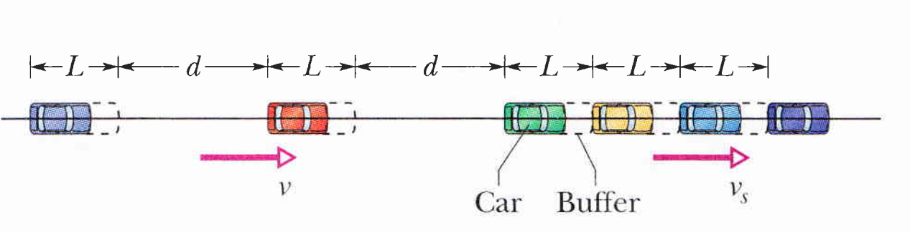
Hydraulic engineers in the United States often use, as a unit of volume of water, the acre-foot, defined as the volume of water that will cover 1 acre of land to a depth of 1 ft. A severe thunderstorm dumped 2.0 tn. of rain in 30 min on a town of area 26 km². What volume of water, in acre-feet, fell on the town (Hint: 1ft = 0.305 m | 1tn = 907. kg).

Problem 4 (From Halliday, Resnik, Walker)

Traffic shock wave. An abrupt slowdown in concentrated traffic can travel as a pulse, termed a shock wave, along the line of cars, either downstream (in the traffic direction) or upstream, or it can be stationary. The figure above shows a uniformly spaced line of cars moving at speed v = 25.0 m/s toward a uniformly spaced line of slow cars moving at speed v = 5.00 m/s. Assume that each faster car adds length L = I2.0 m (car length plus buffer zone) to the line of slow cars when it joins the line, and assume it slows abruptly at the last instant. (a) For what separation distance d between the faster cars does the shock wave remain stationary? If the separation is twice that amount, what are the (b) speed and (c) direction (upstream or downstream) of the shock wave?

