Name ________________________
PHY2049C, Homework 1

A- Submit a handwritten version of the solutions (clearly readable) at the beginning of class.
---------------------------------------------------------------------------------------------------------------------------

Problem 1

(a) The average weight of 12 rocks is 25 kg. Adding a rock raises the average to 29 kg. How much does this last rock weights?
(b) According to the National Institute of Statistics and Census (Instituto Nacional the Estadística y Censo), the birth-rate per family is 1.9 babies. Given that no family can have 1.9 children, what’s the meaning of this number? Build a set of 10 families whose average is 1.9 babies.

Problem 2

In the vertex of a triangle three point charges were places: Q, Q’, and q. What ratio Q’/Q makes the force on Q net zero?

Problem 3

Two equally charged particles have a distance between them of 3.2x10⁻³ m. After freeing them, one starts moving with an acceleration of 7.0 m/s², and the other moves with and acceleration of 9.0 m/s^{2.}. If the mass of the first particle is 3.6x10⁻⁷ kg, determine the mass of the second particle and the charge of each (ignore gravitational interactions).

Problem 4 (Wolfson and Passachof)

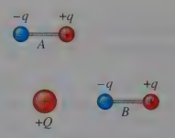
Dipoles A and B are both located in the field of a point charge Q, as shown in Figure 1. Does either experience a net torque? A net force? If each dipole is released from rest, describe qualitatively its subsequent motion.

Figure 1

Problem 5 (Wolfson and Passachof)

In Figure 2, take q₁ = 68 µC, q₂ = —30 µC, and q₃ =12 µC. Find the electric force on q₃.
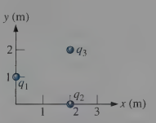

Figure 2
Problem 6

Two small plastic spheres are given positive electric charges. When they are 15.0 cm apart, the repulsive force between them has magnitude 0.220 N. What is the charge on each sphere (a) if the two charges are equal and (b) if one sphere has four times the charge of the other?

